Bài lab hướng dẫn cài

* Active directory (PDC)
* ADC
* Certificate sevice
* Federation service
* Right manage service
* IIS service
* Ipam service

Chuẩn bị 6 window server: lần lượt là

PDC-01, ADC-01, CA-SERVER(sãn cài IIS), ADFS-SERVER, RMS-SERVER, IPAM-SERVER

Bước 1: cài đặt các máy server  
chọn : New machine , chọn typical

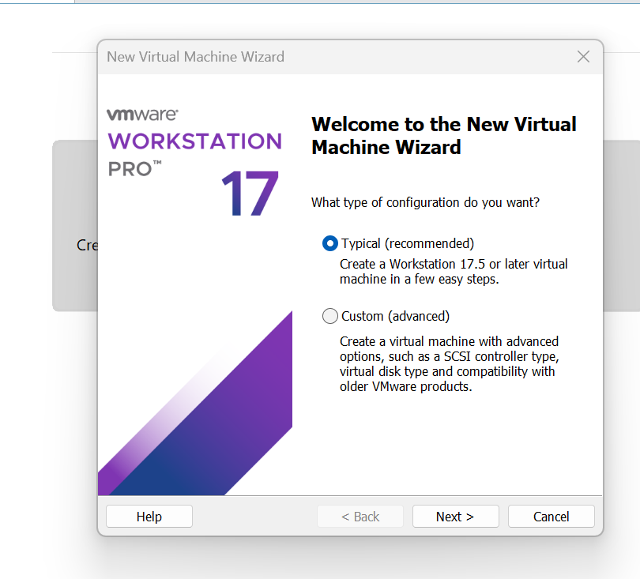

Chọn i will install the operating system later

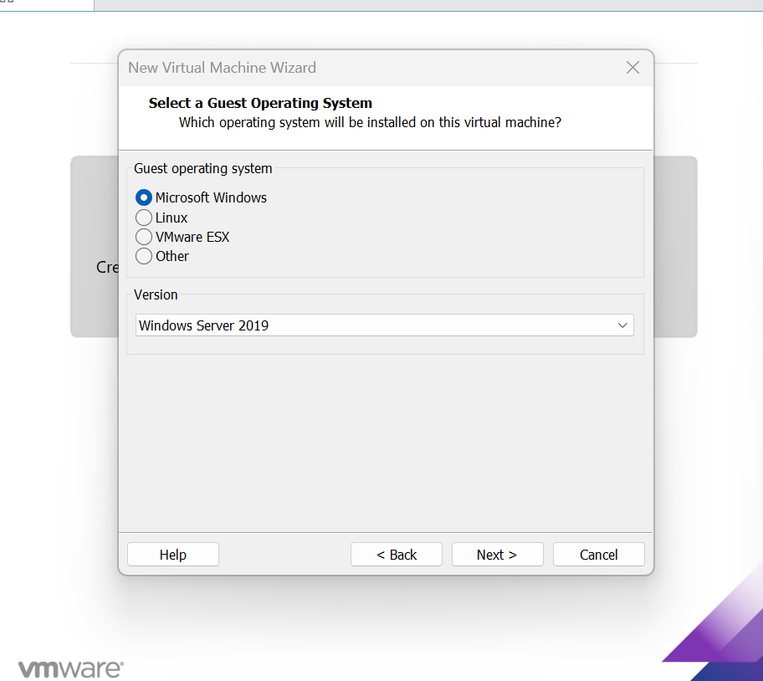

Chọn Microsoft window 2019

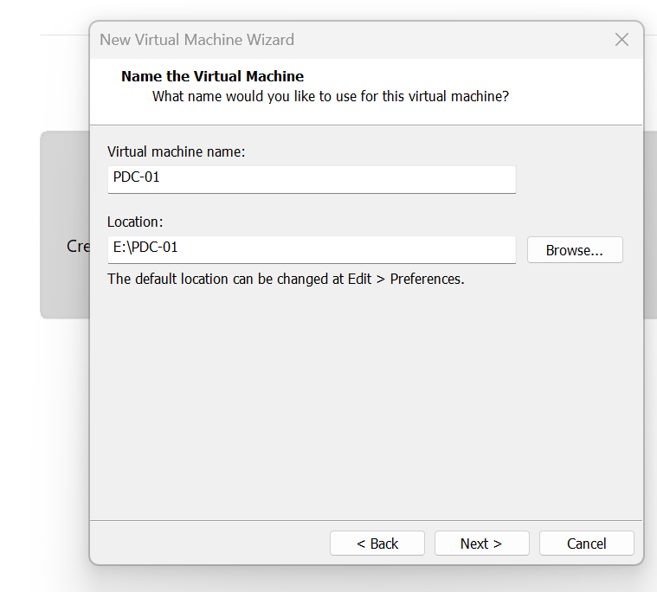

Chọn đường dẫn lưu trữ máy ảo và đặt tên máy

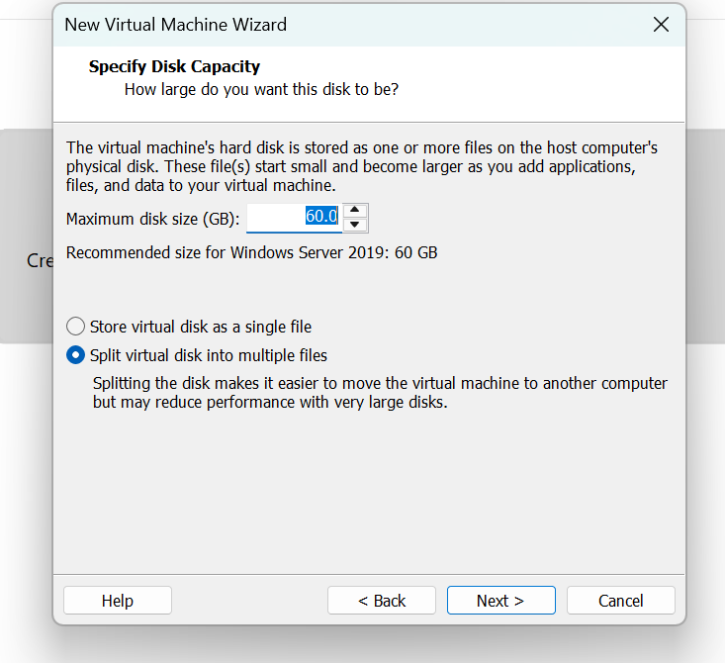

Giữ nguyên

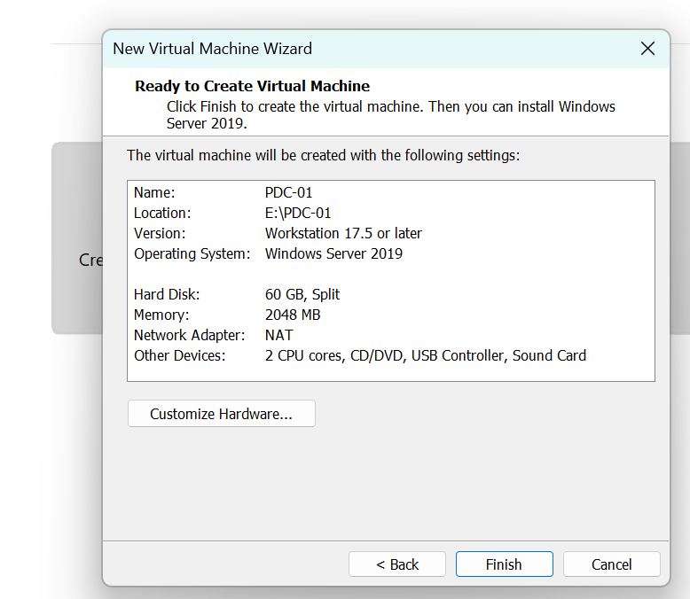

Chọn finish

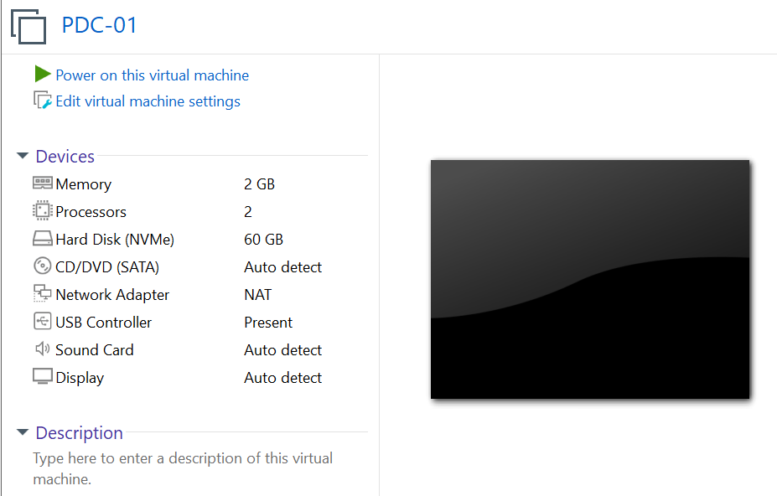

Chọn Edit virtual machine settings

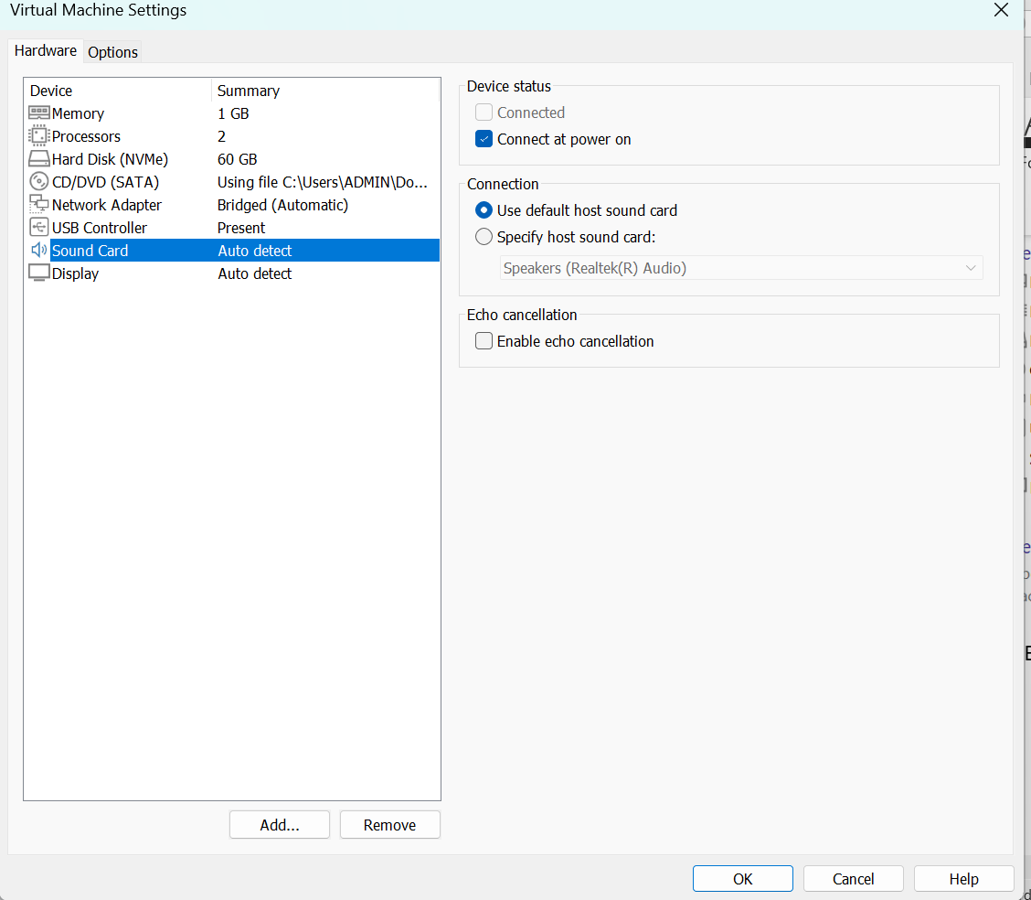

Cấu hình như hình phần CD/DVD chọn file iso win 2019

Chọn ok

Khởi động máy ảo -> click liền phím bắt kì để bắt đầu install

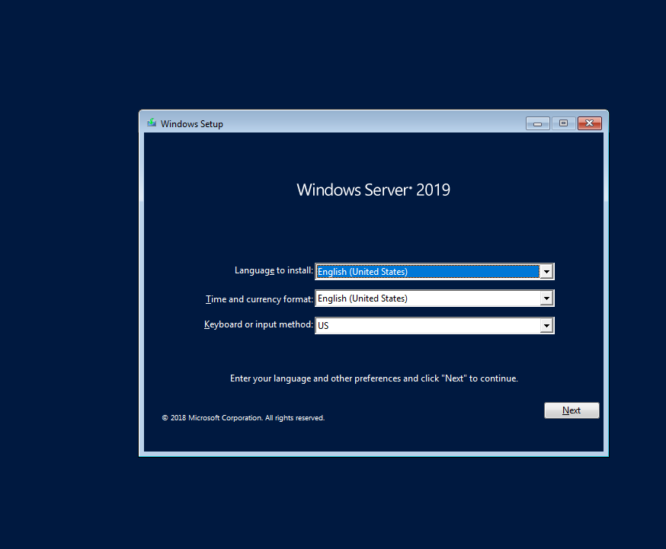

Chọn next

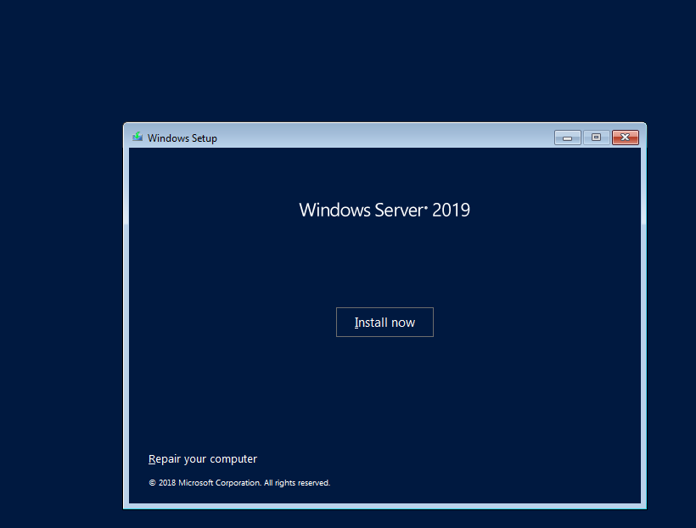

Chọn install now

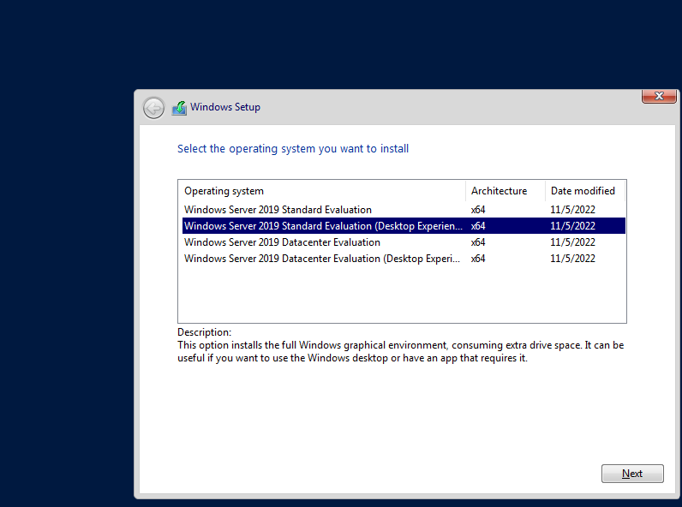

Chọn standard evalution(desktop experience)

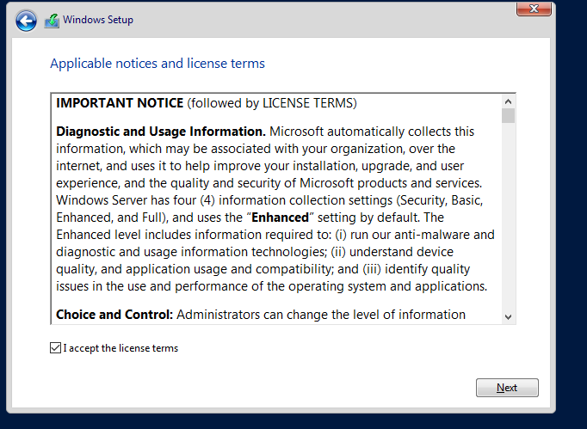

Chọn i accept , click next

* Click custom advanced next

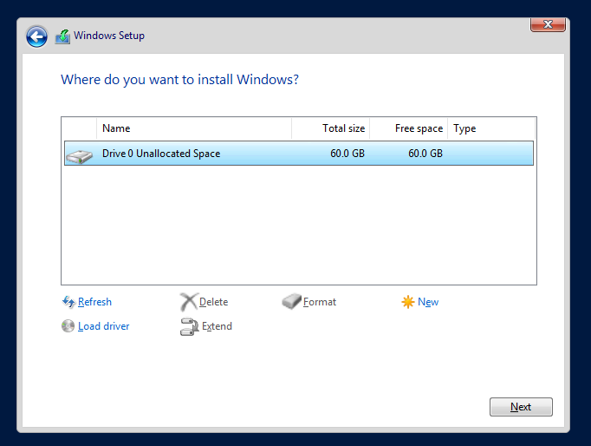

Chọn next để bắt đầu cài đặt

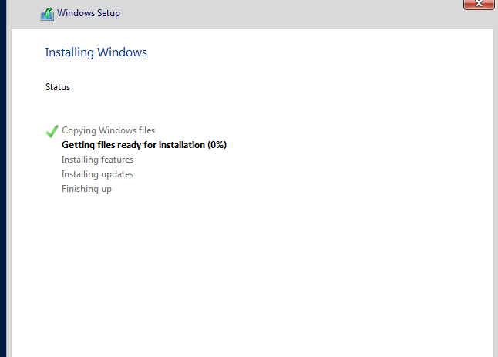

Sau khi cài xong chọn Restart now

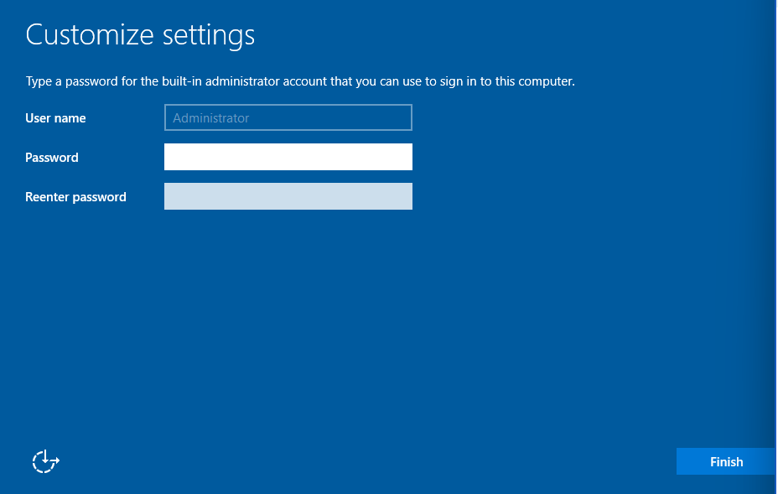

sau đó hiển thị đặt pass cho máy thì pass tự đặt và chọn finish

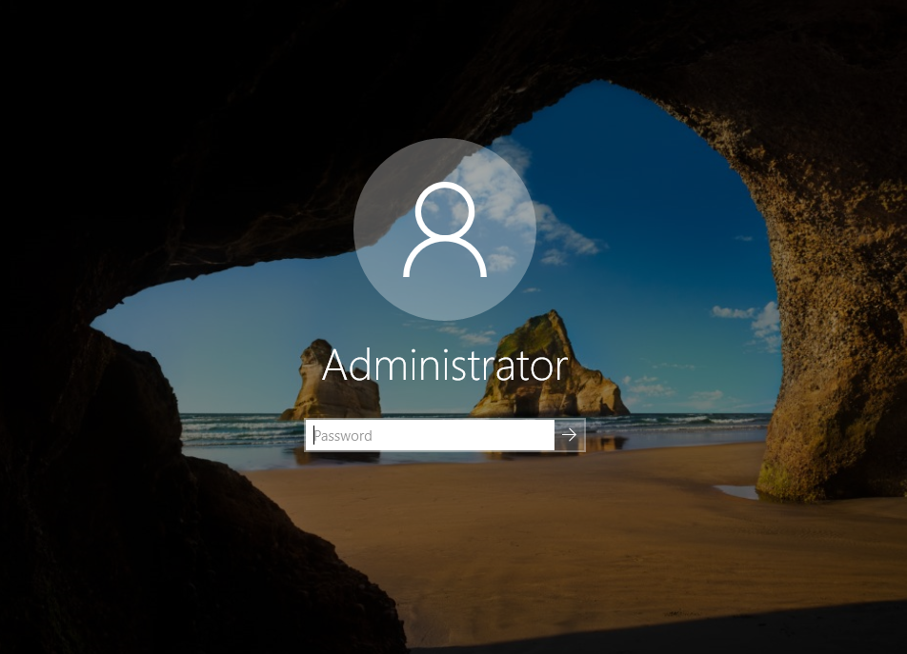

Nhấn tổ hợp phím ctl+alt+insert để login

Sau khi cài xong các bước đầu tiên chúng ta cần thực hiện để chuẩn các bước cài đặt các dịch vụ  
1. Tắt firewall

2.đặt tên máy

3. đặt địa chỉ ip

4. cài vmware tool

5 . snapshot backup máy(phồng trường hợp bị lỗi cài win lại)

1. Tắt firewall

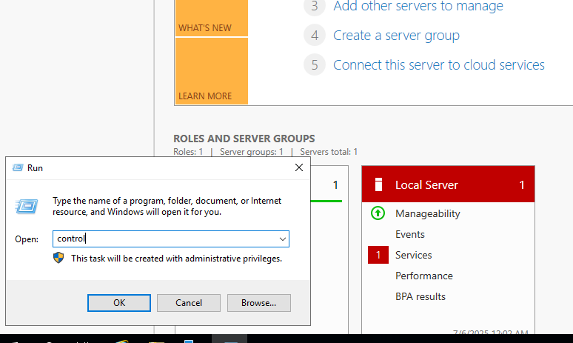

window+r nhập control

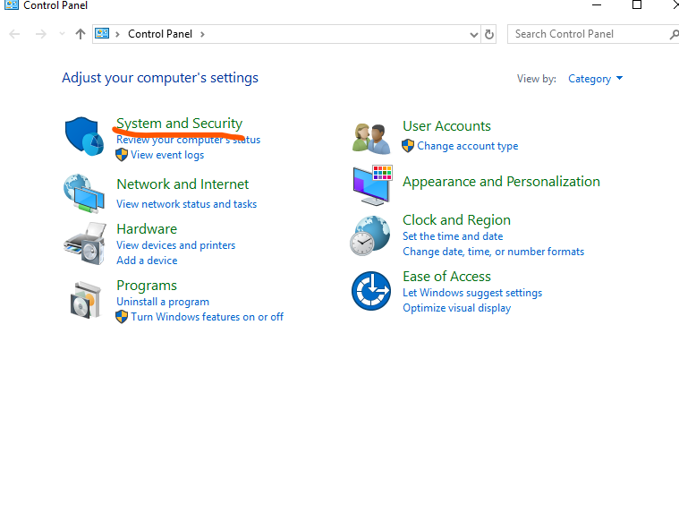

Chọn system and security

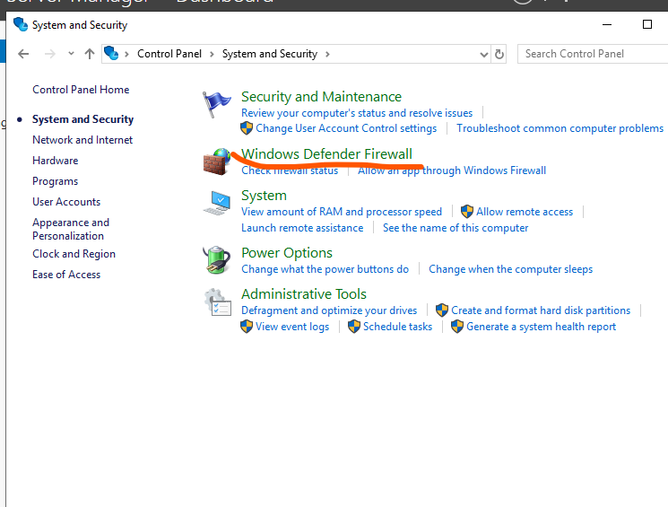

Chọn window defender firewall

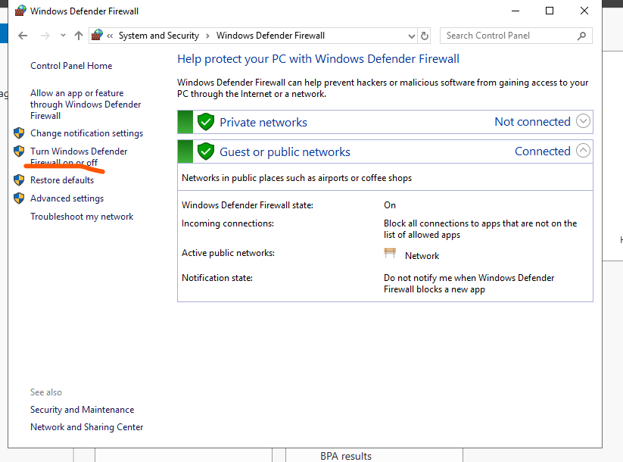

Chọn turn window defender firewall on or off

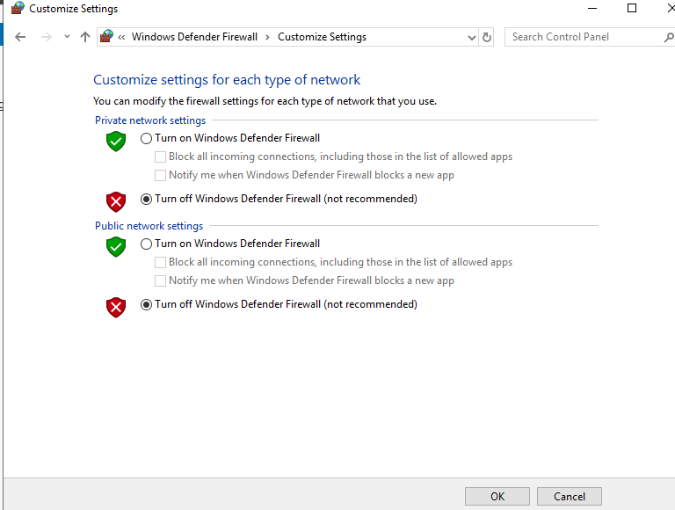

Click như hình trên chọn ok

1. Đặt tên máy

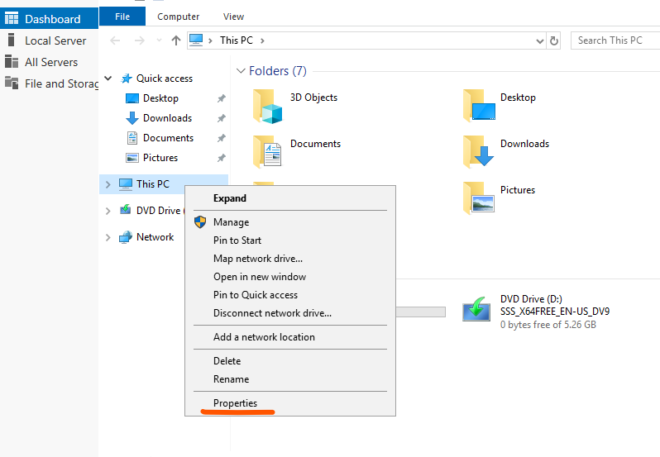

Vào this pc chọn properties

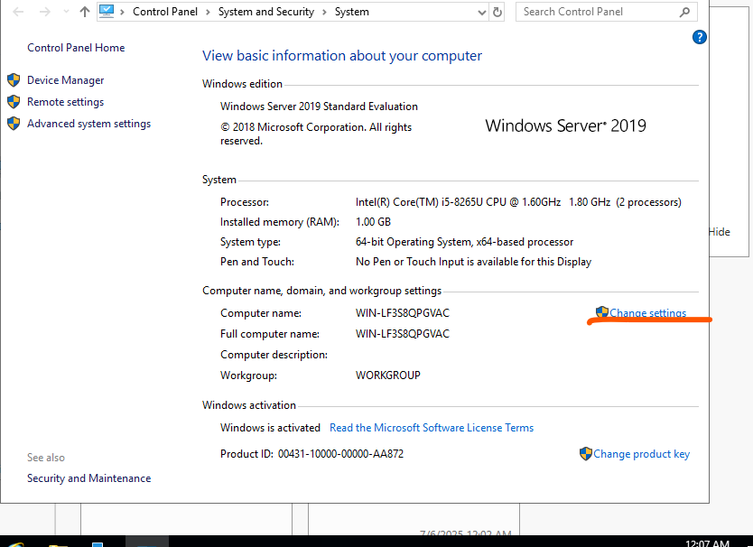

Chọn change settings

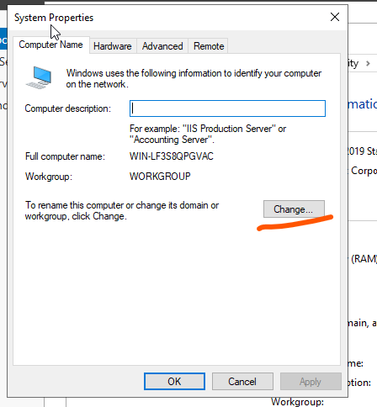

Chọn change

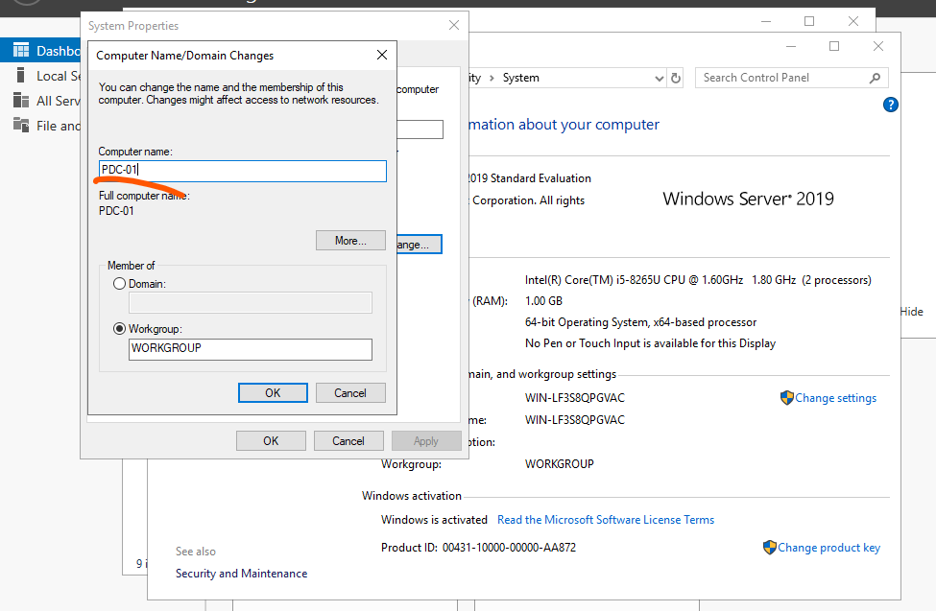

Chọn tên mình muốn đặt -ở đây mình đặt tên là PDC-01 sau đó chọn OK

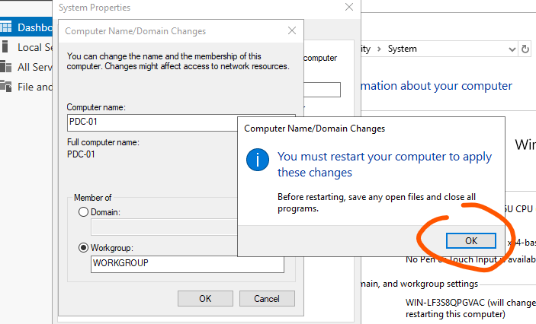

Chọn OK

Chọn close-> restart later

1. Đặt địa chỉ ip tĩnh

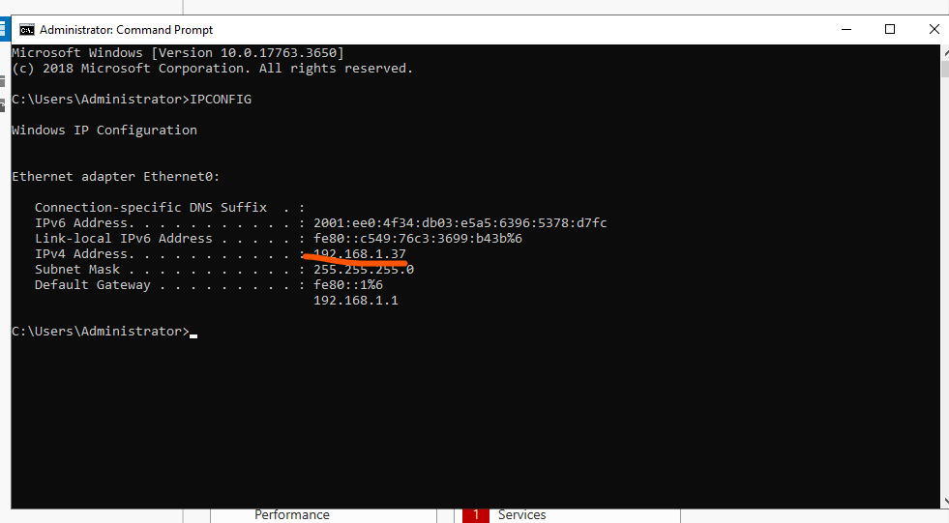

Mở cmd gõ ipconfig để biết ip máy

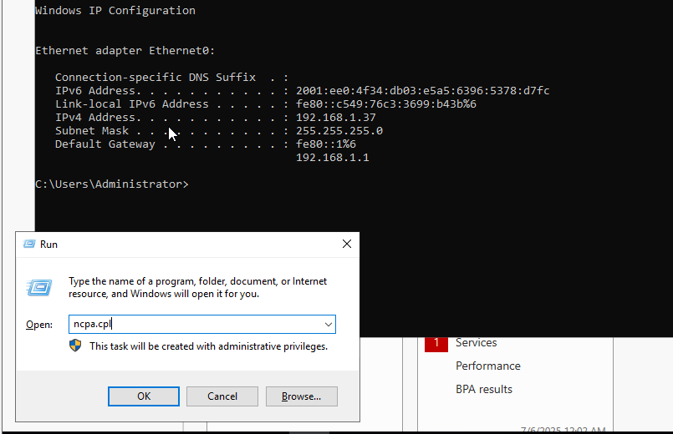

Mở window +R nhập ncpa.cpl

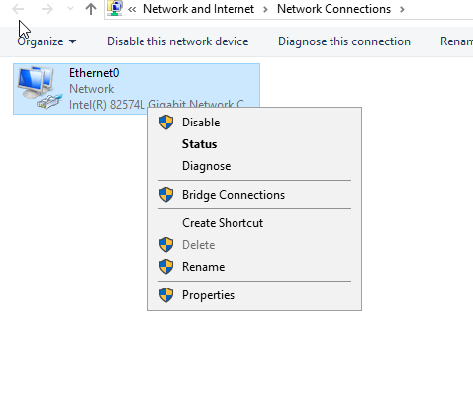

Click chuột phải chọn properties

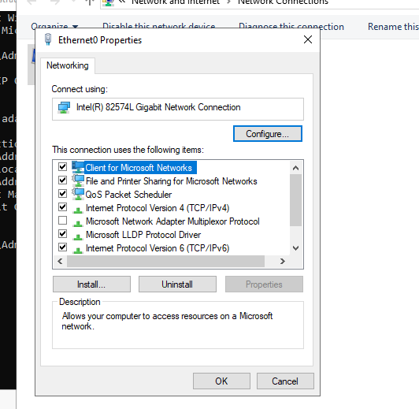

Click bỏ ipv6 để nslookup ra tên miền

Sau đó click chọn ipv4

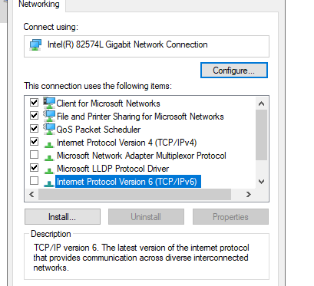

Sau đó đặt ip theo ipconfig

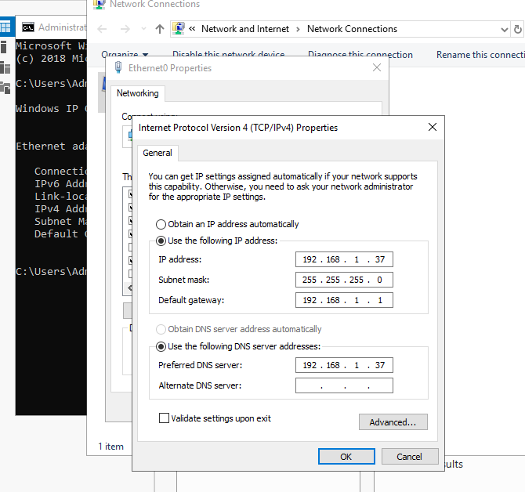

Và dns chọn ip của máy sau đó click chọn ok

1. Cài vmware tool-> mục đích copy file từ máy ảo – máy ảo, máy ảo -máy thật

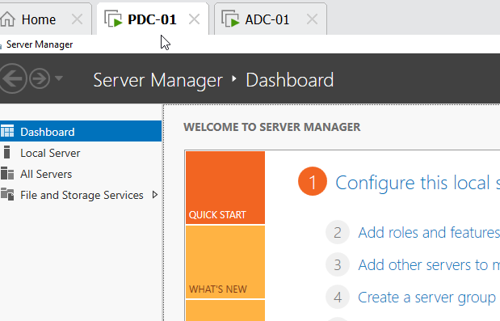

Click chuột phải chọn install vmare tool

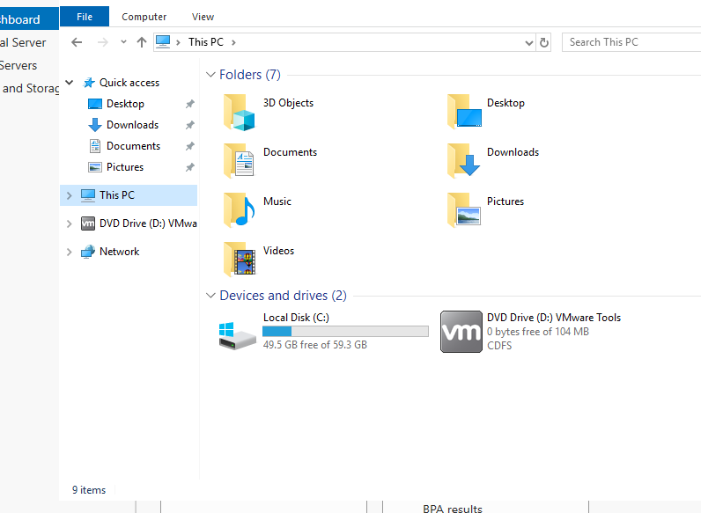

dupble click vào biểu tượng vm

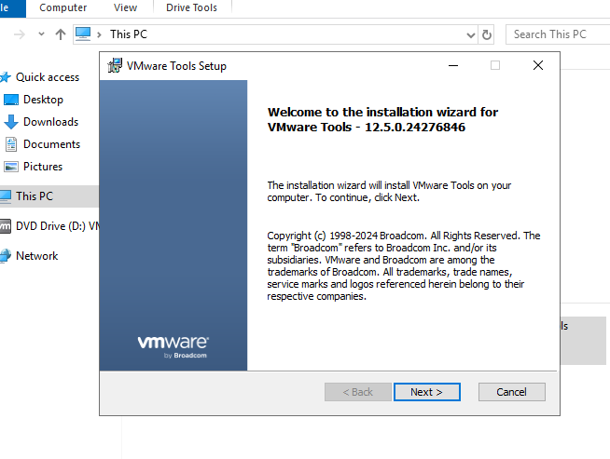

Chọn next

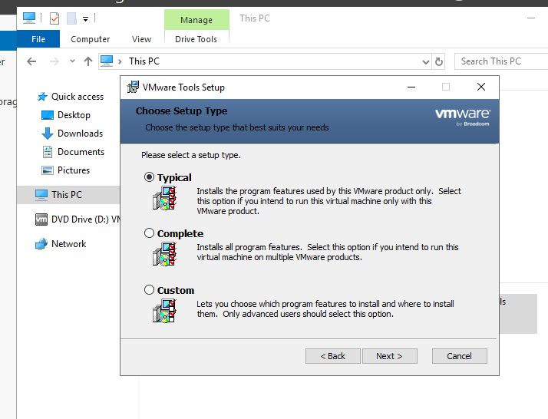

Chọn typical

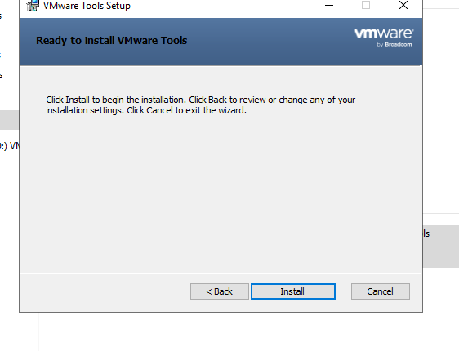

Chọn install

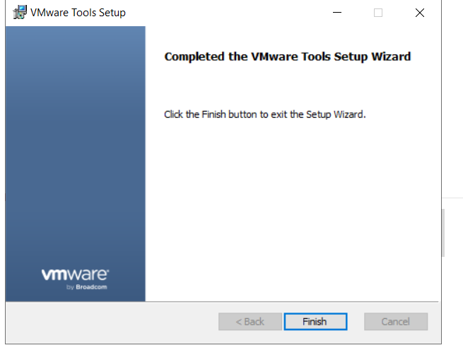

Chọn finish

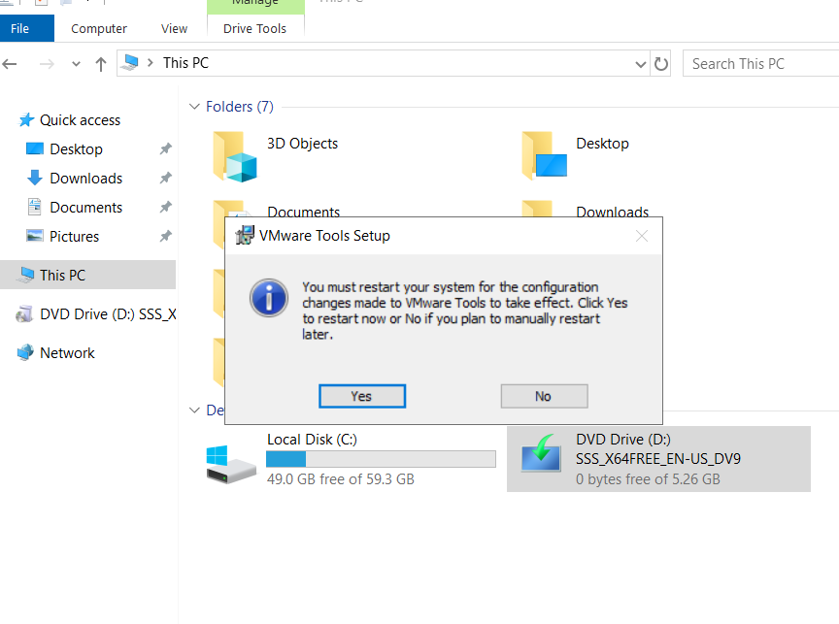

Chọn khởi động lại máy (yes) để nhận vmware tool và tên PDC-01

1. Take snapshot (mục đích back up máy ảo )

Click chuột phải vào tên PDC-01 chọn take snapshot

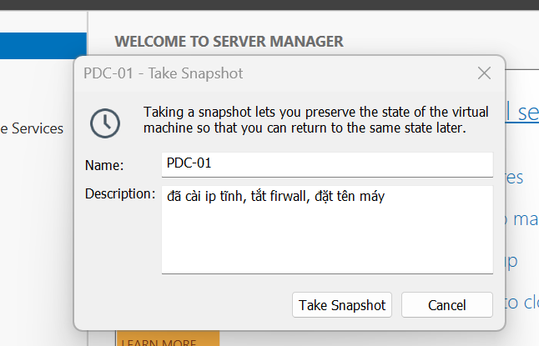

Sau đó chọn take snap shot

=🡺 làm tương tự các bước cài đặt và cấu hình như trên cho các server   
[ADC-01, CA-SERVER, ADFS-SẺVER, RMS-SERVER, IPAM-SERVER]

1. CÀI ĐẶT DỊCH VỤ ADDS

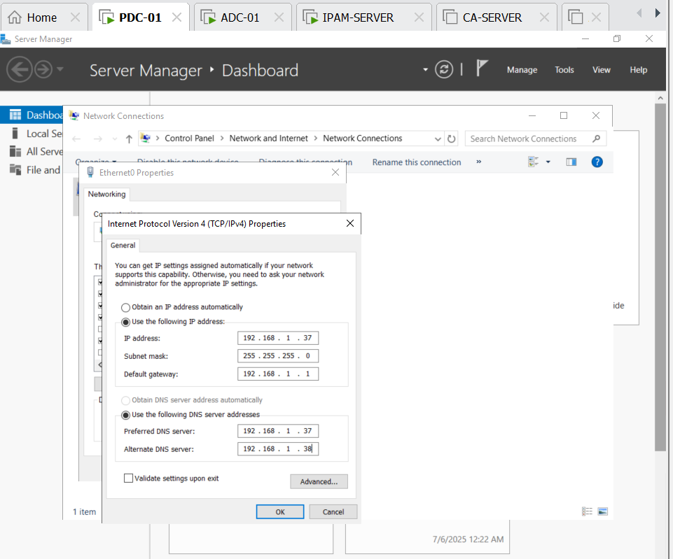

Configure ip like this(ofcourse your ip add)

192.168.1.37 (pdc-01)

192.168.1.38(pdc-02)

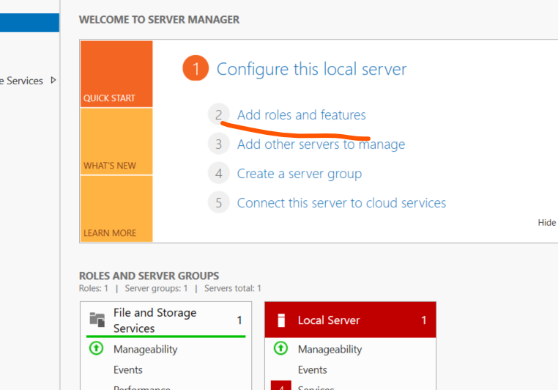

Add new role

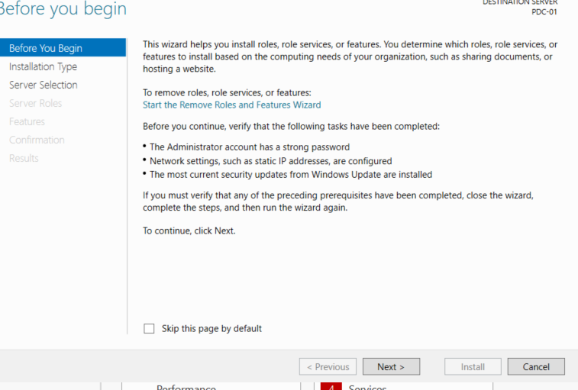

Next

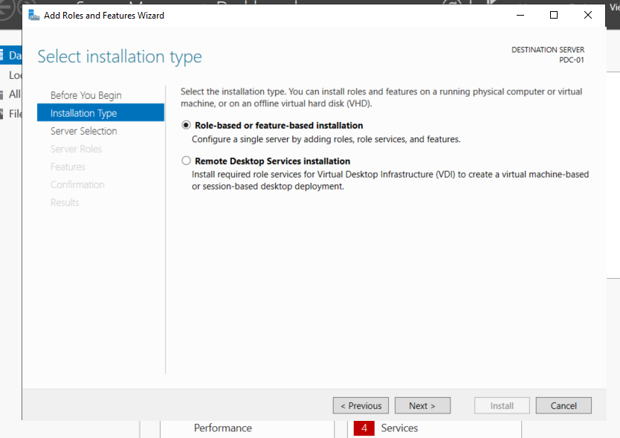

Next

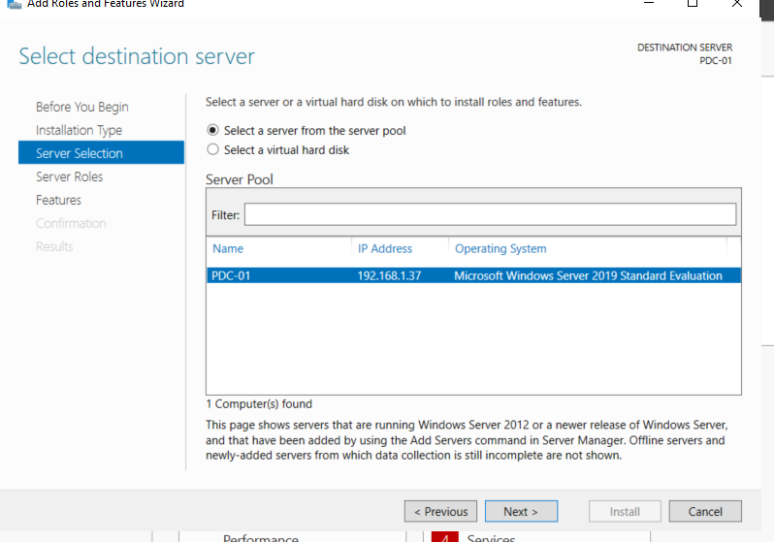

Next

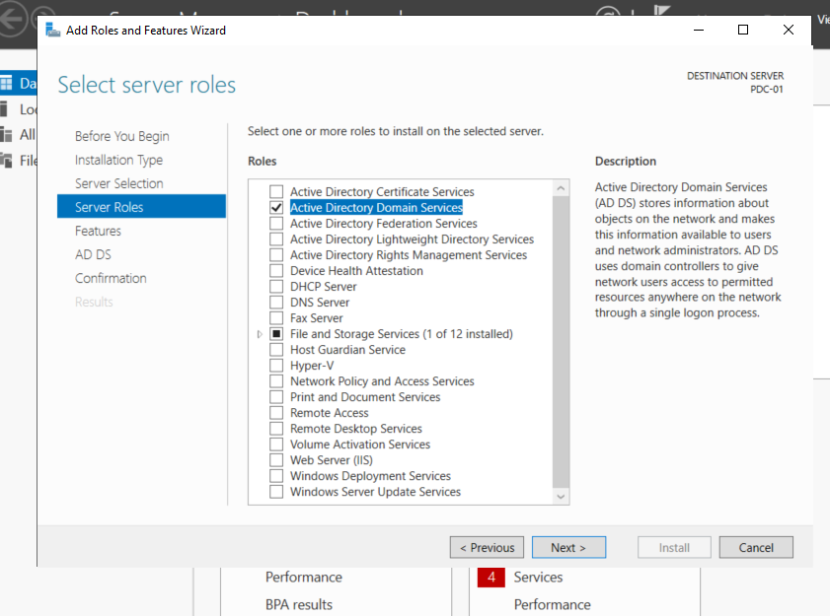

click active directory domain service and after that click add feature

click next

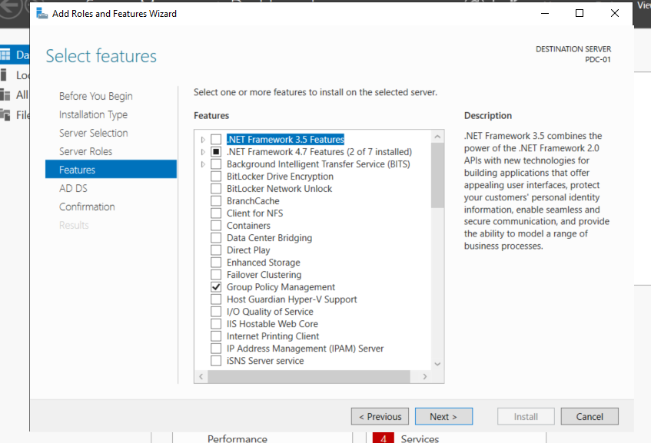

Click next

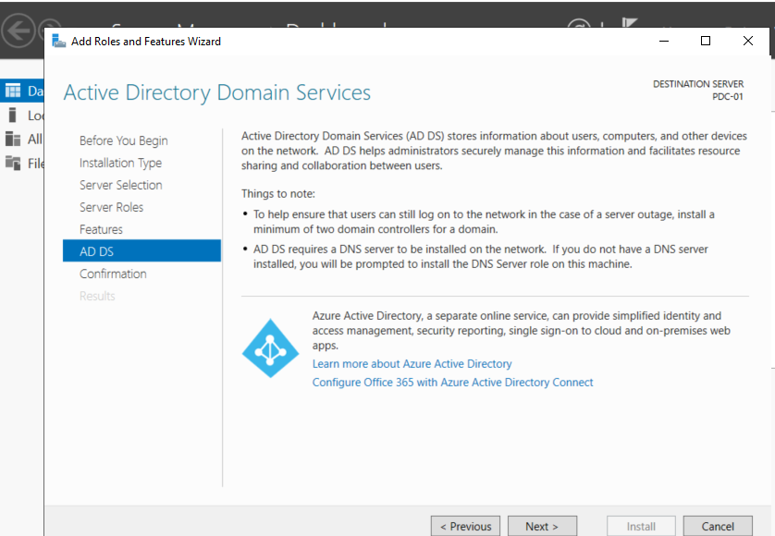

Click next

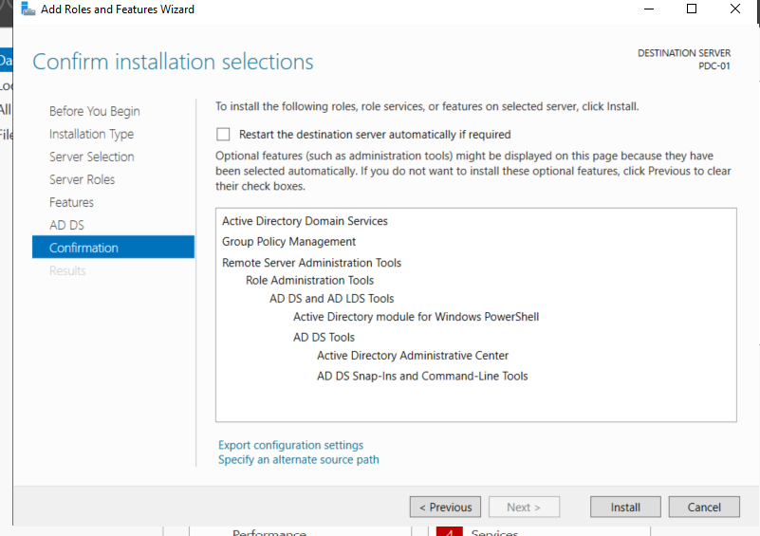

Click install

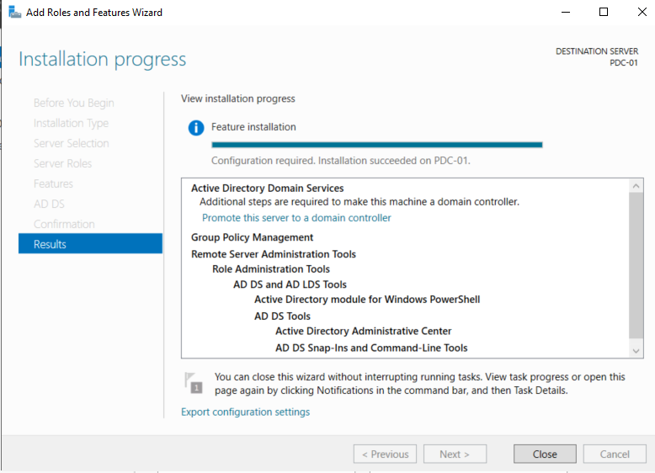

Click close

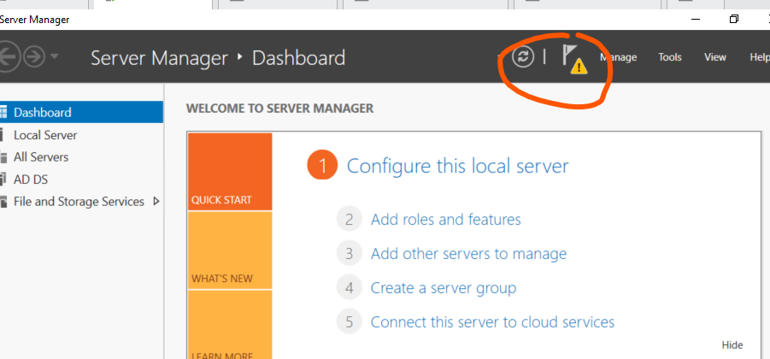

Click yellow flag

And choose promote this server to a domain controller

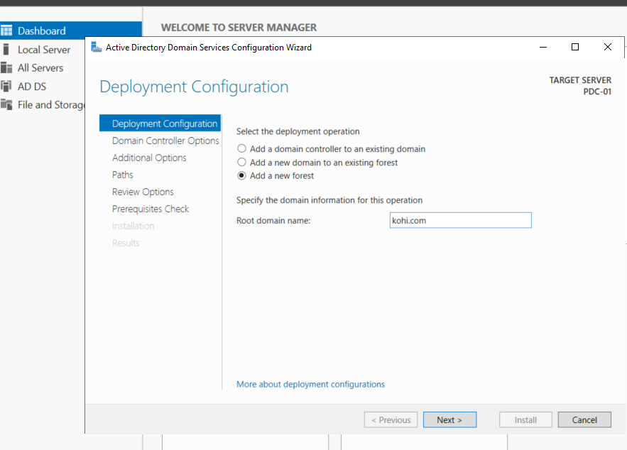

Click add a new forest and name root domain kohi.com, then next

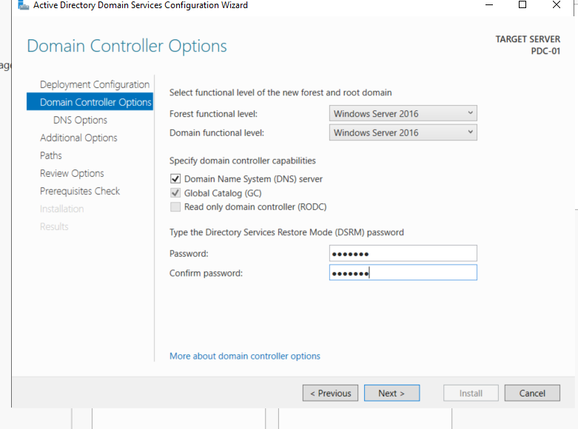

Set password and next

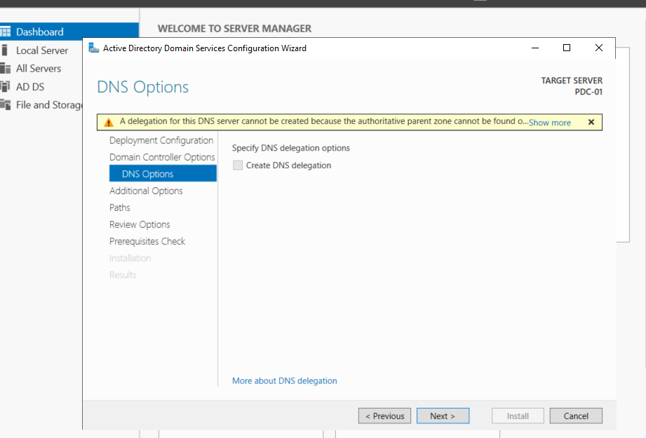

Click next

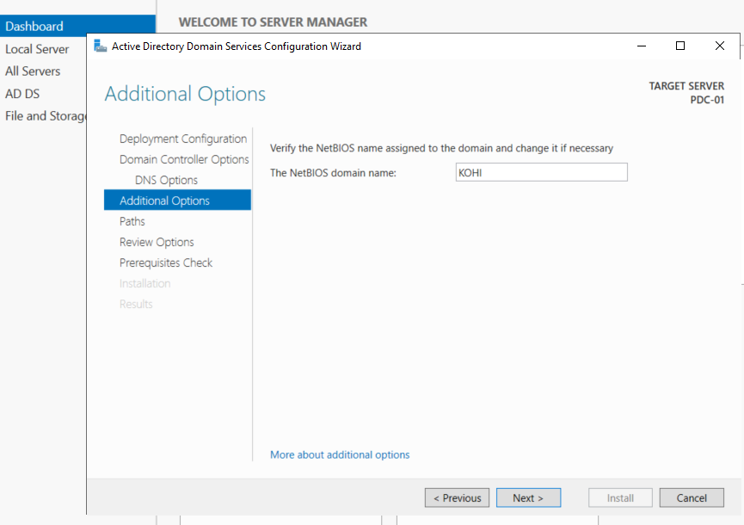

Click next

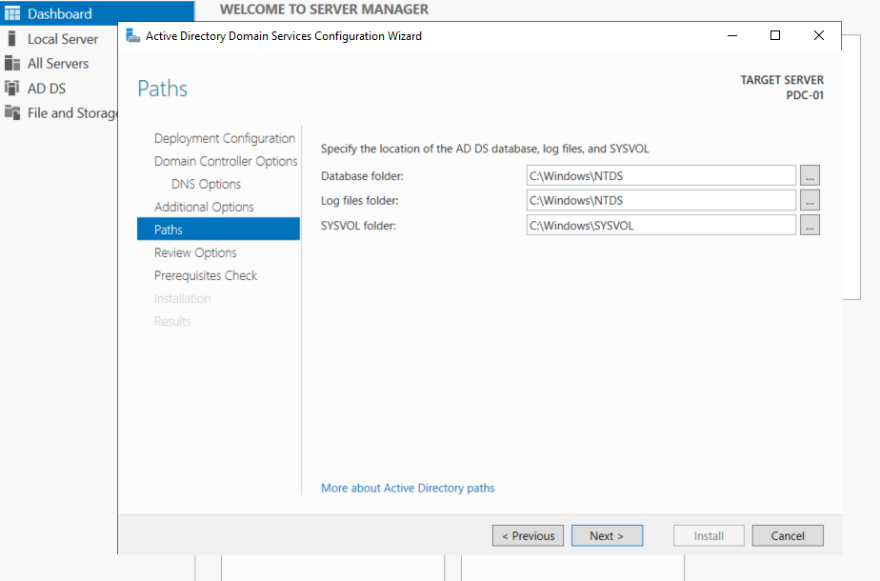

Click next

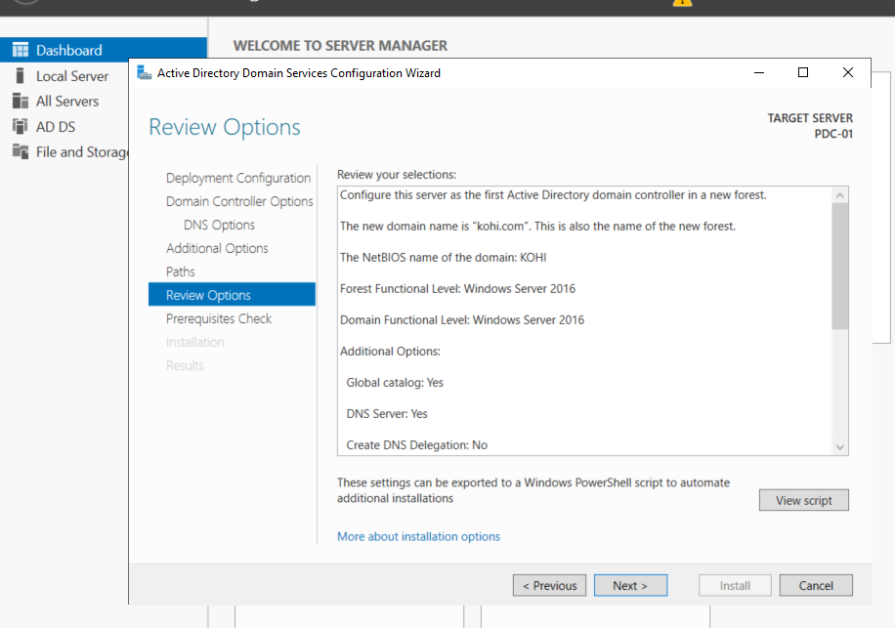

Click next

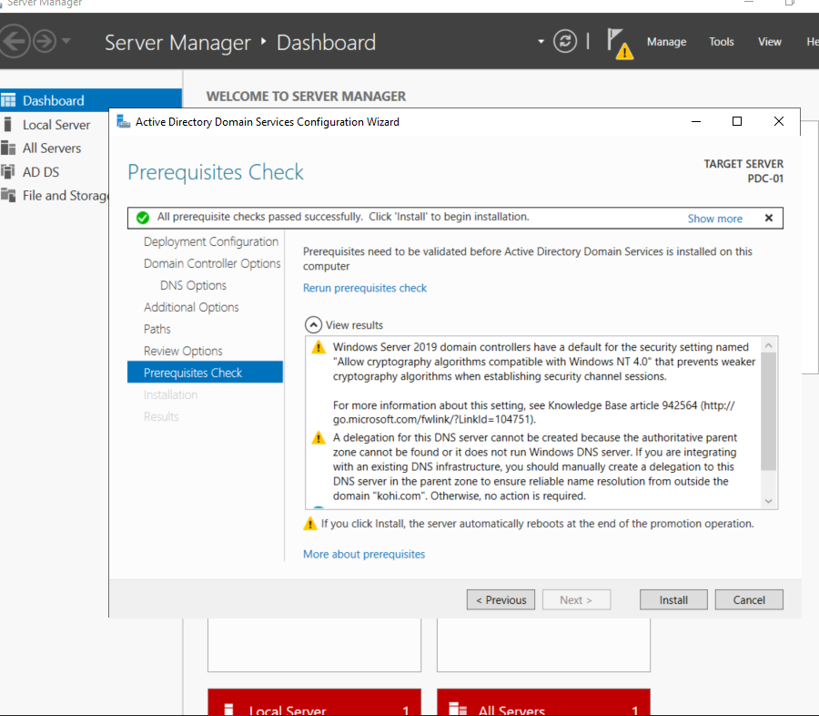

Click install

After that window automatically restart to update and appear new account which name is kohi\administrator

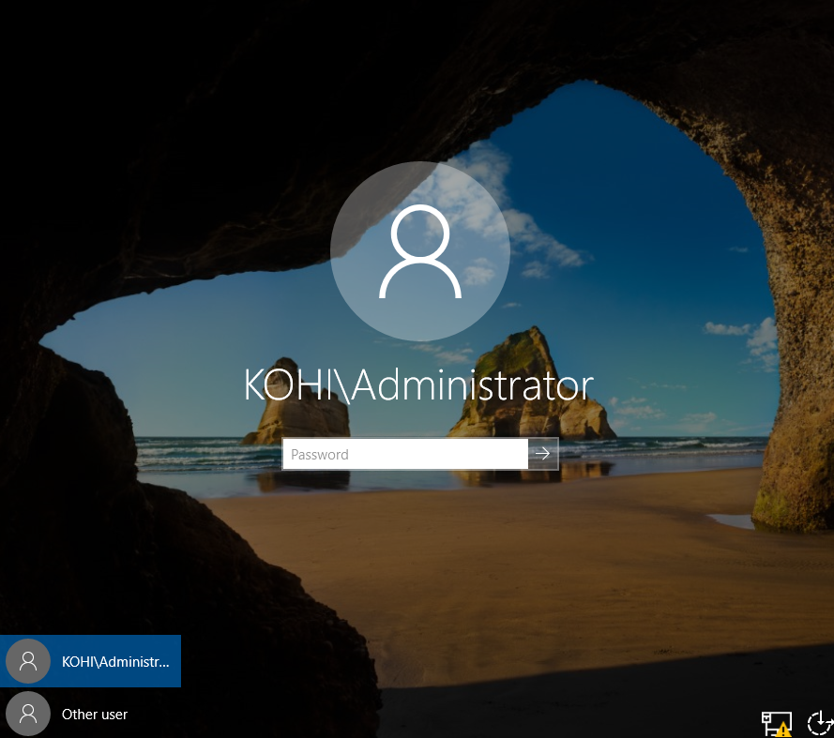

Then we ‘ve already finished installing ADDS

Next part

Next we must configure dns after restarting window

Notice: after installing , the window automatically updates new DNS we need to adjust it which is like normal

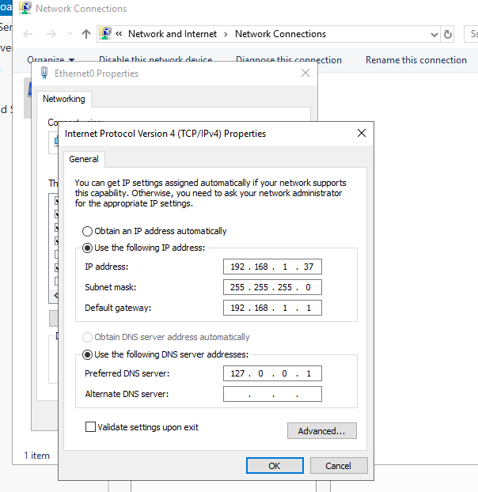

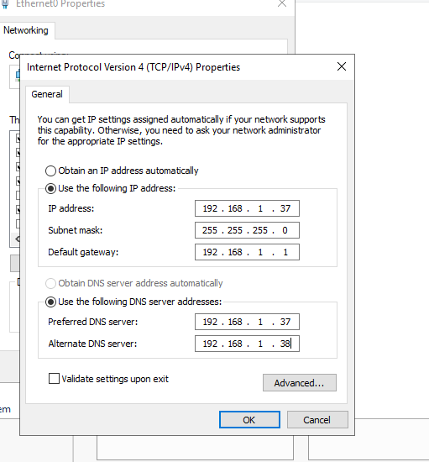

After that we choose tools , and click DNS

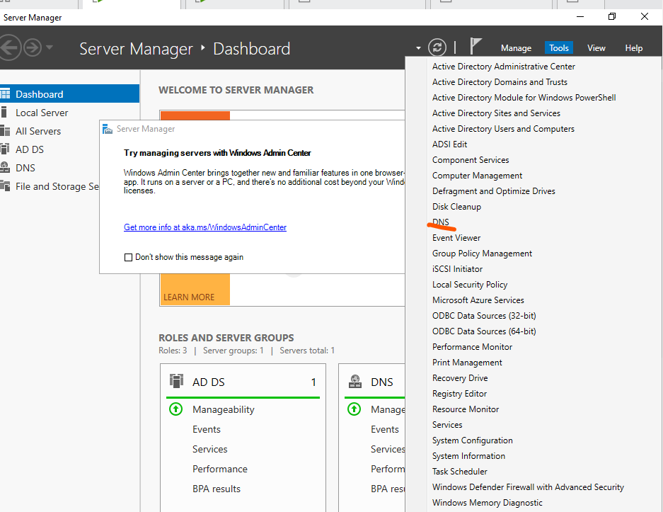

Right click reverse lookup zone and new zone

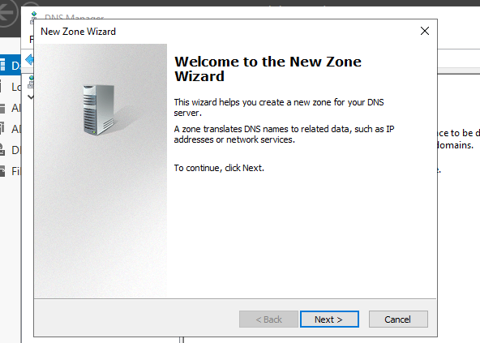

Next

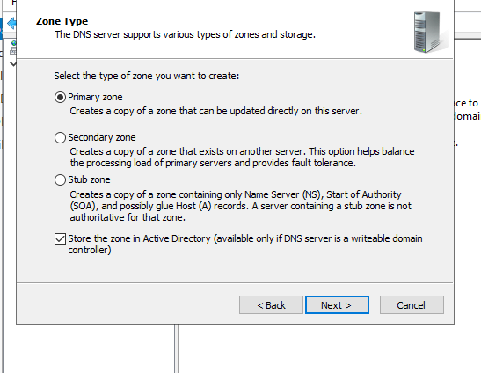

Next

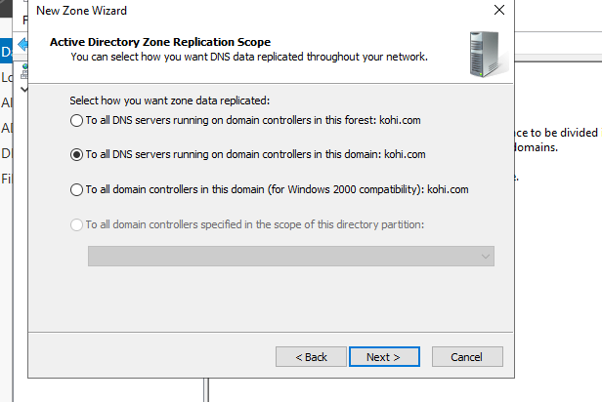

Next

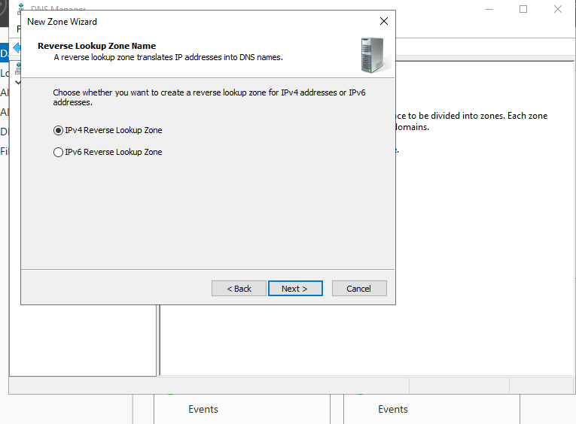

Next

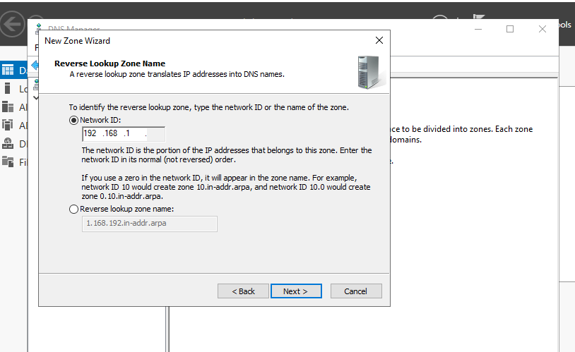

Filling out this box with your ip network and next

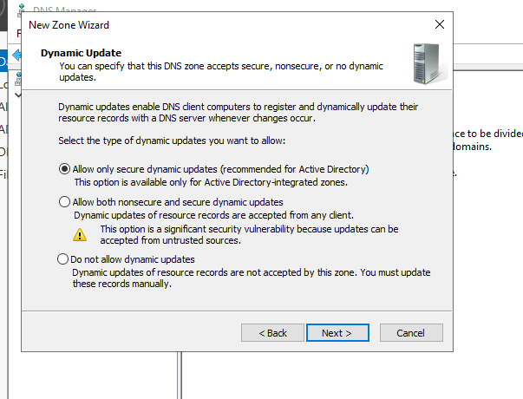

Next

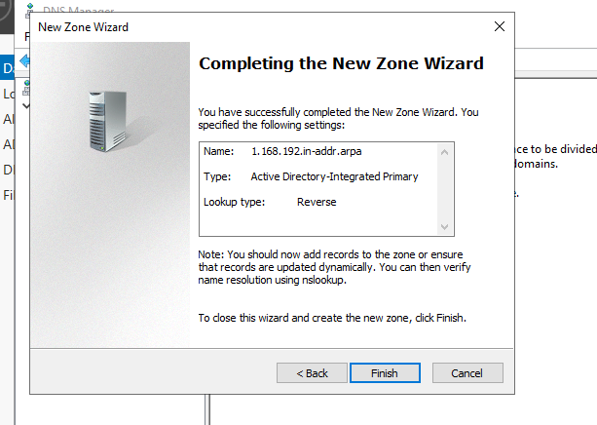

Finish

Then, right click inside 1.168.192.in-addr.arp and choose new pointer(PRT)

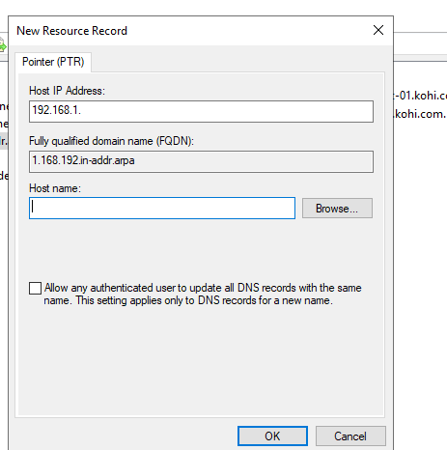

We choose browse

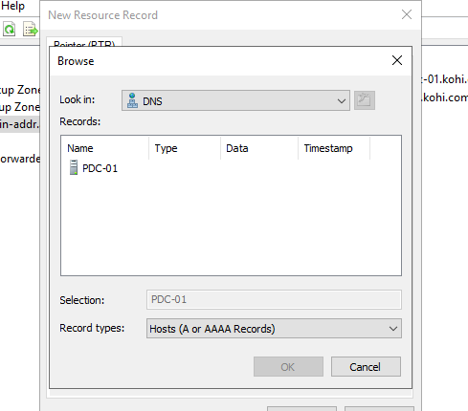

Click this SERVER

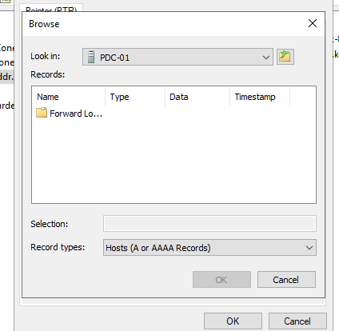

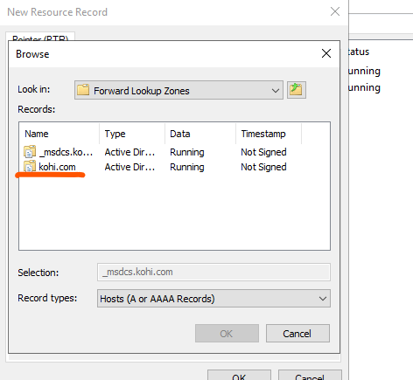

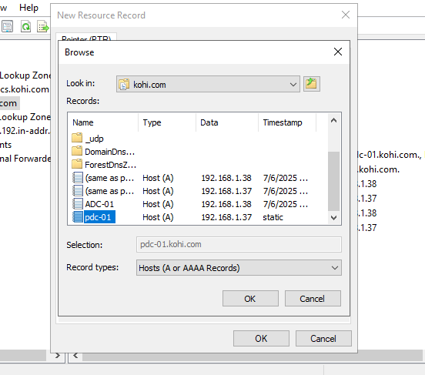

Choose PDC-01 and click ok

When you set up those steps , it appears the line like this, you’re succesfull

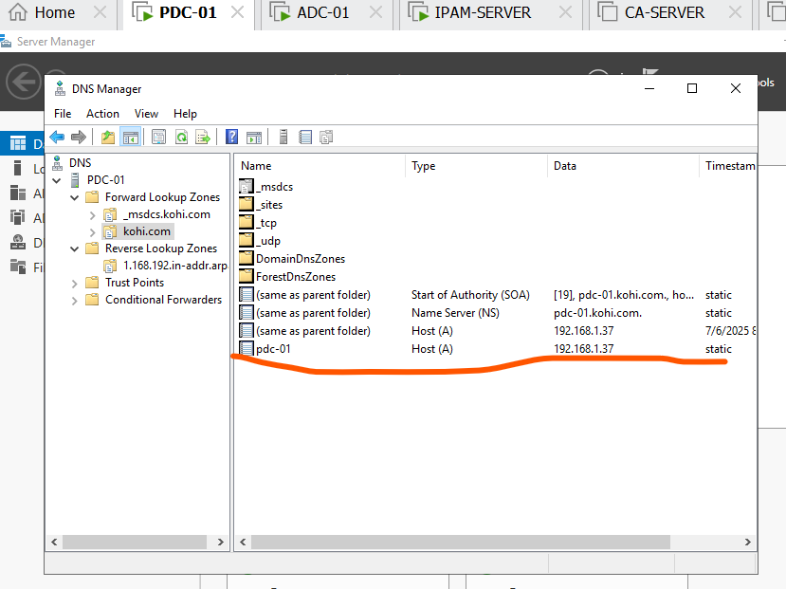Now we ‘re going to check nslookup on cmd

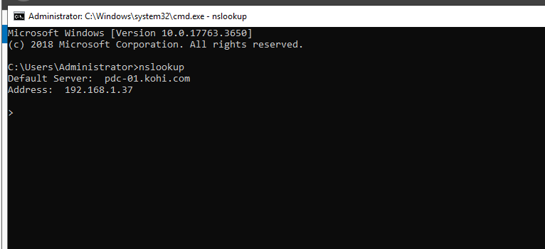

Next , normally when clients access internet through DNS root automatically having in rootHint

We can access it by following the steps

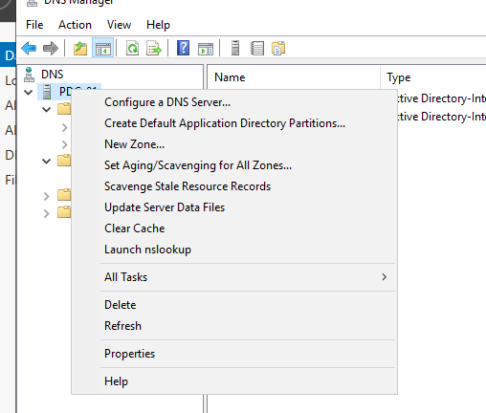

We right click and choose properties

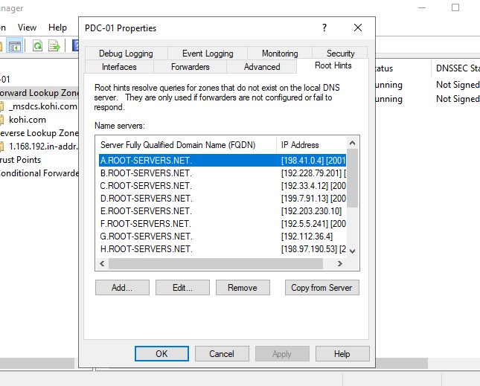

Now we will remove it

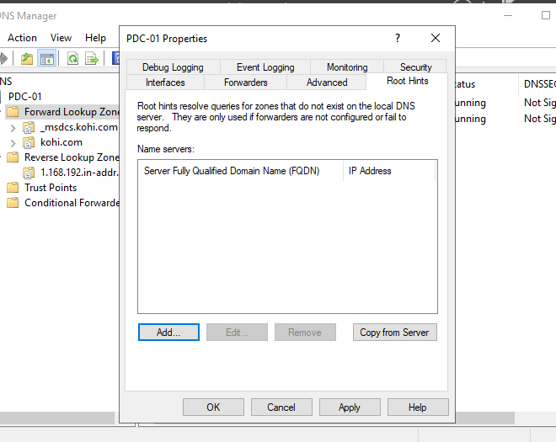

Click apply and ok

And click right restart PDC-01

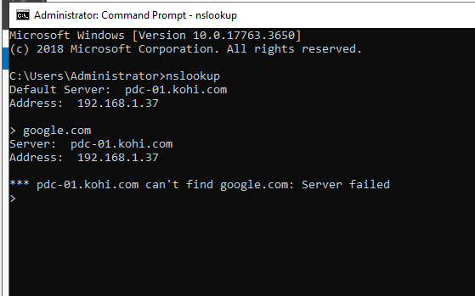

We can see it failed

Now in order to acsess internet again through this domain we click tab forwarder and edit

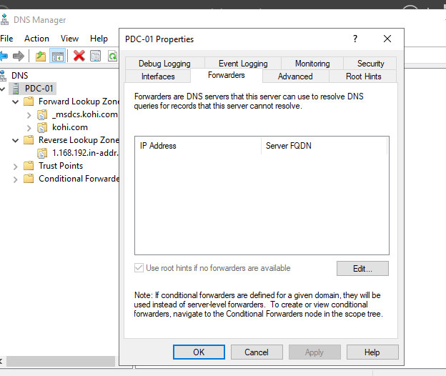

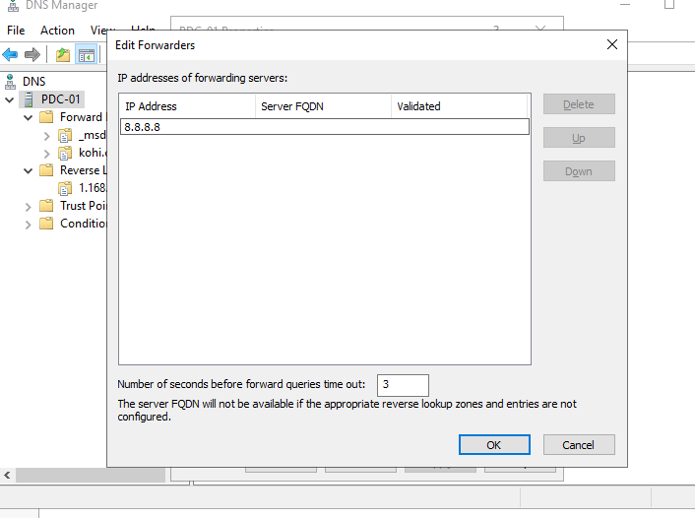

Enter 8.8.8.8 and ok

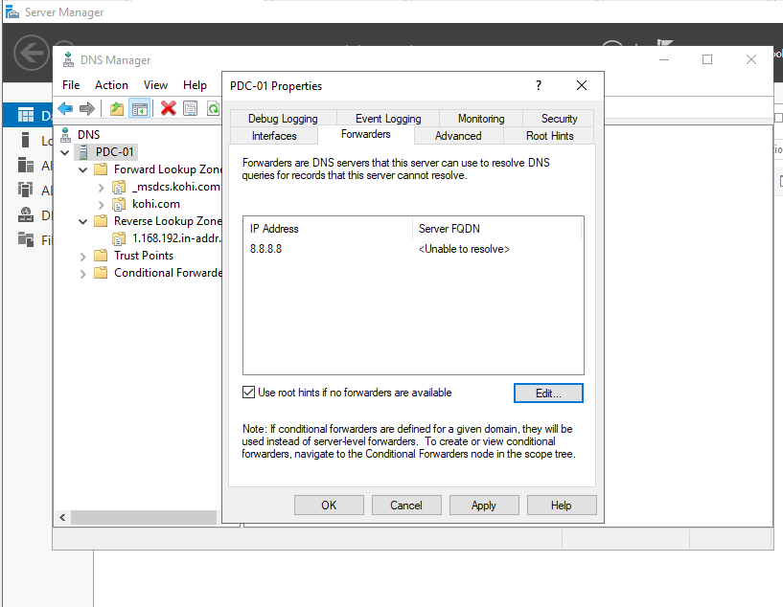

Apply=> ok=> and restart PDC-01

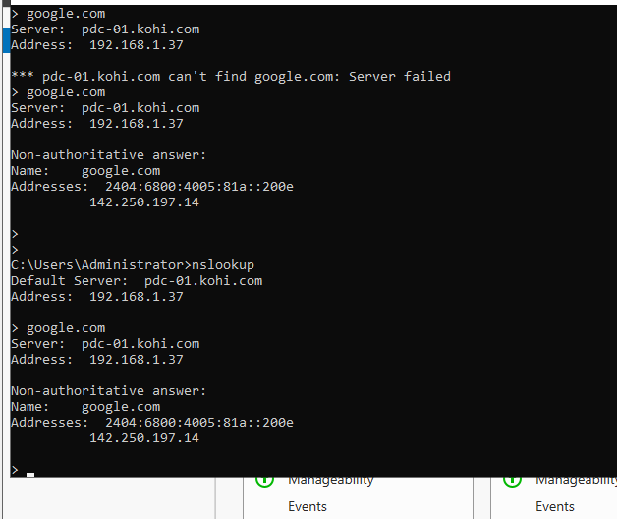

You can see , it’s success

1. CÀI ĐẶT ADC-01(the other domain controller)

Firstly, we need to join domain

We click this pc and choose properties

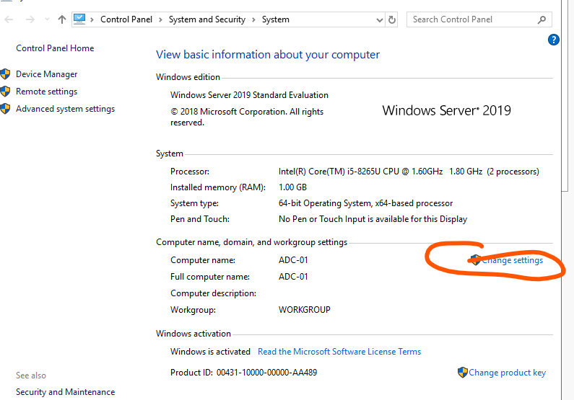

Change settings => change

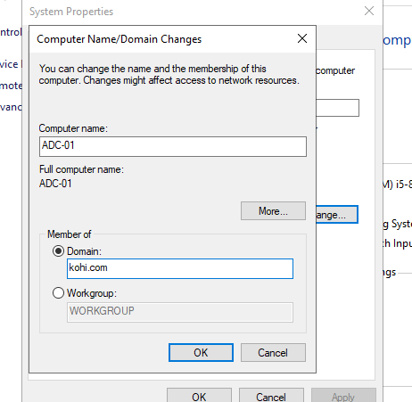

Enter your domain

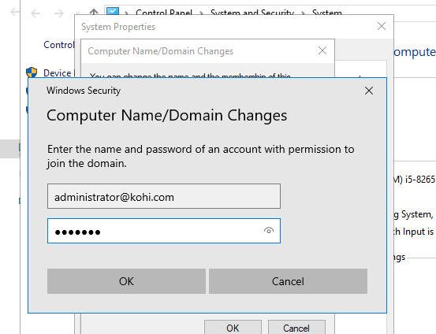

Enter administrator account and pass of this account

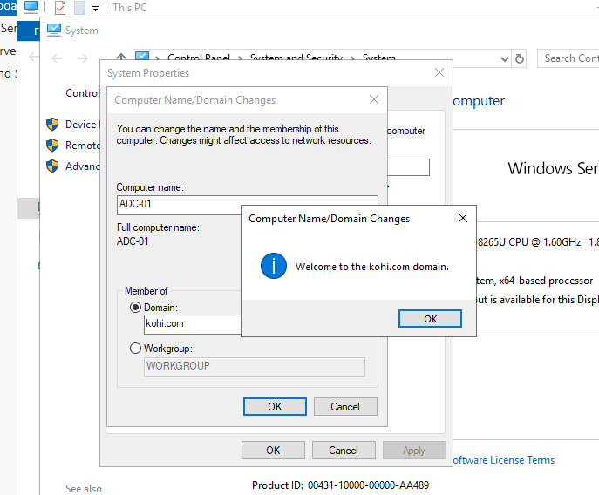

We join domain successfully =>

We click ok=> close=> and restart now

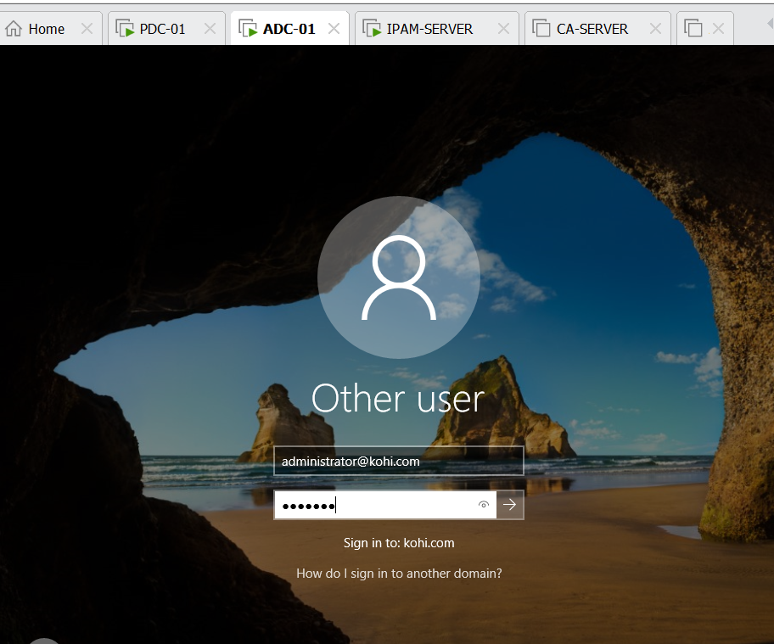

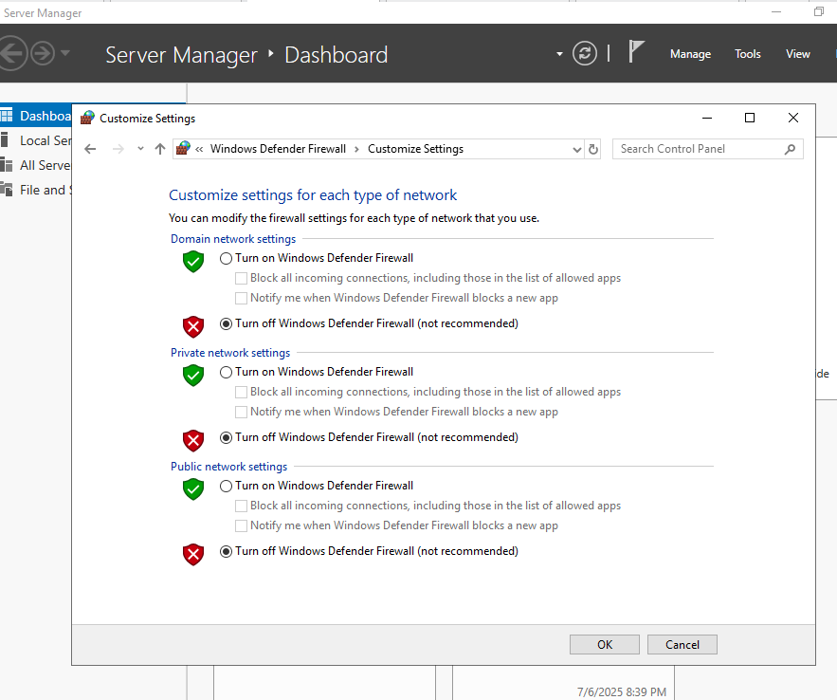

Remember turning off domain network

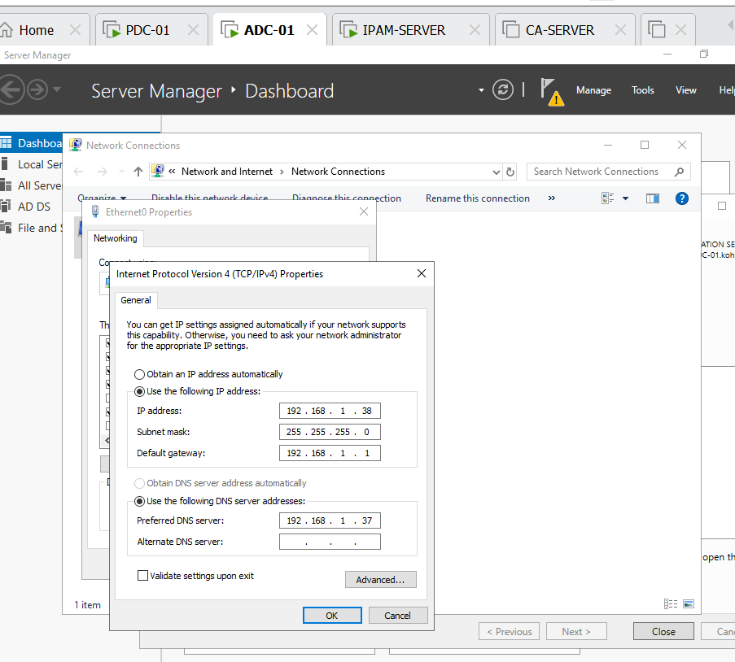

Now we start to set up the other domain controller, we install ADDS normally but when promoting this pc to be controller we have a few steps different

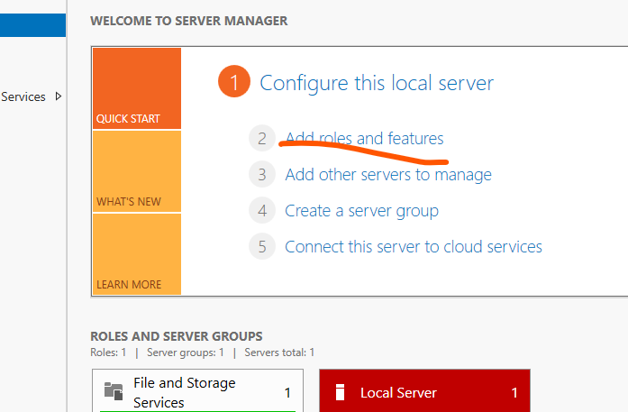

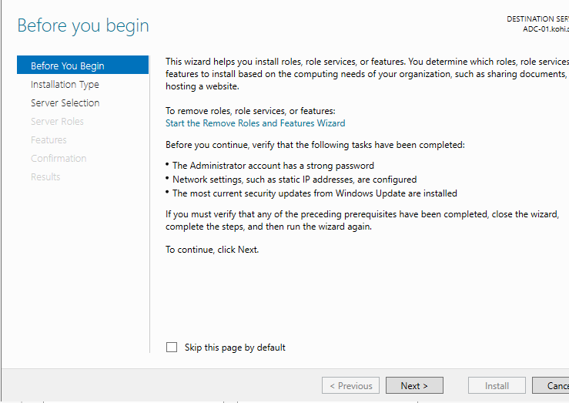

Click next

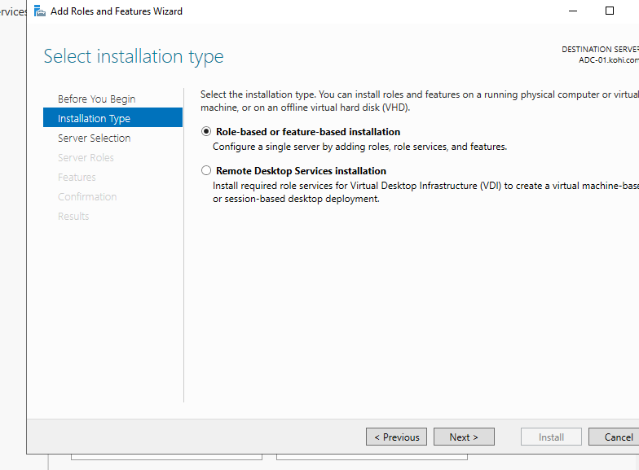

Click next

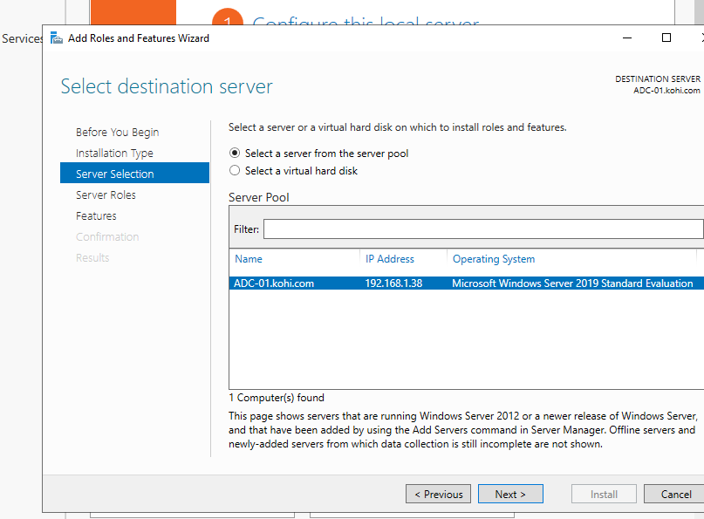

Click next

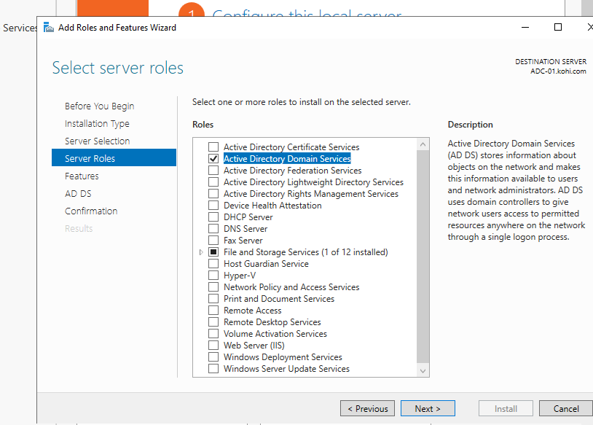

Choose active directory domain service

Click next

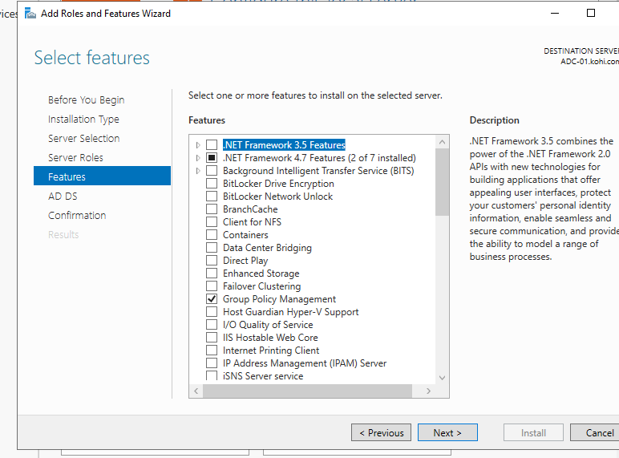

Click next

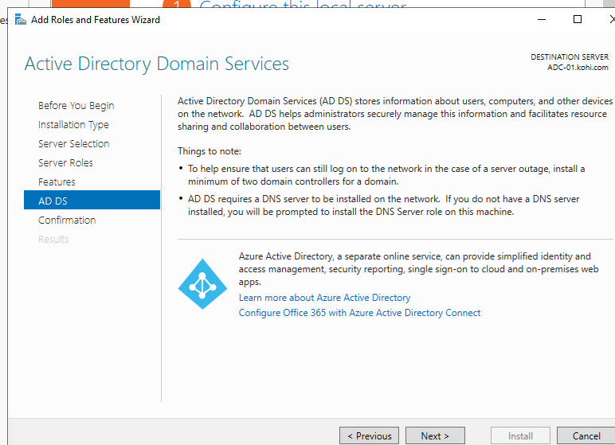

Click next

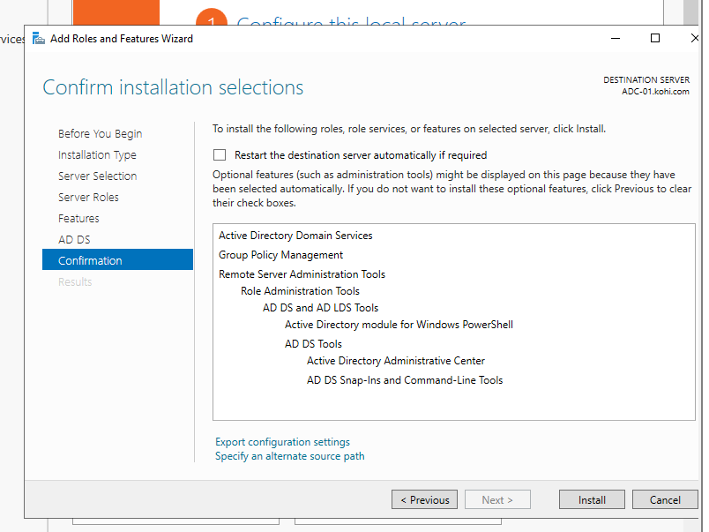

Click install

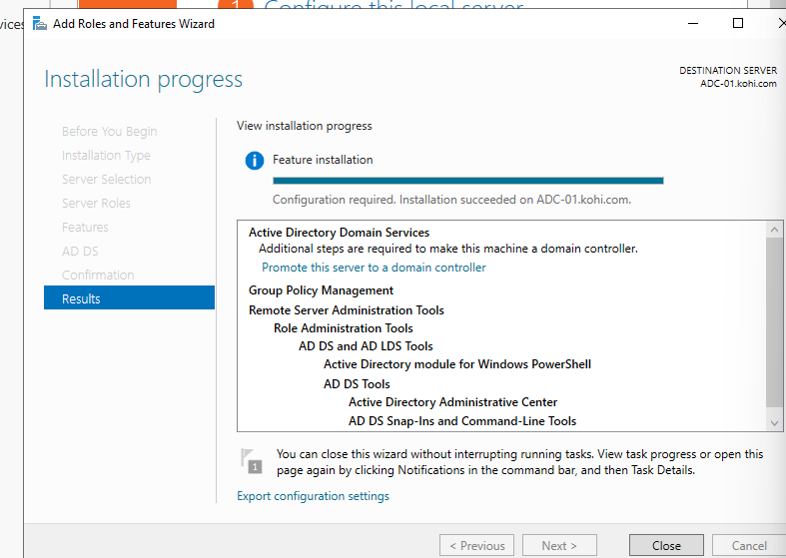

We click close

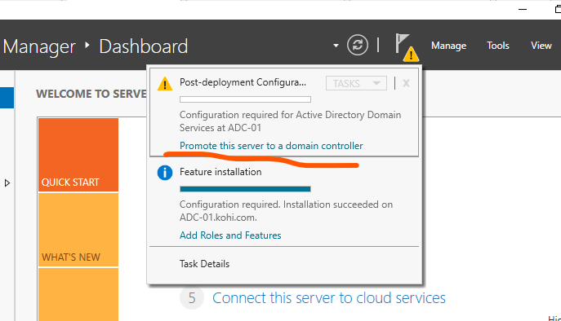

We choose it

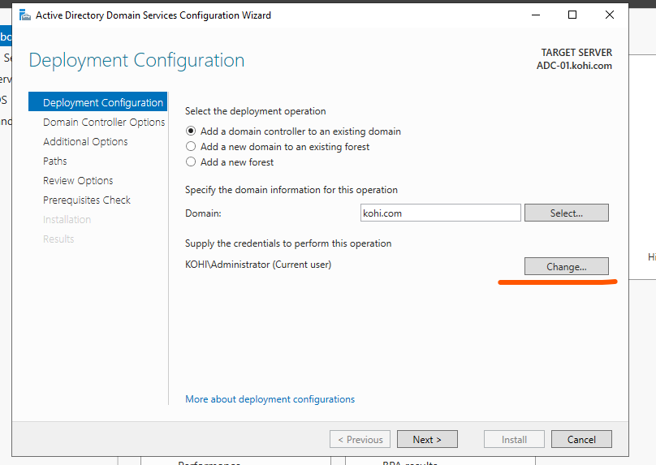

We click change [administrator@kohi.com](mailto:administrator@kohi.com)

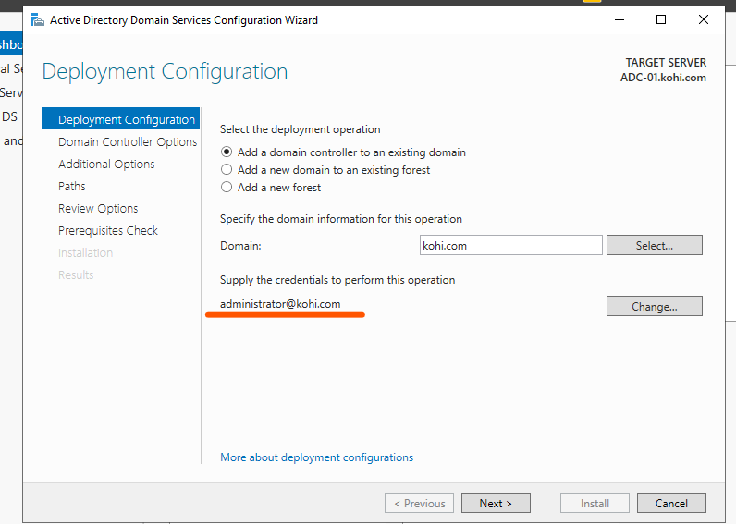

Click next

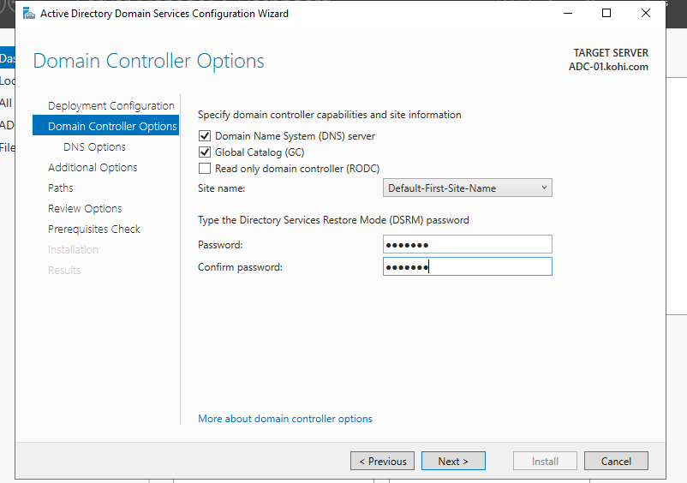

We fill out the box with our pass and next again

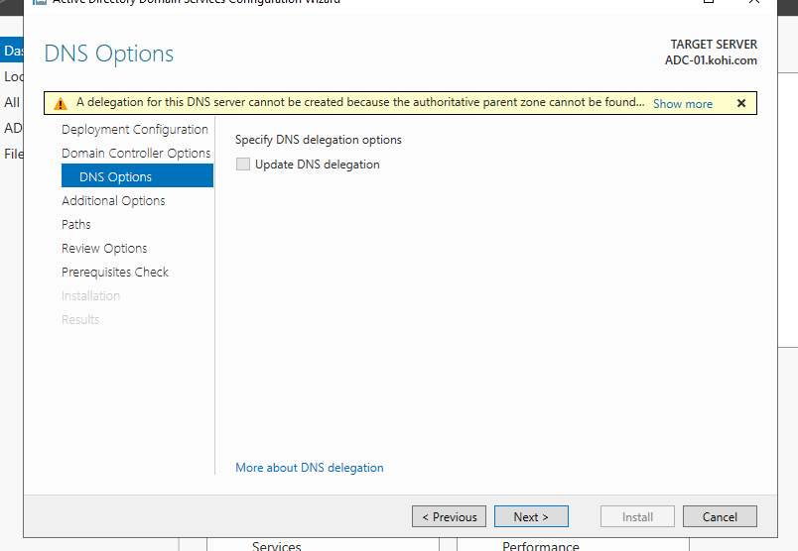

Click next

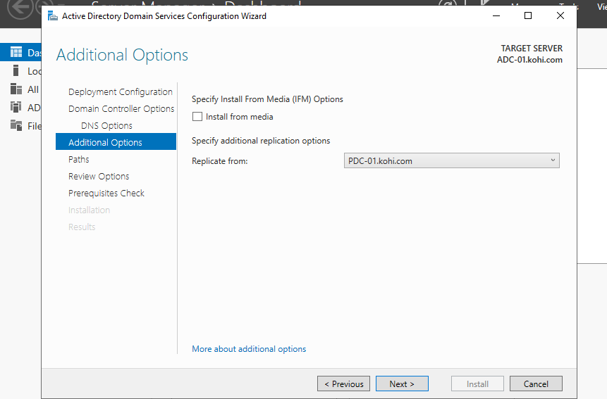

Choose replicate PDC-01.kohi.com and next

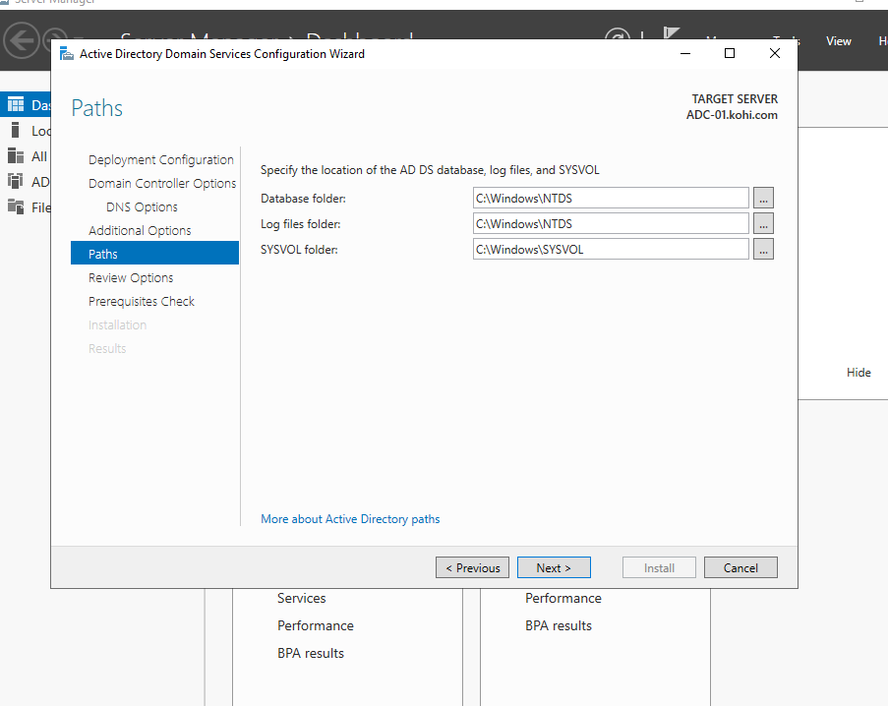

Next

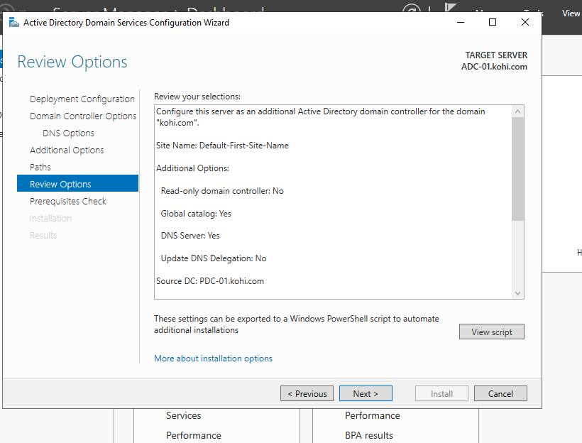

We click next

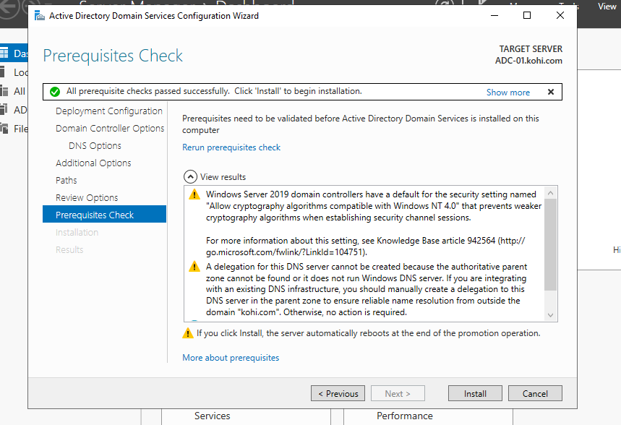

And we click install

Now equivalating PDC-01 it automatically restarts after installing domain after we have the other controller to back up when system is orored

Now we can change IP pri DNS address (ADC-01)

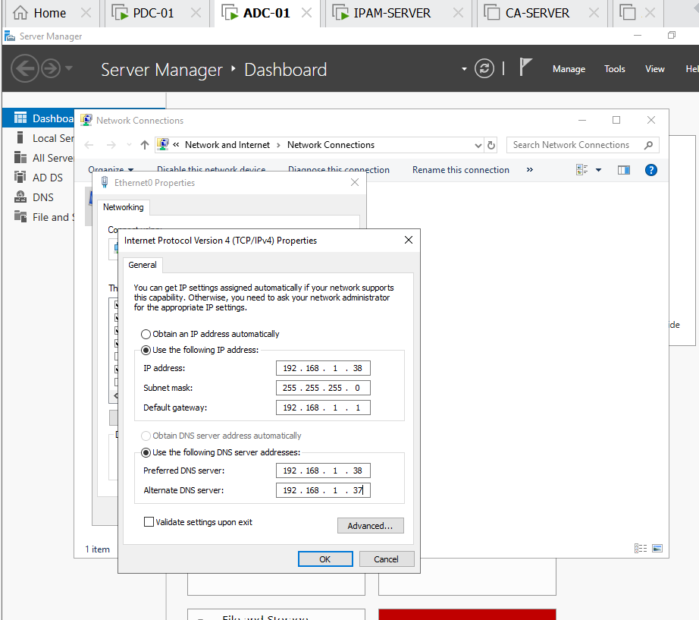

We can check nslookup on ADC-01

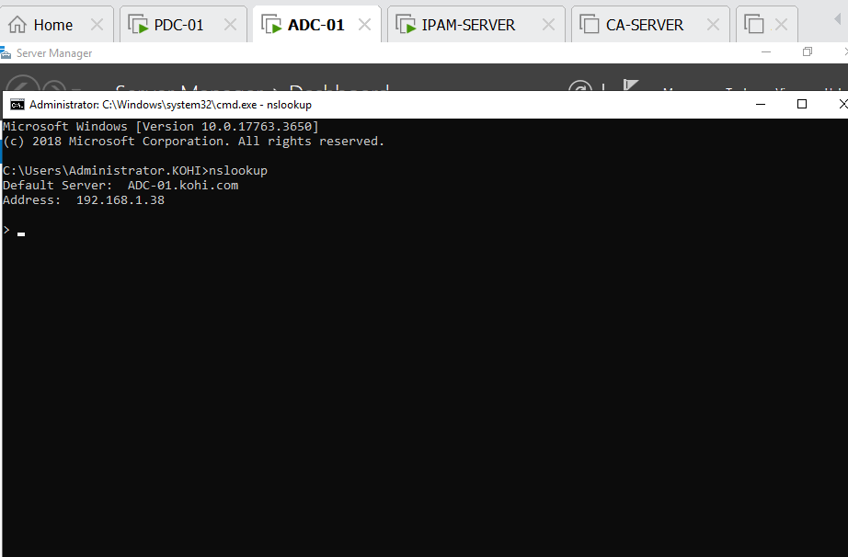

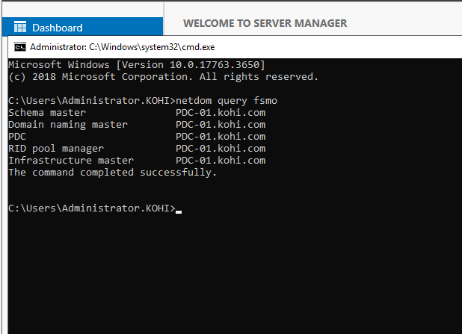

Now you can see the all 5 roles are belong to PDC , I want to transfer the roles RDC, RID, AND INFRAS for ADC, how do I start:

In active directory users and computerS ADC-01 right click kohi.com

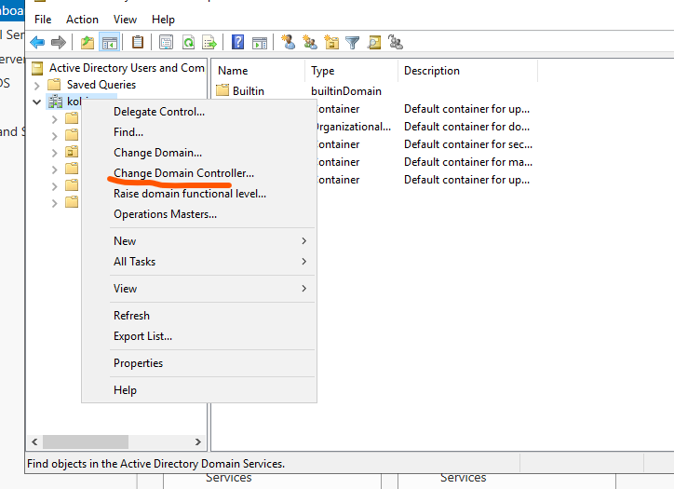

Click change domain controller

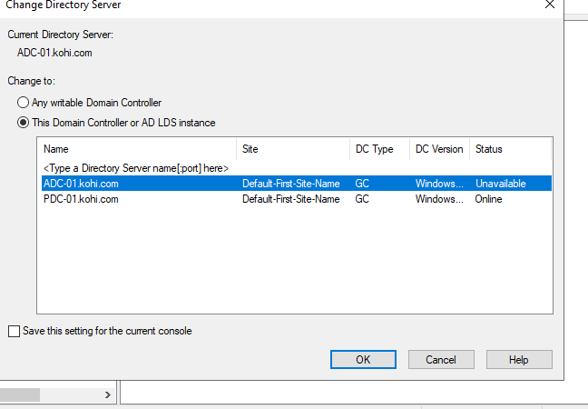

Click ADC-01 => OK

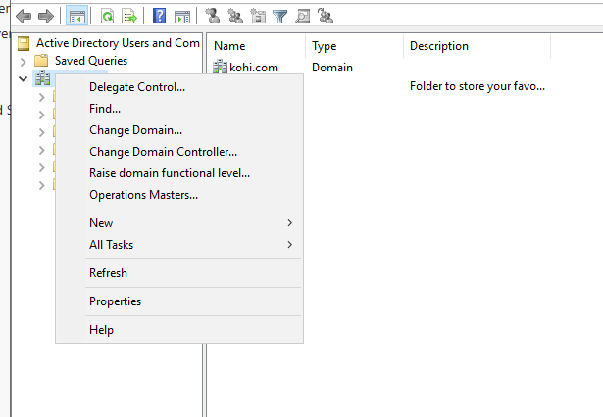

Continue right click kohi.com and choose operation master

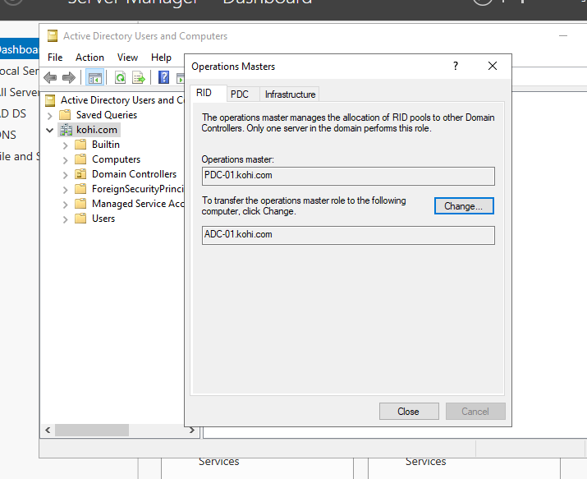

Click change and yes

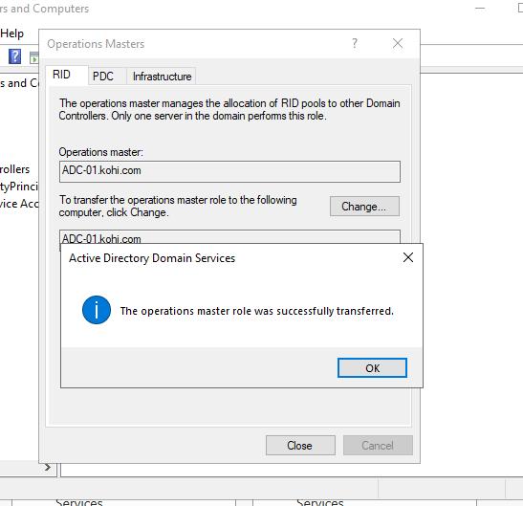

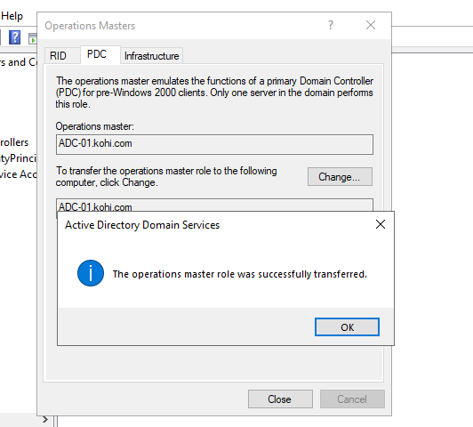

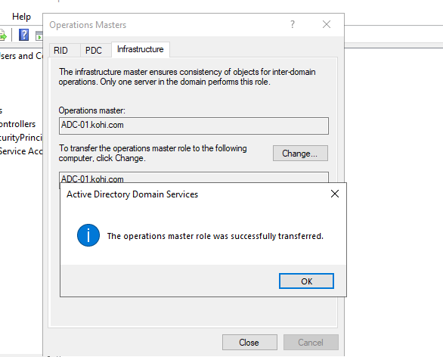

RID, PDC, INFRAS do this similarly

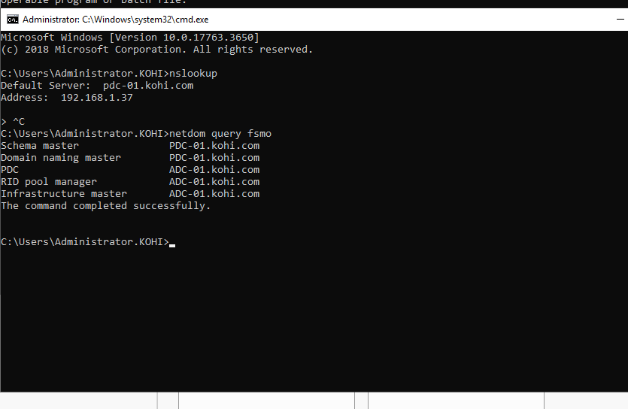

We check again , now PDC, RID AND INFRAS are belong to ADC-01

1. CÀI ĐẶT IPAM-SERVER

First , we also join domain

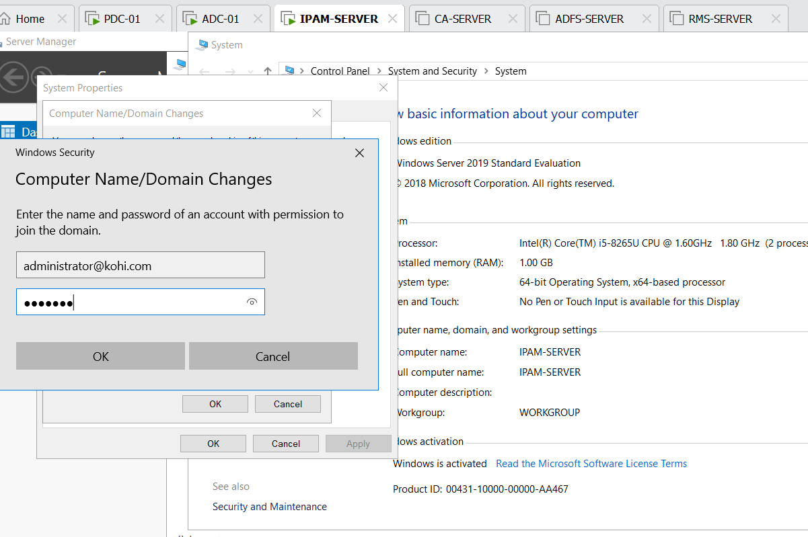

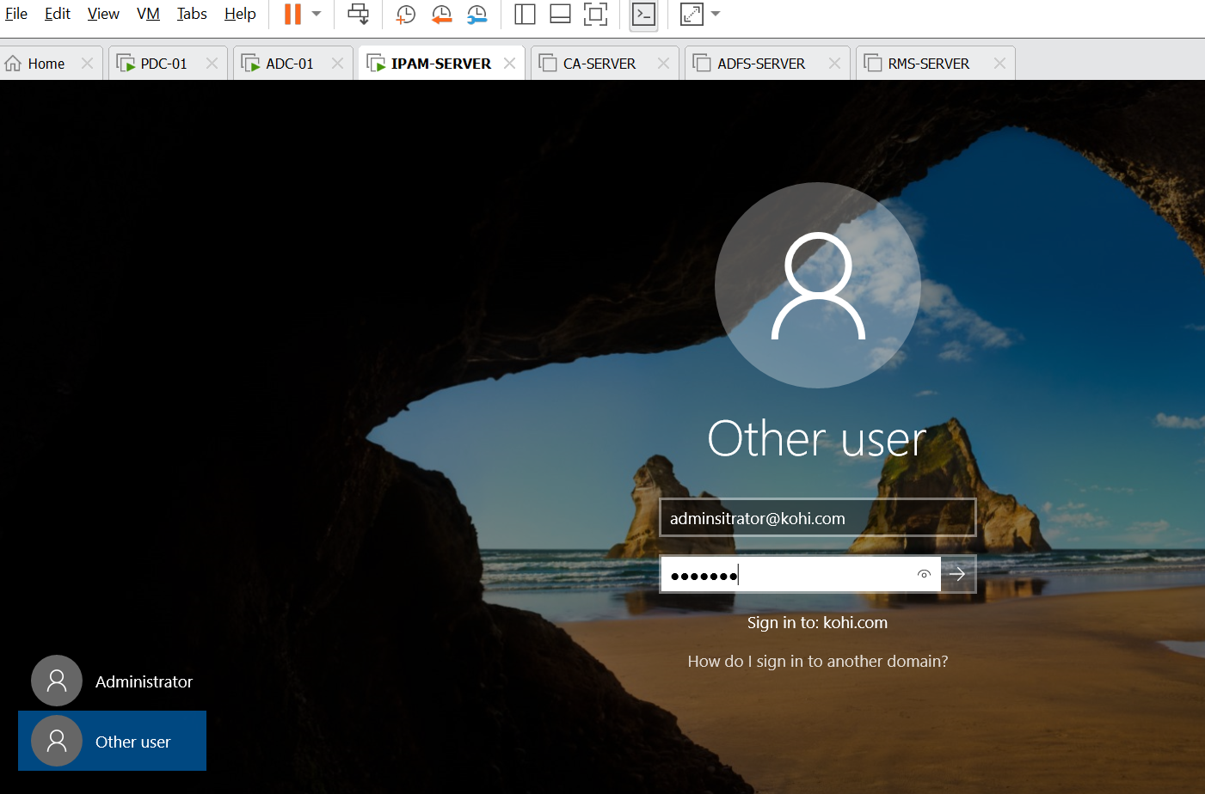

Remember turning off domain network

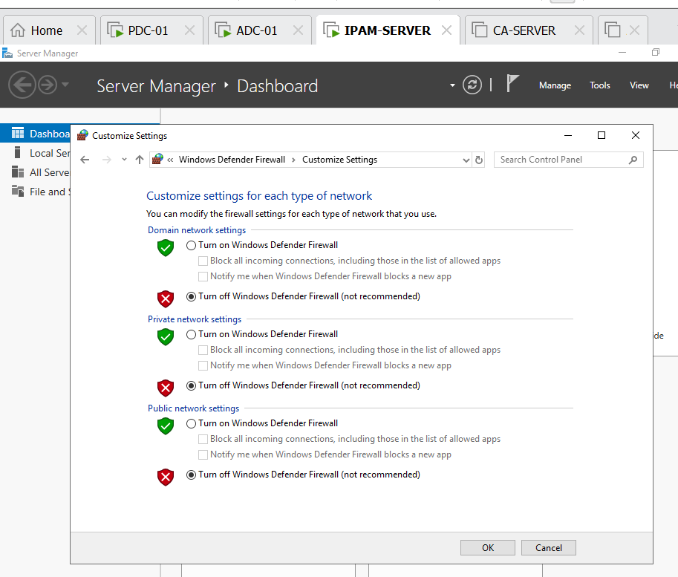

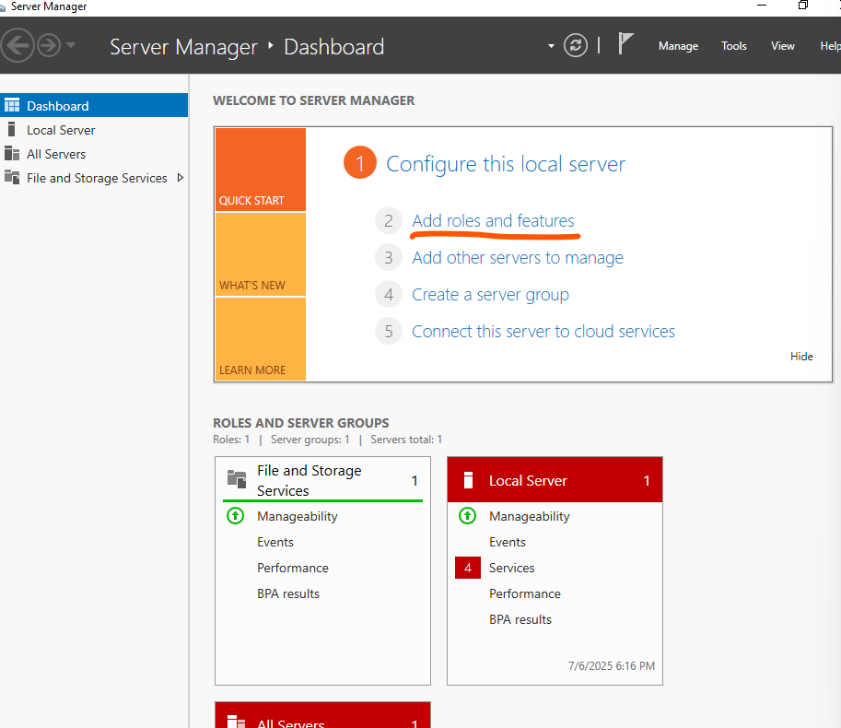

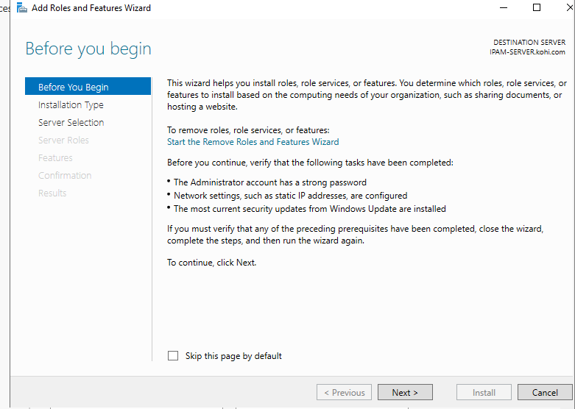

Choose next

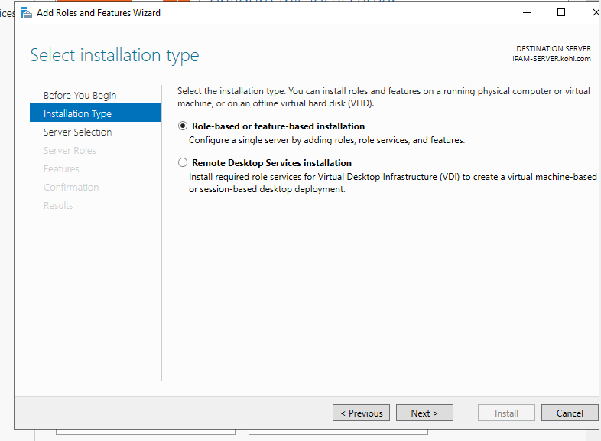

Next again

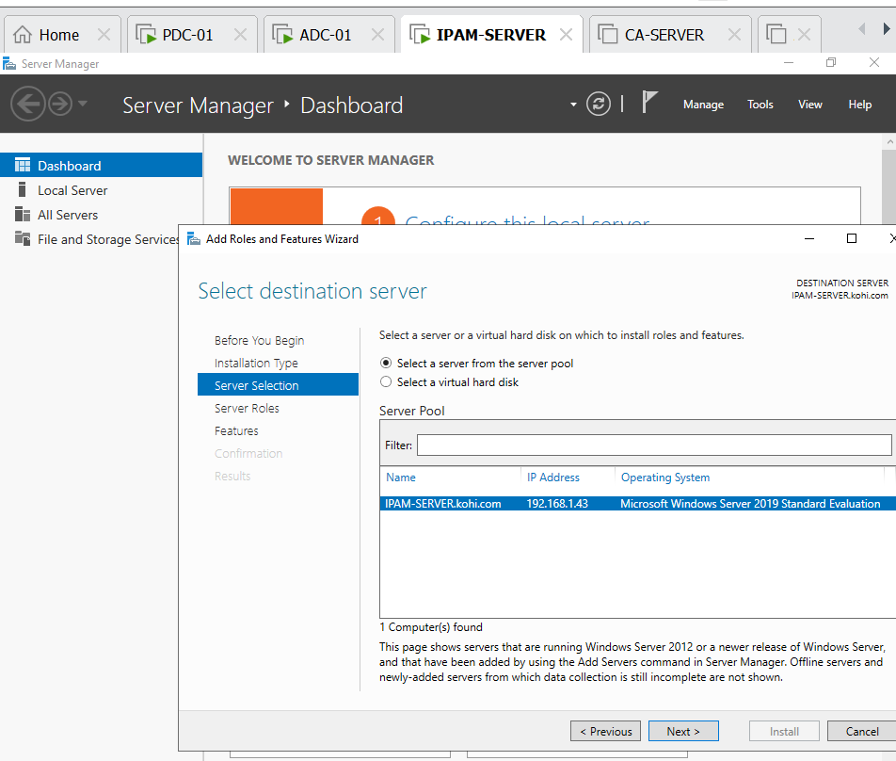

Next

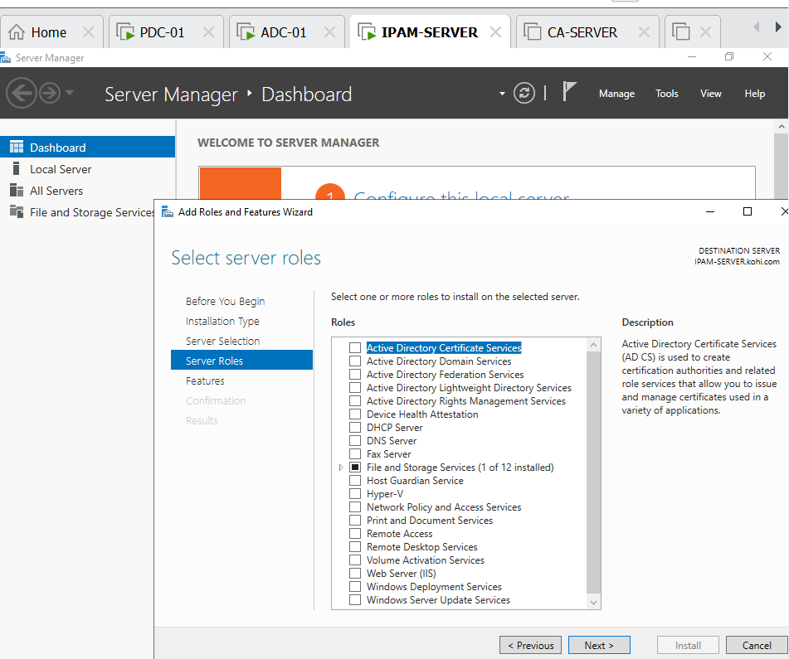

Next

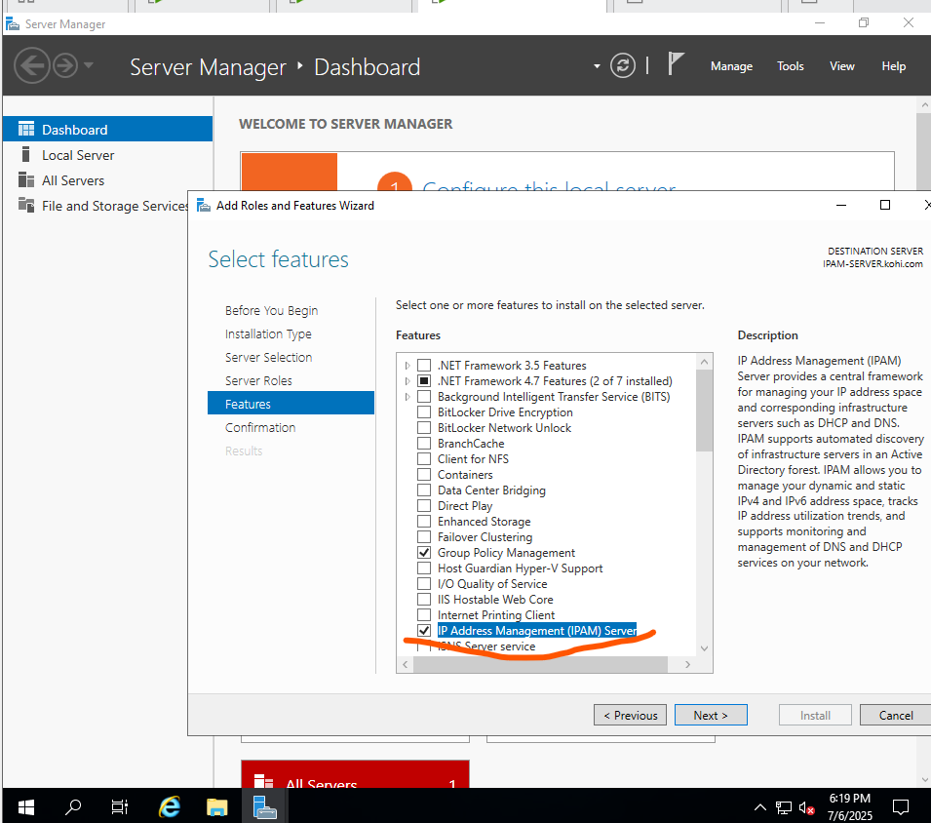

Click IP address management (IPAM)server => and next

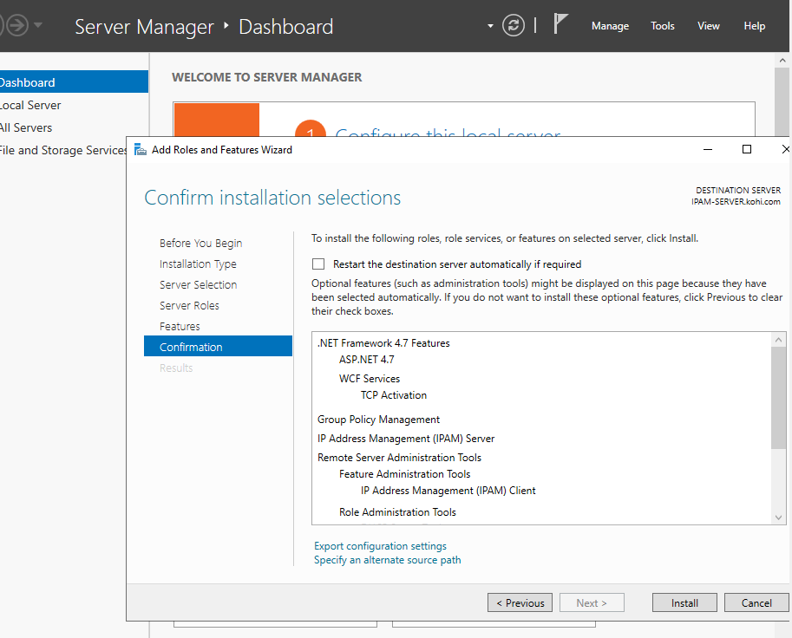

Install

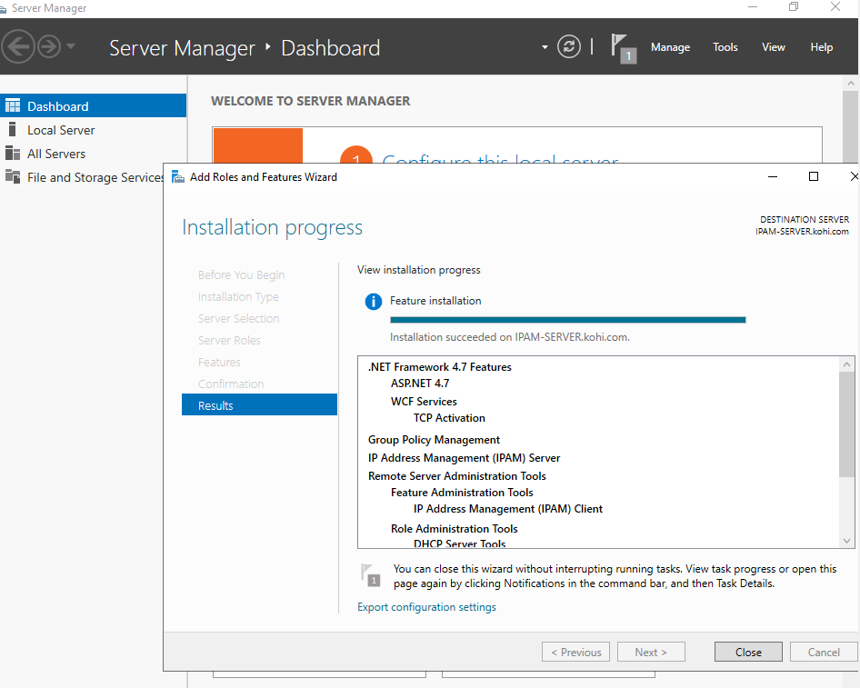

Close

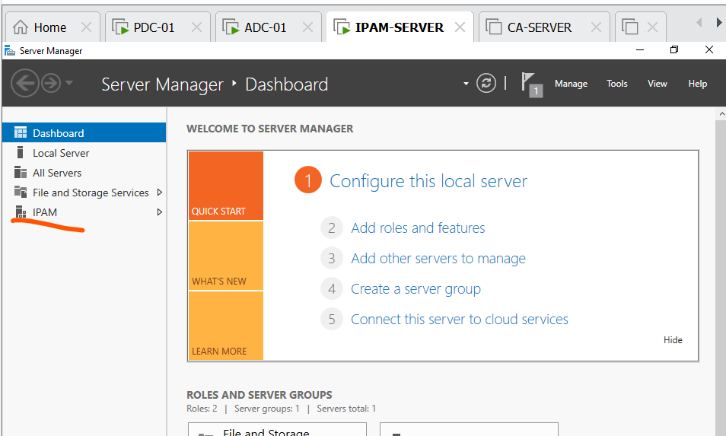

Click IPAM to configure

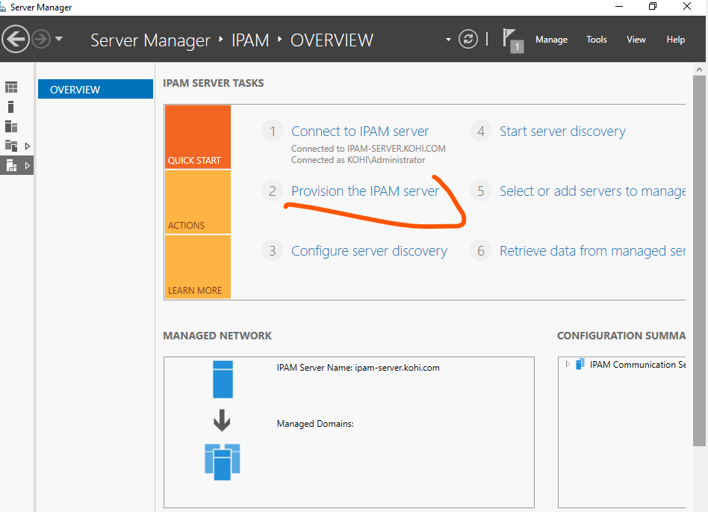

Click provision the IPAM server

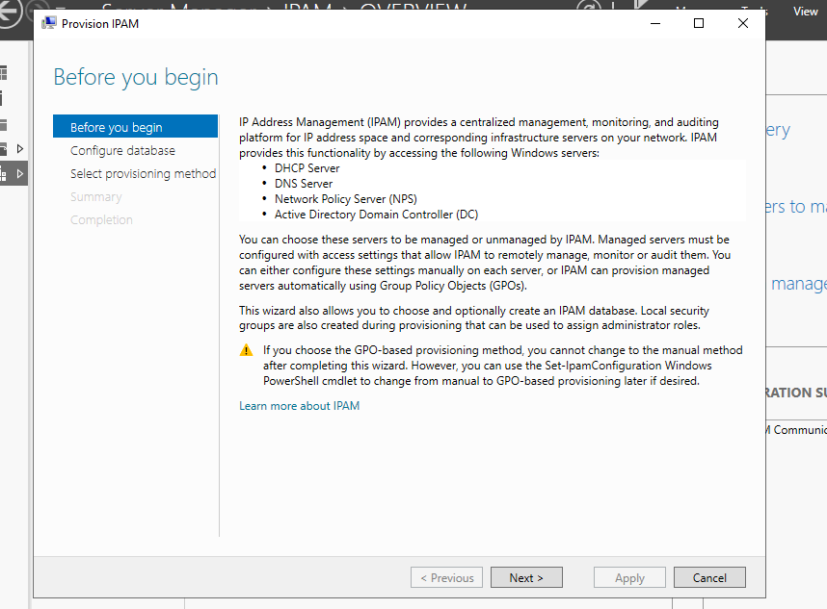

Click next

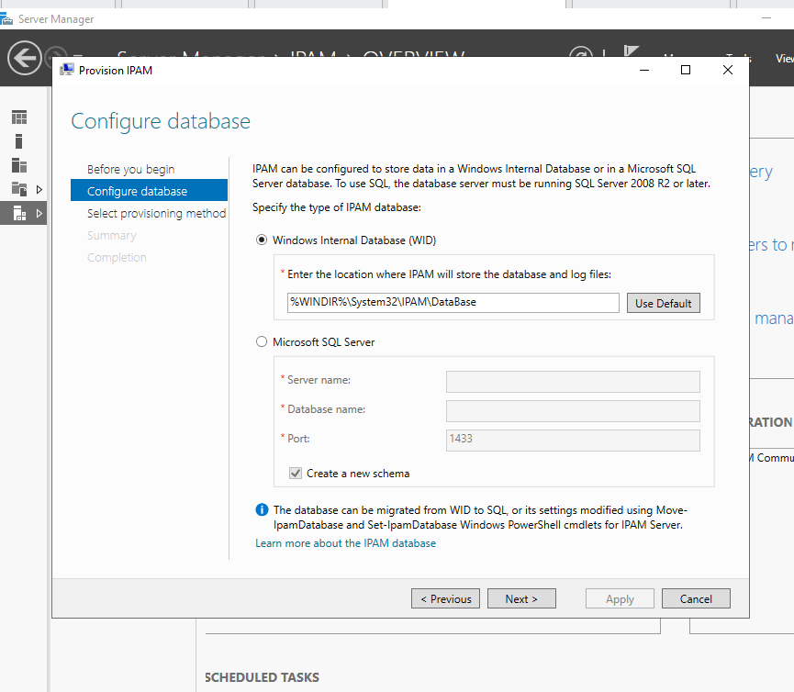

Click next

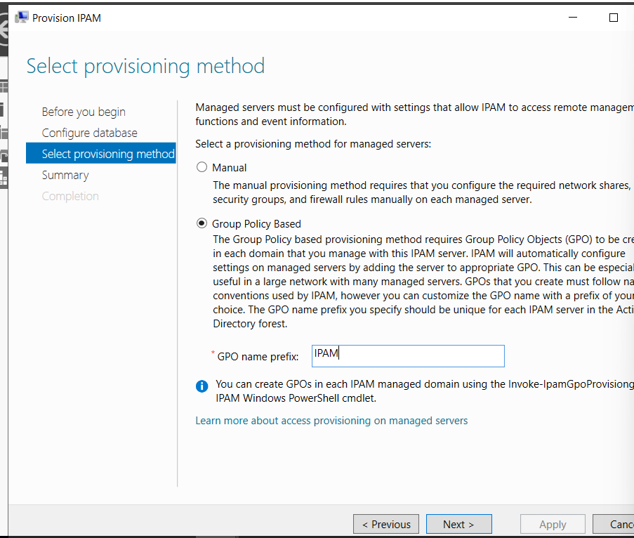

Enter the name of GPO and next

We apply

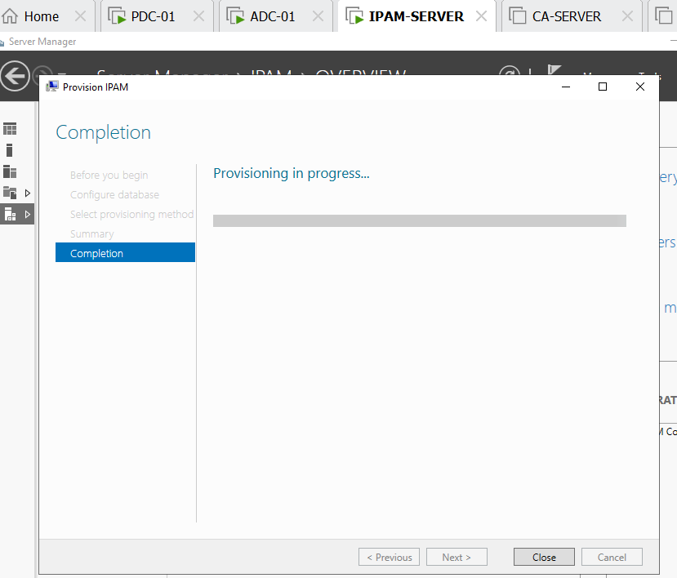

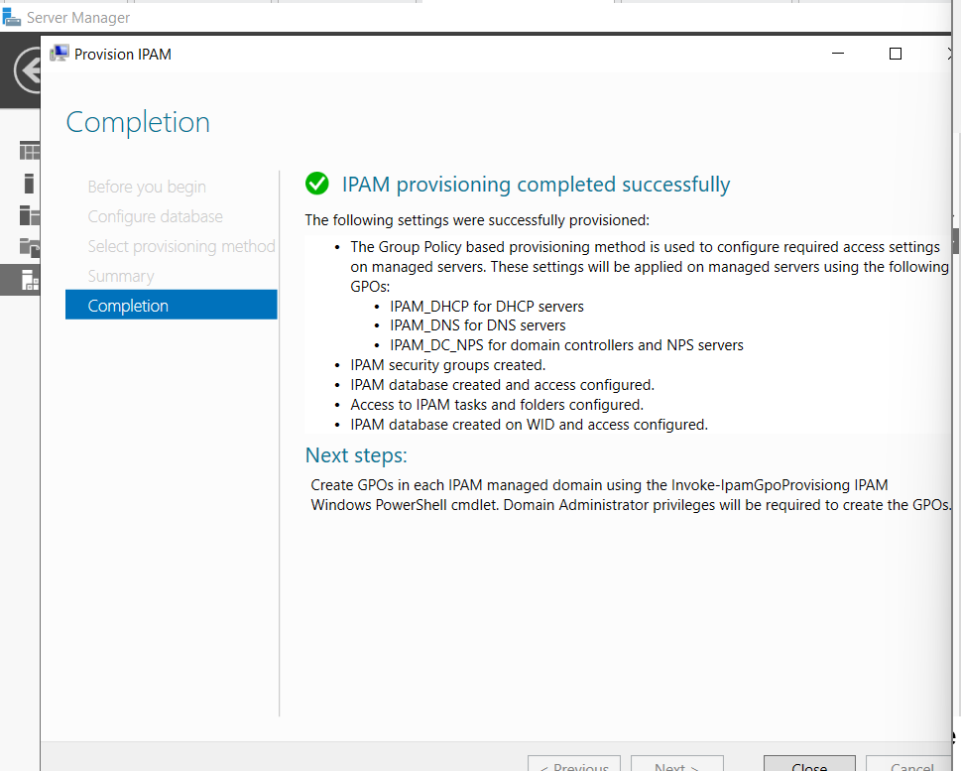

IPAM provision has installed successfully, now we just click close

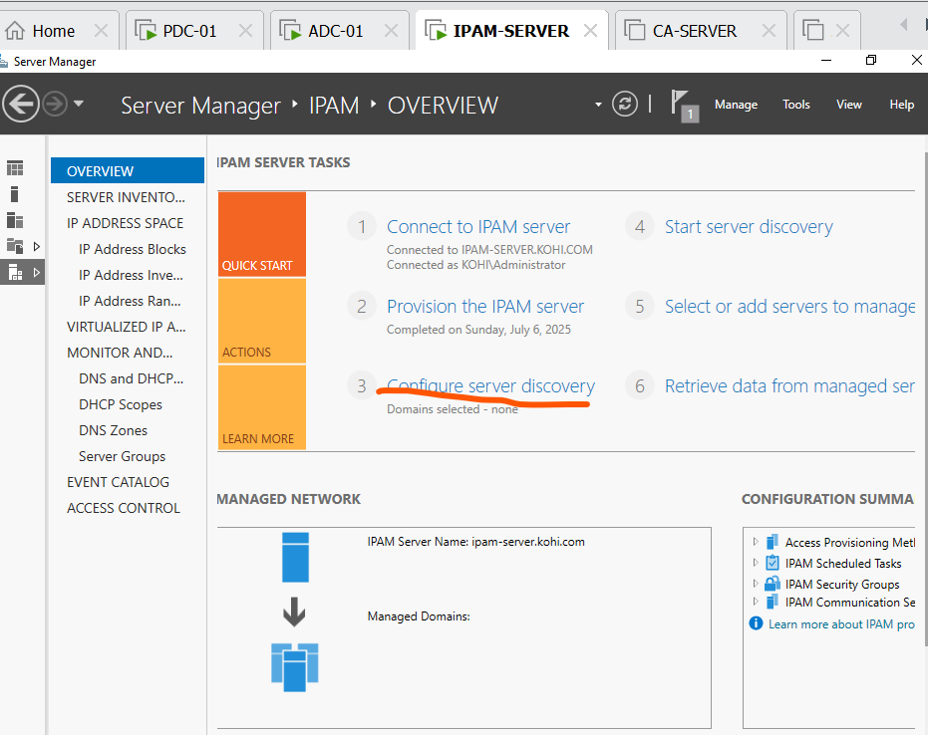

We click configure discovery

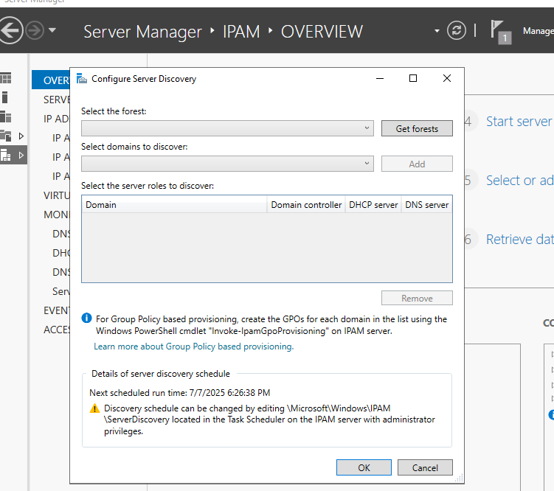

We click get forests and click ok

Click again configure server discovery

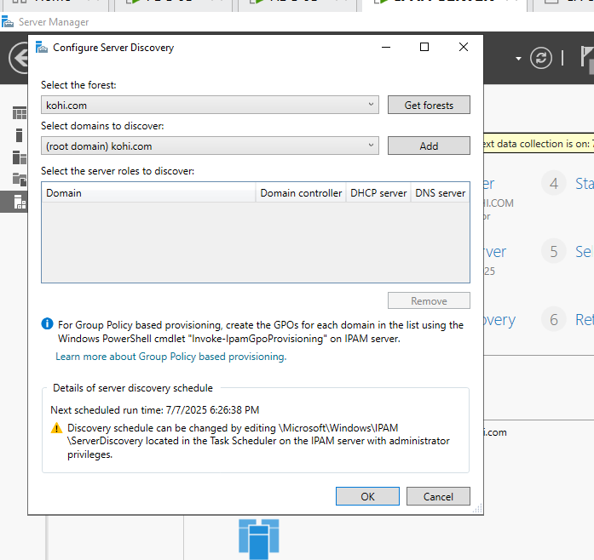

Click add

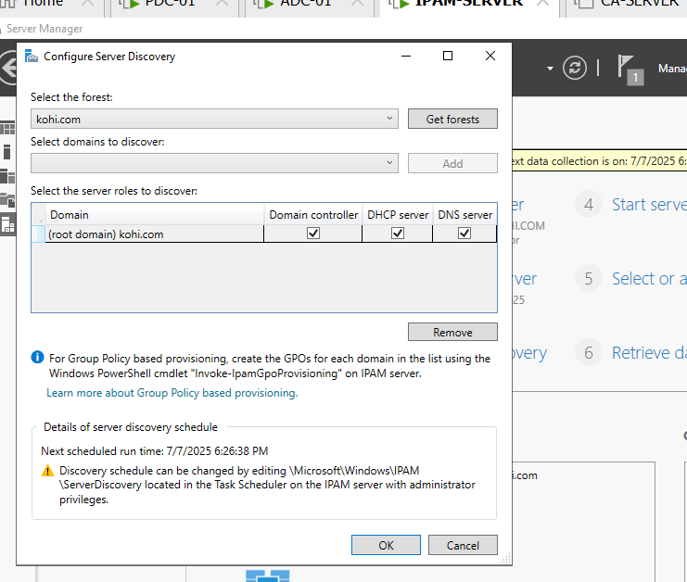

Click ok

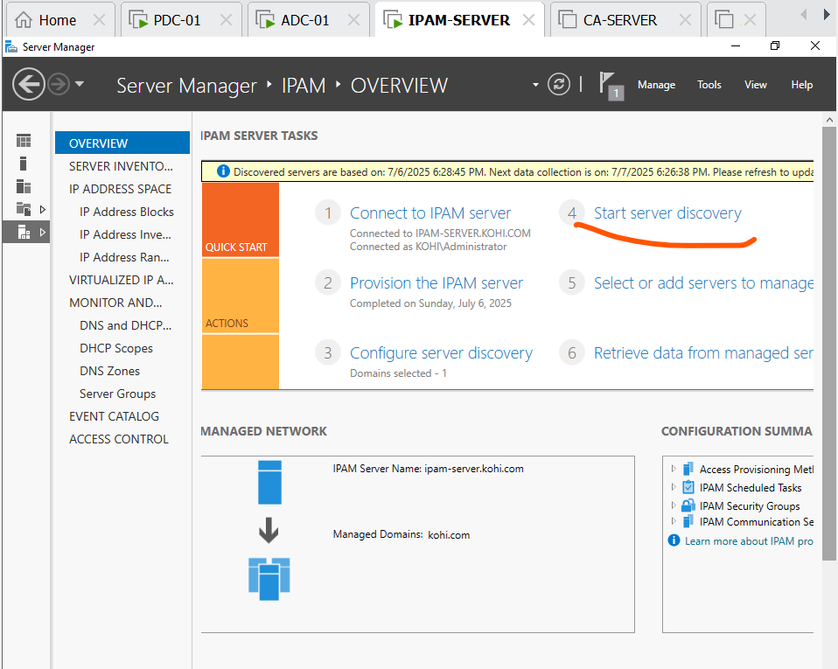

Click step 4 and wait for their completion , otherwise we ‘ll be failed when we conduct the step 5

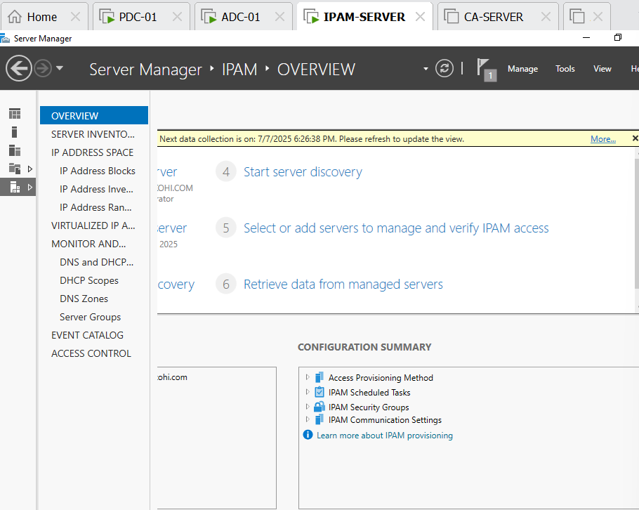

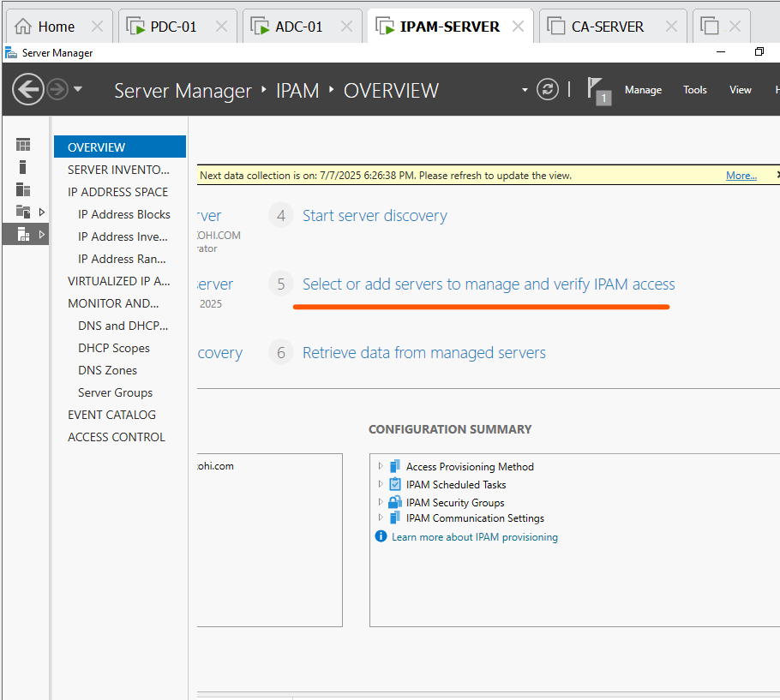

Select step 5

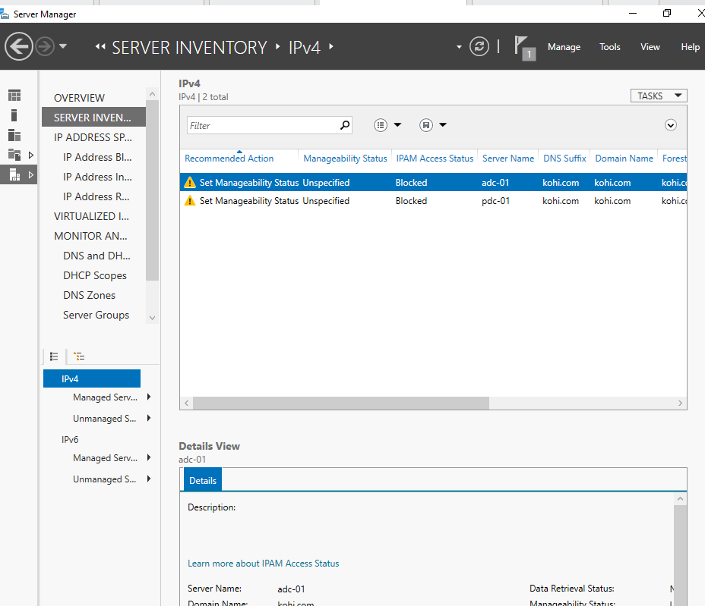

We can see two server have clocked, now we need to unclock it by configuring the command on power shell (by administrator)

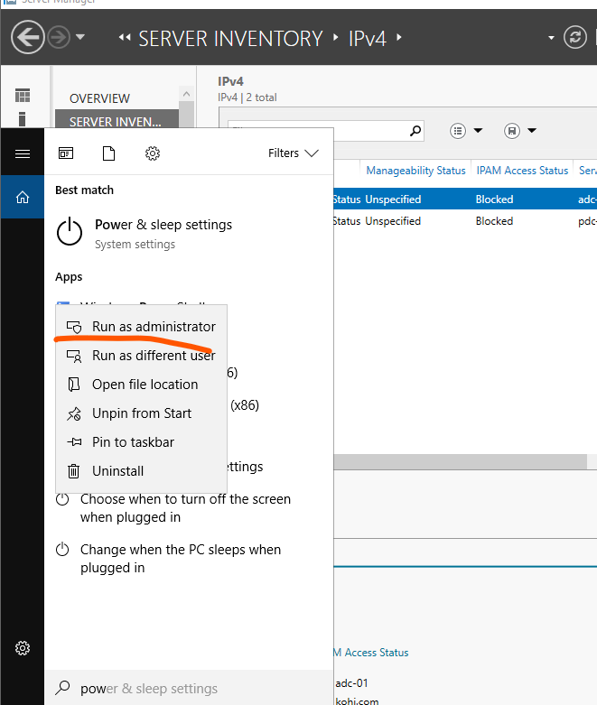

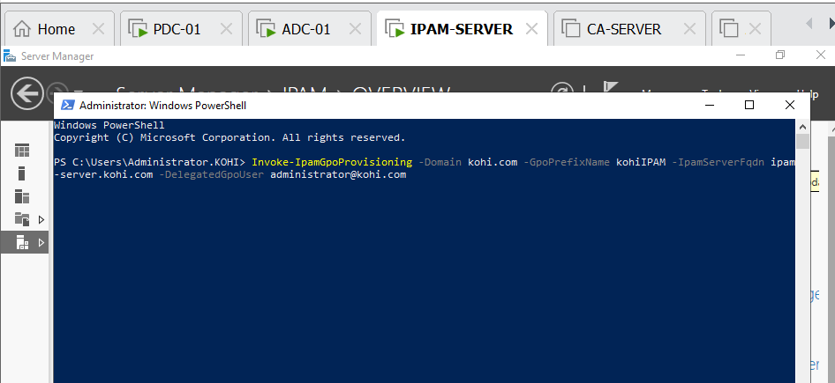

Click enter

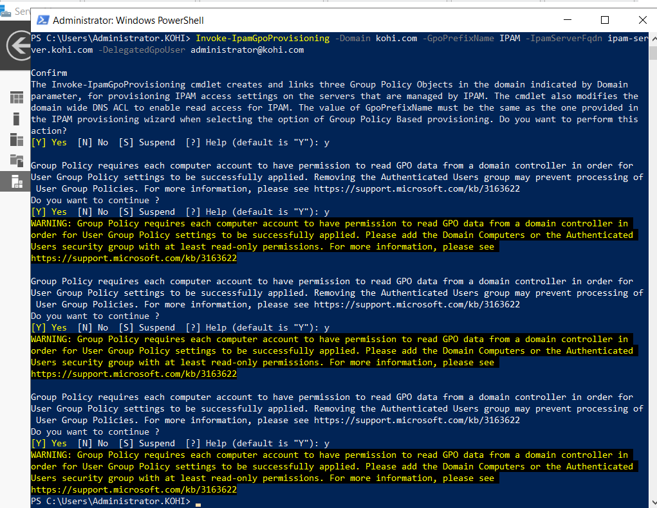

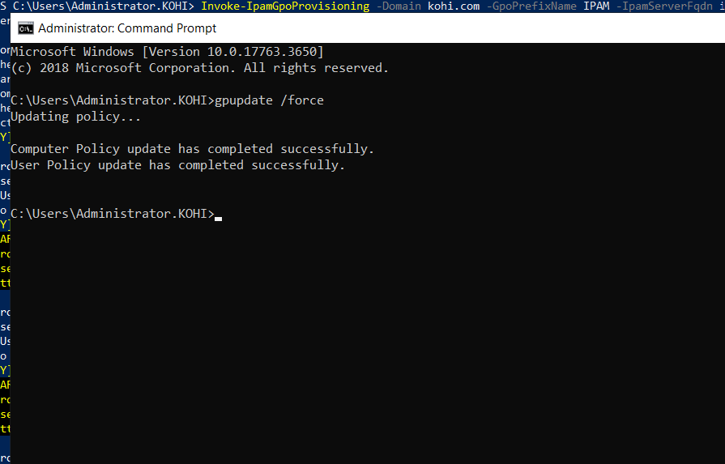

We need command gpupdate /force to update the group policy

After that we need to restart pdc-01, adc-01 and ipam-server to update

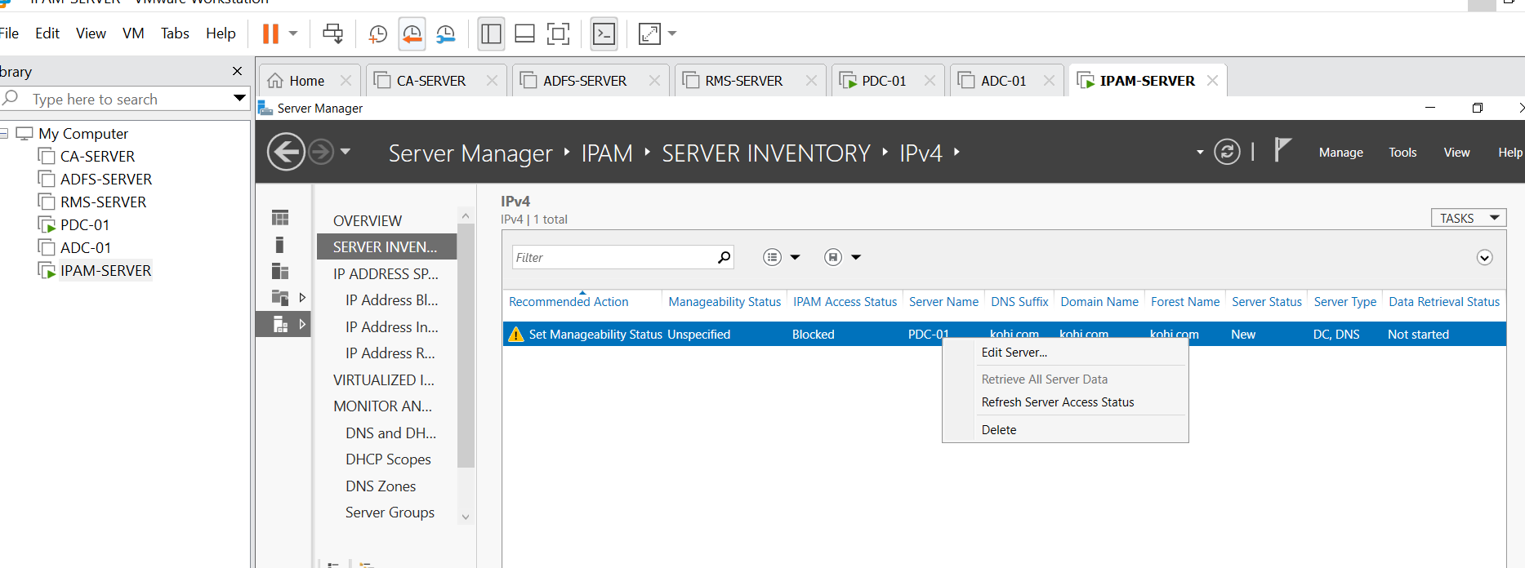

Right click choose edit server

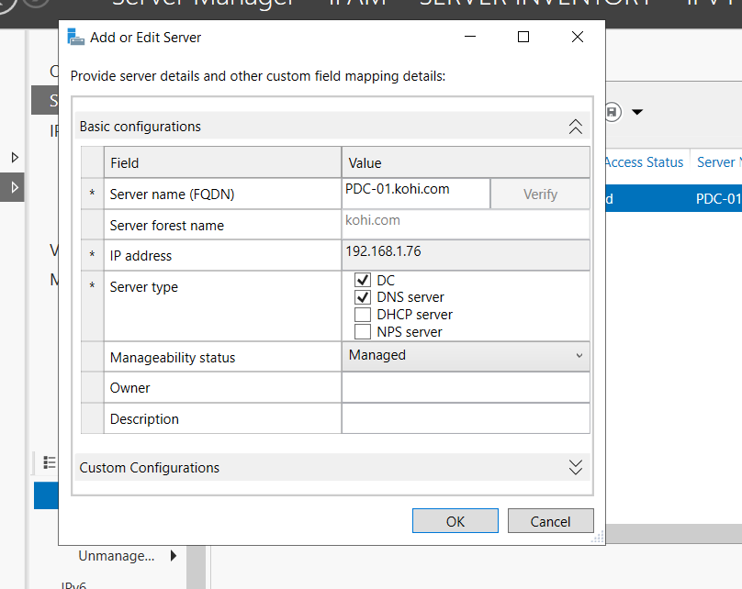

Click DC and DNS, we haven’t installed DHCP we can’t choose it otherwise it will be failed when we manage

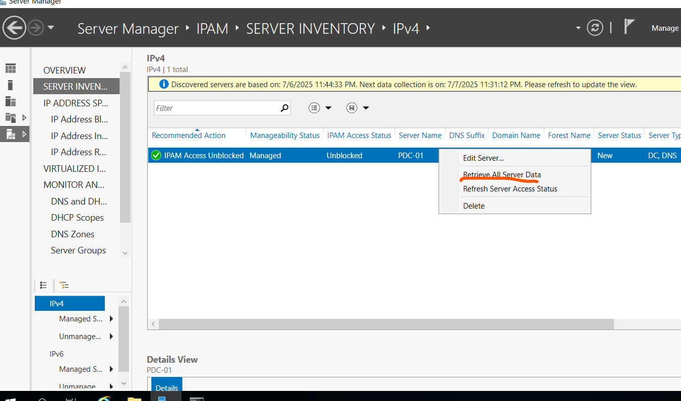

Choose retrieve all data

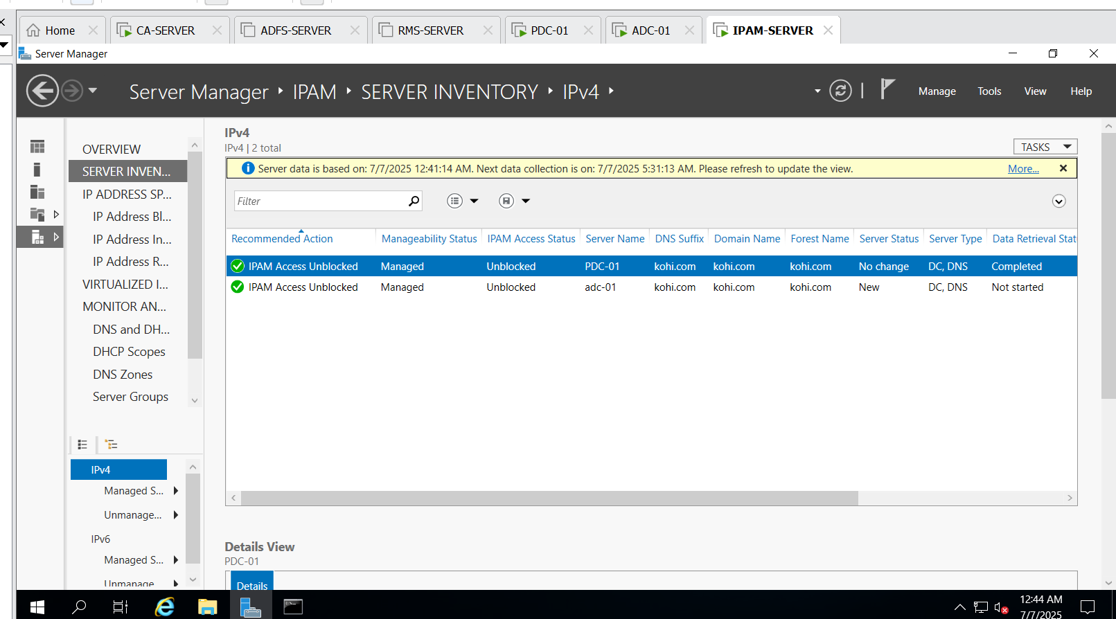

1. CÀI ĐẶT CA-SERVER(IIS SERVER)

The first step is joining domain kohi.com

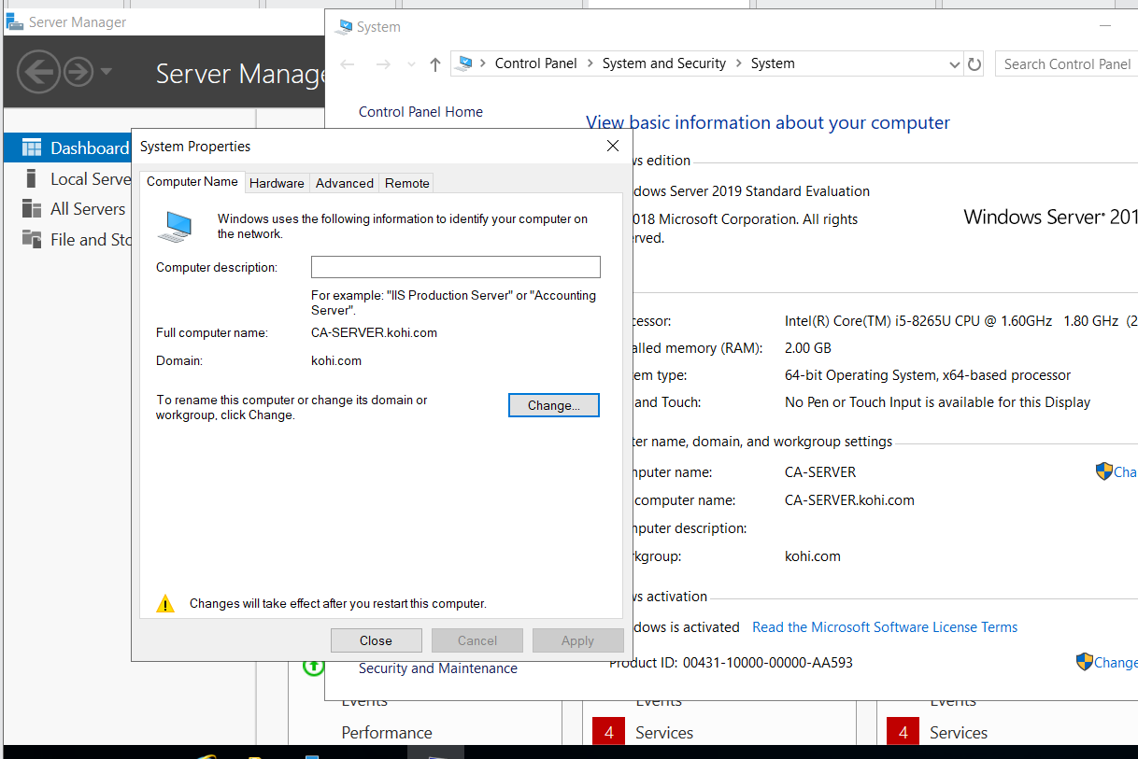

After that we turn off domain network firewall

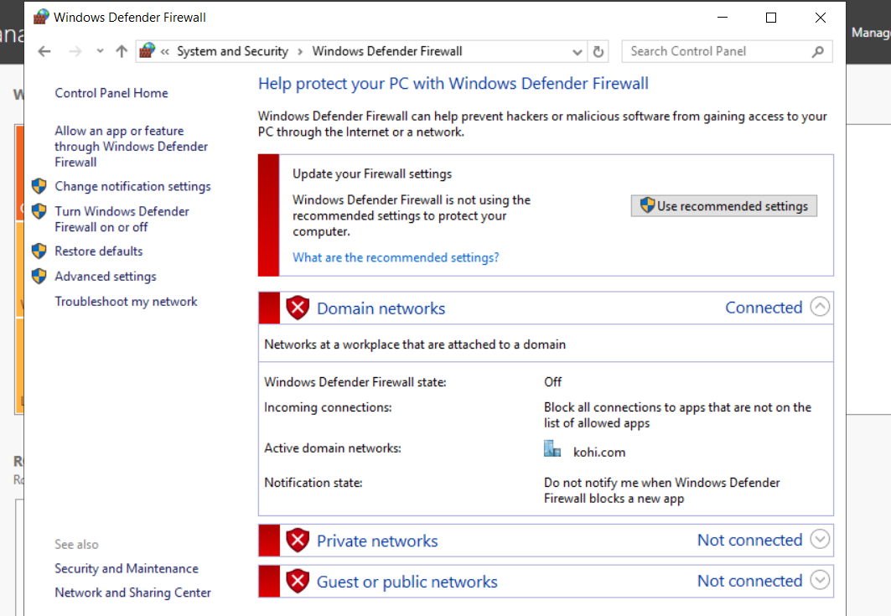

We now start to install CA(certification services)

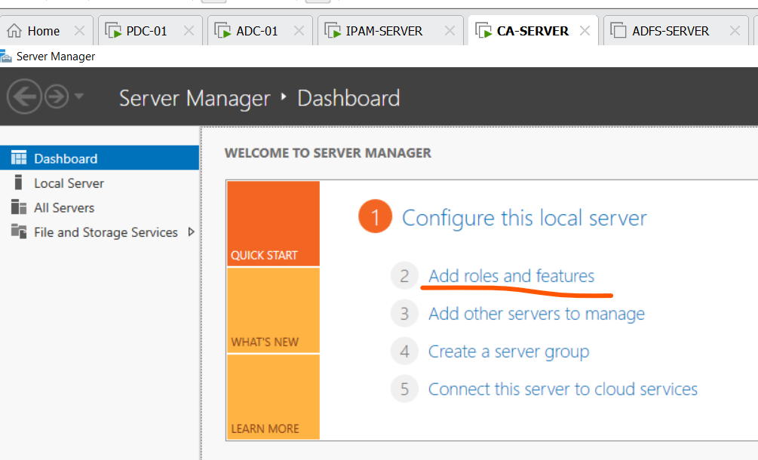

Add roles

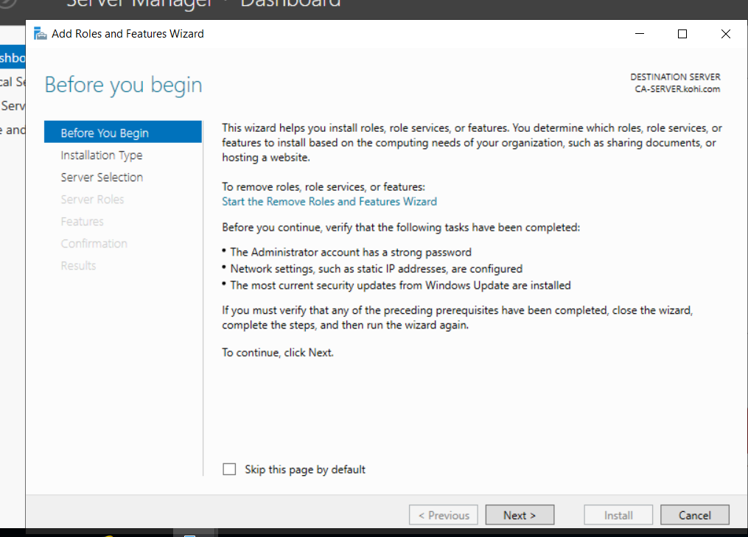

Next

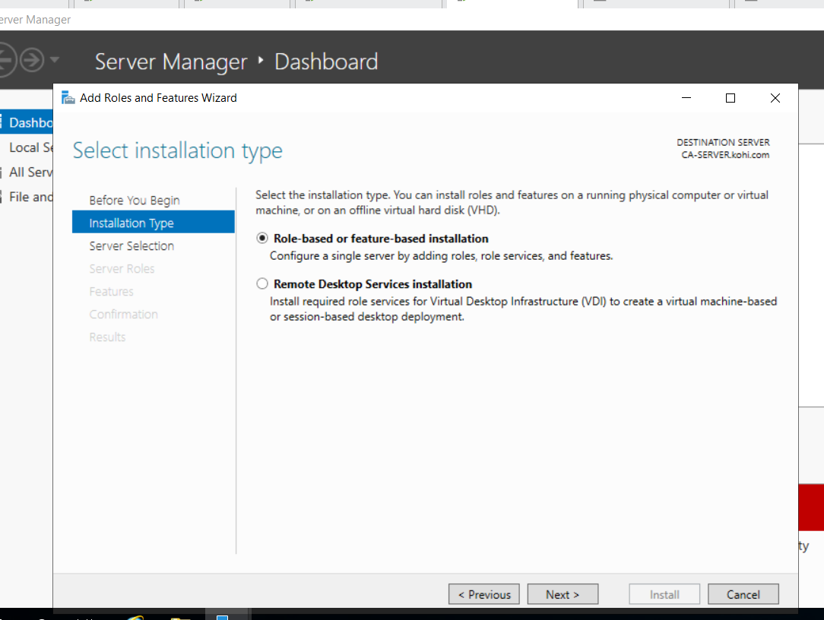

Next

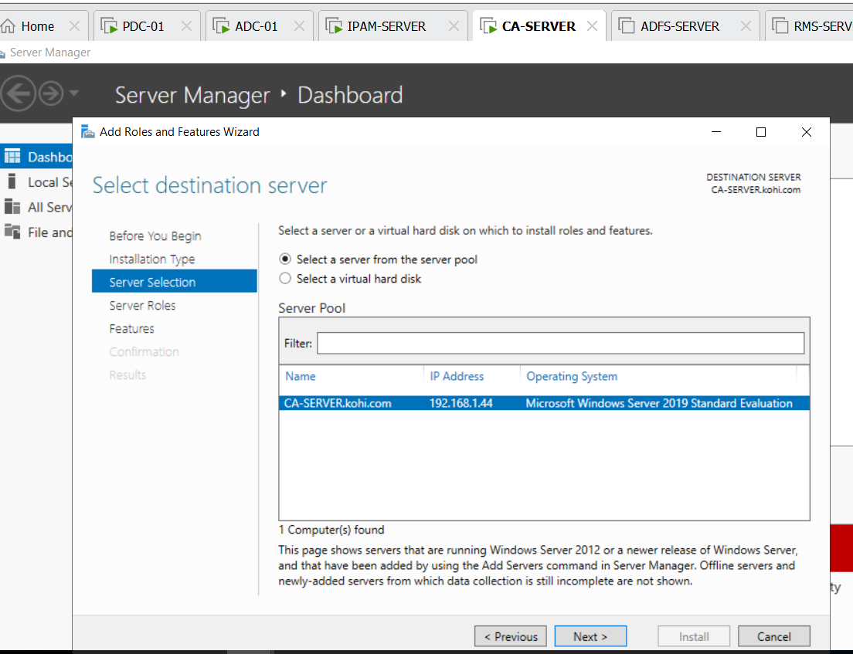

Next

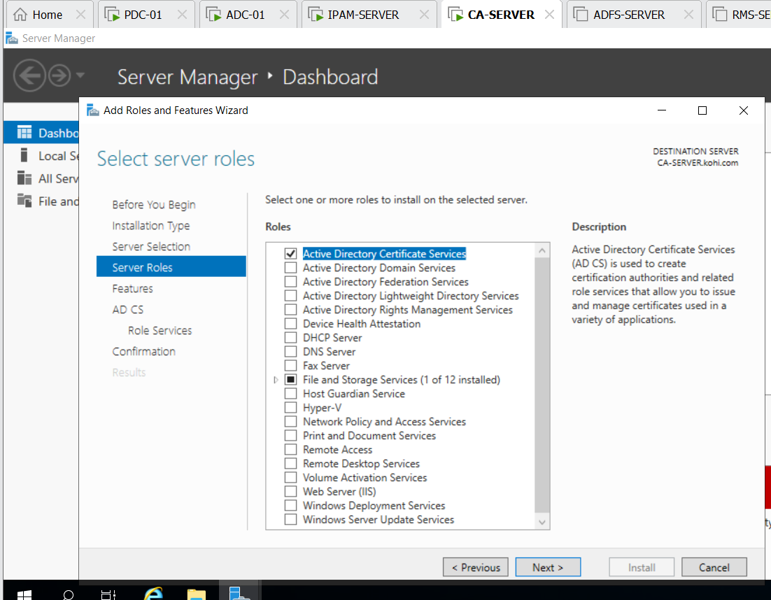

Click active directory certificate services and next

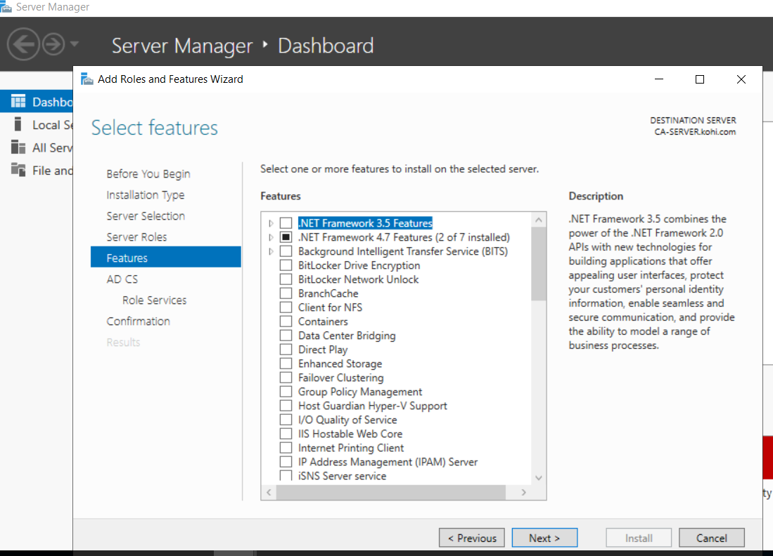

Next

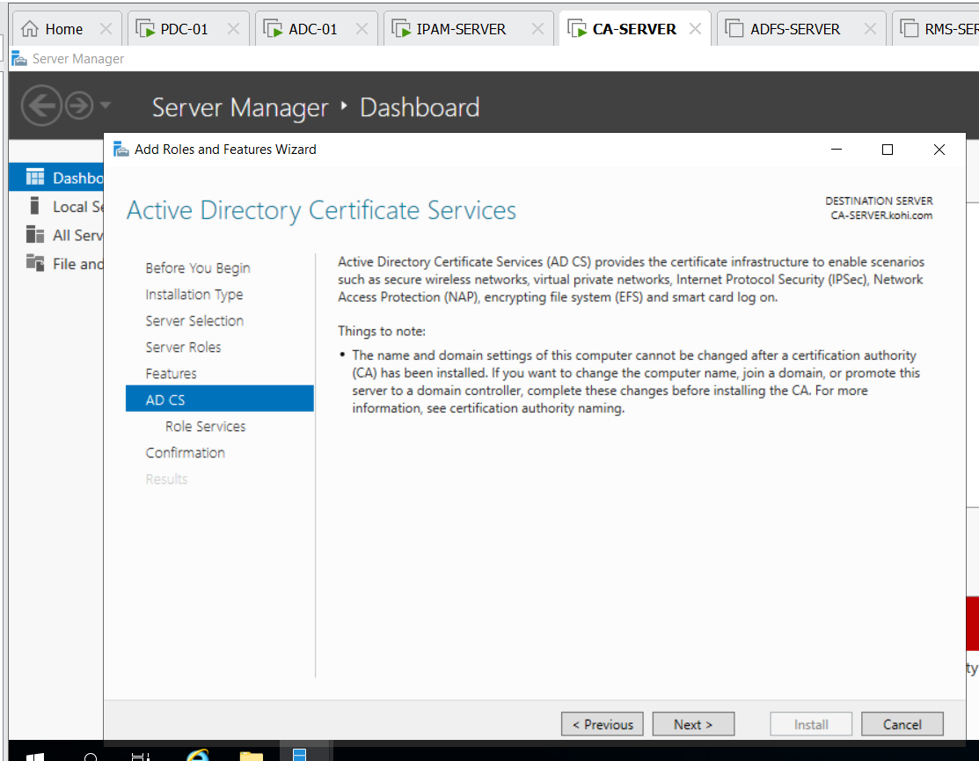

Next

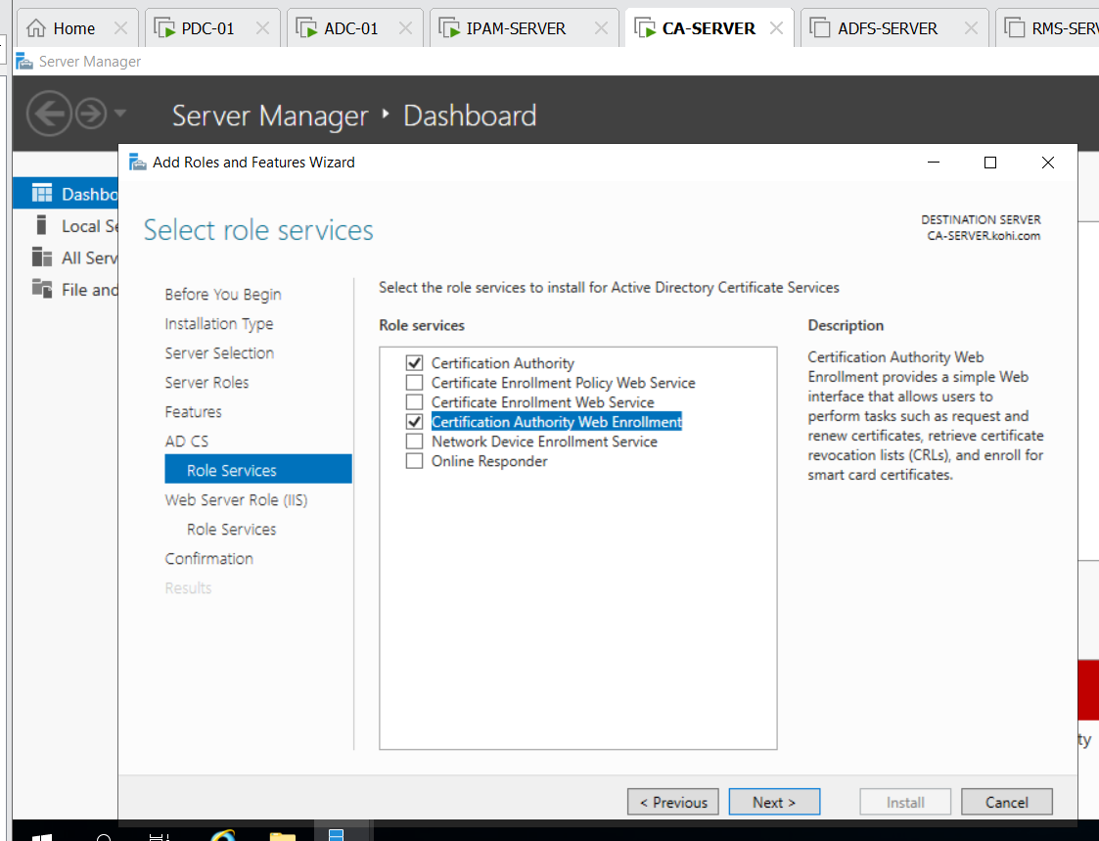

Click certification authority and certification authority web enrollment and next

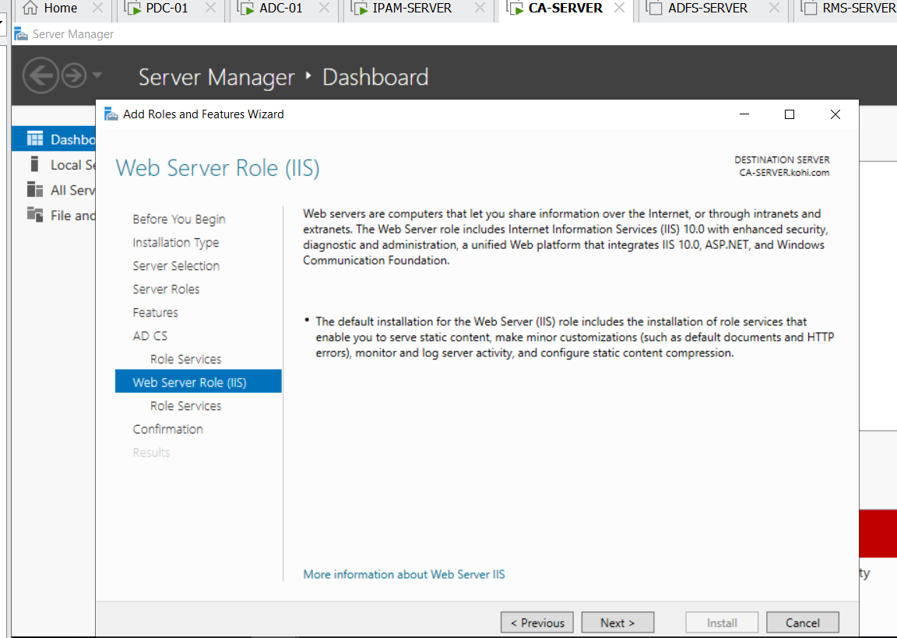

Next

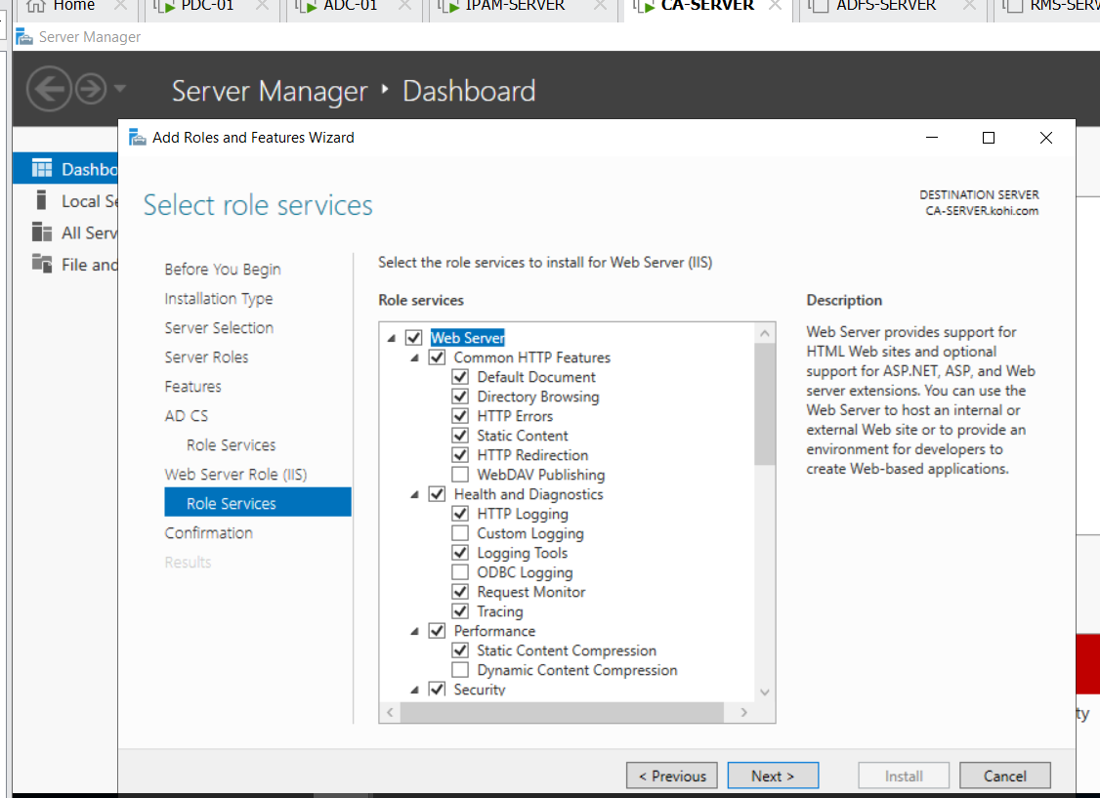

Next

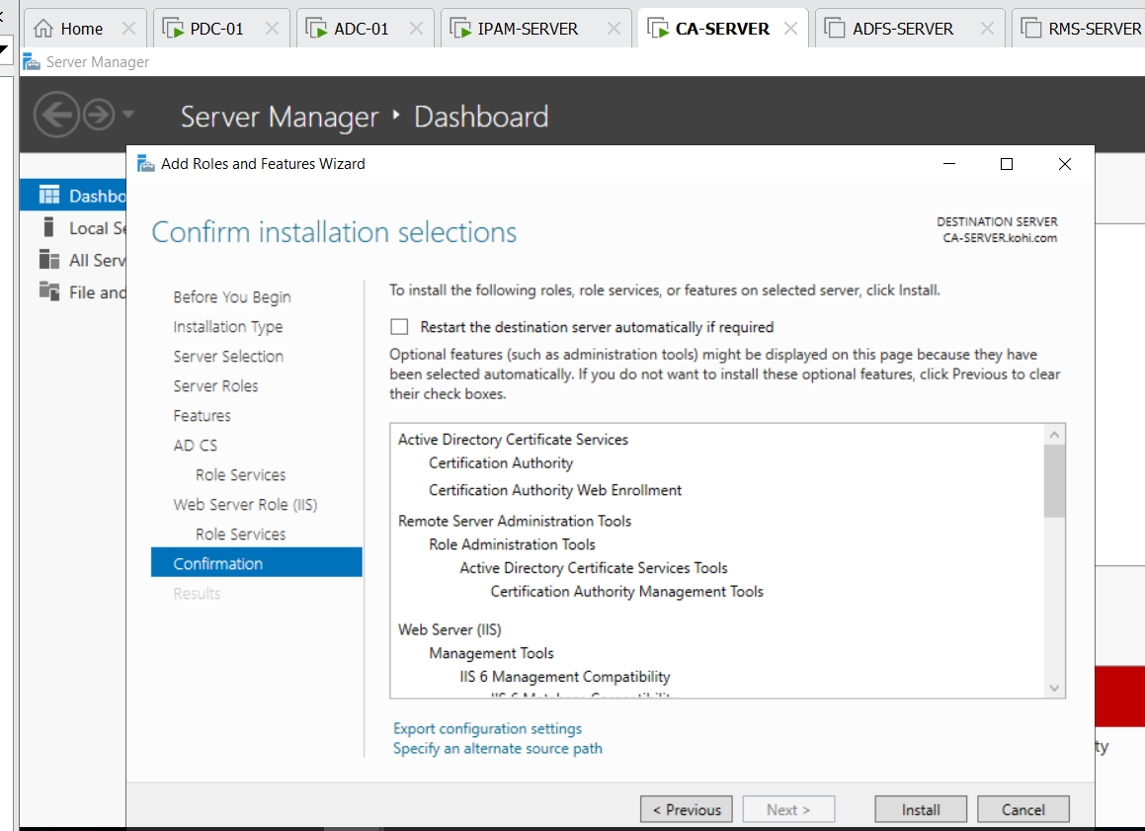

Install

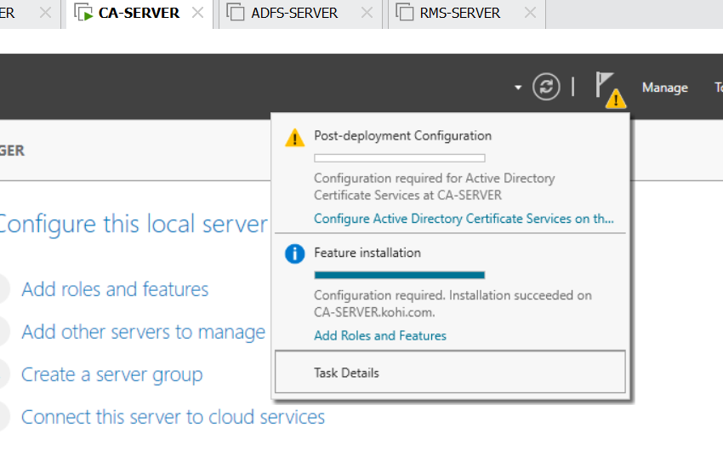

Configure active directory certificate ………

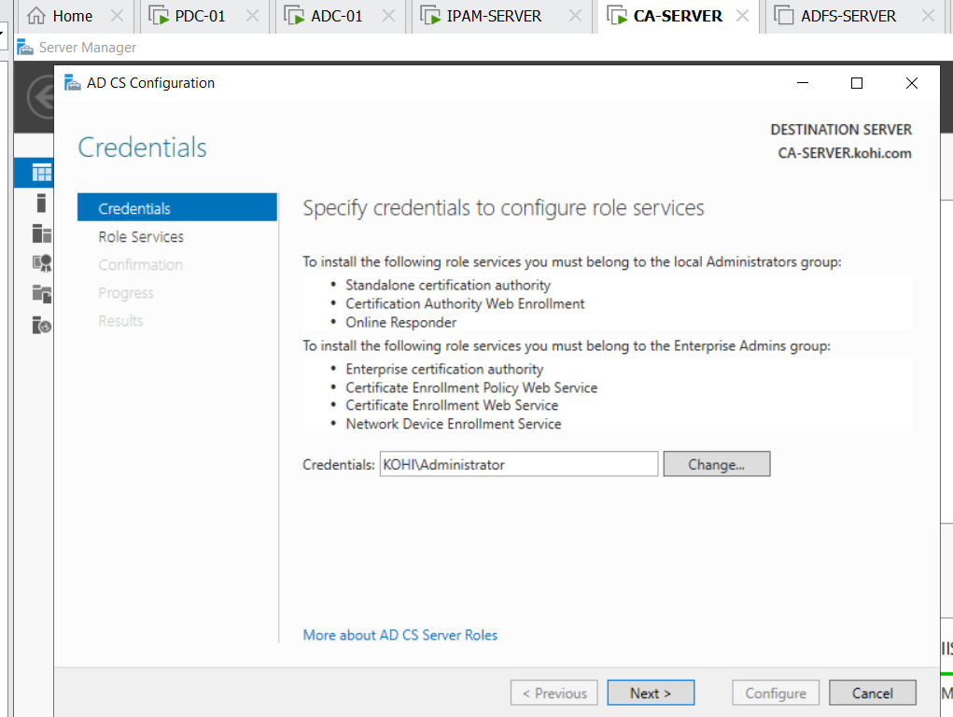

Click next

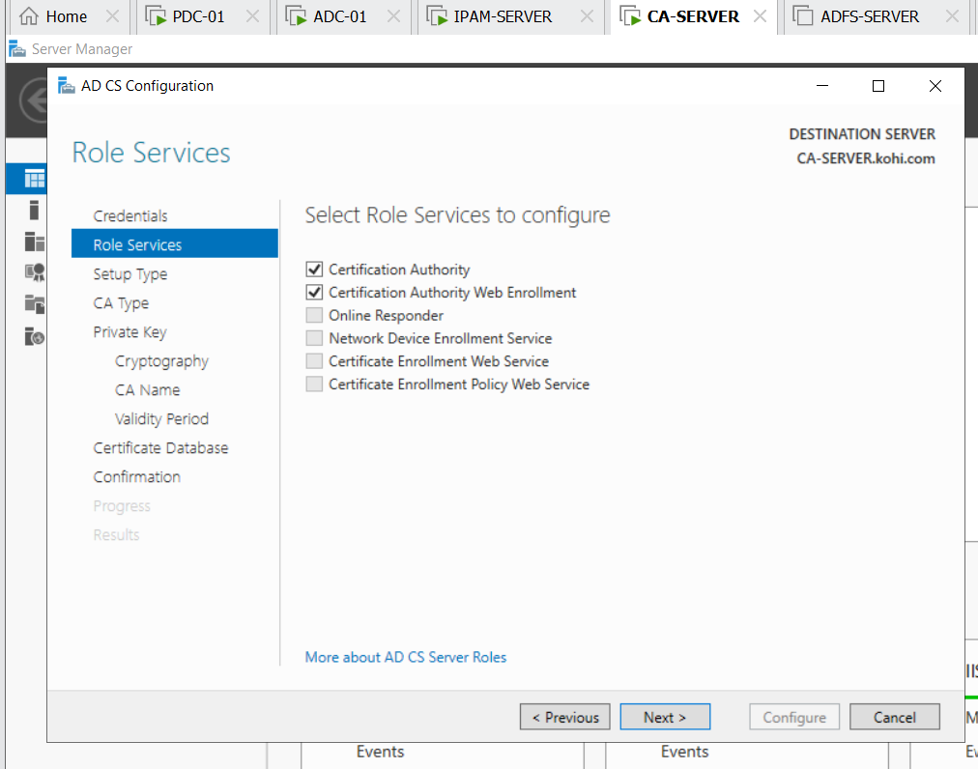

Click two boxes and next

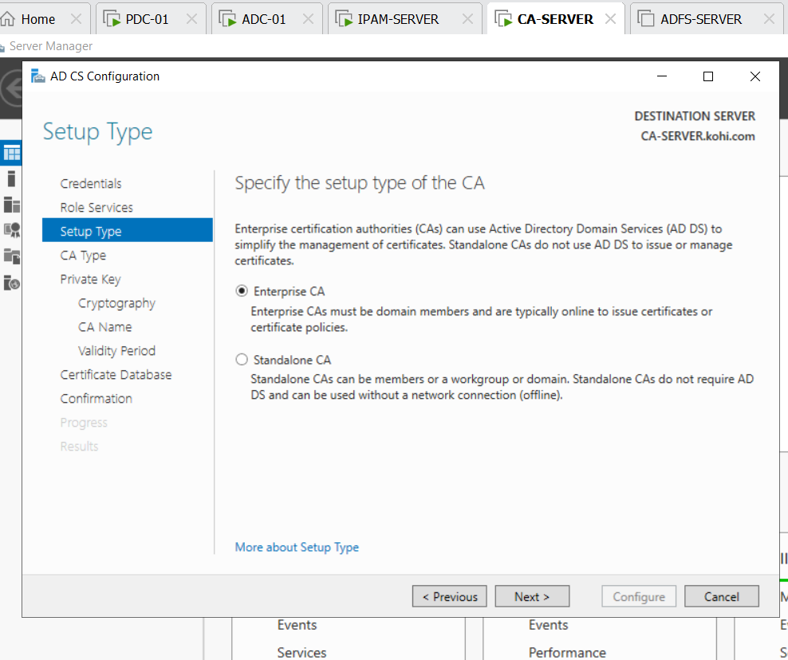

Click next

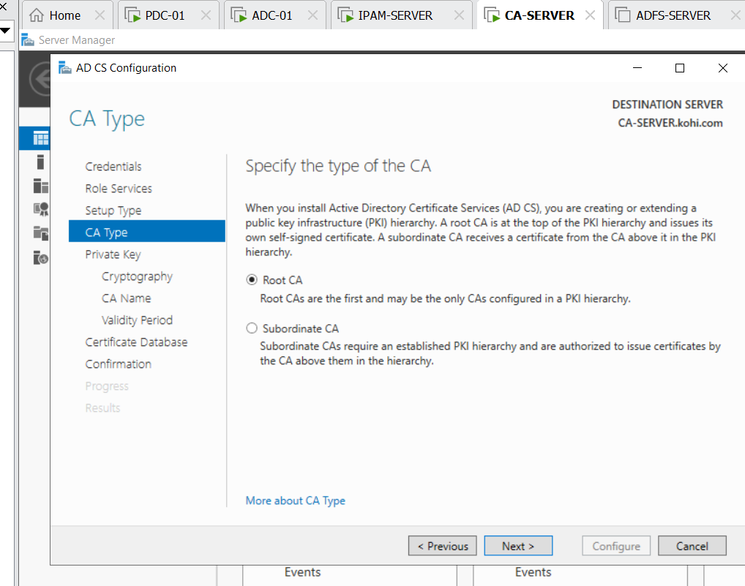

Click next

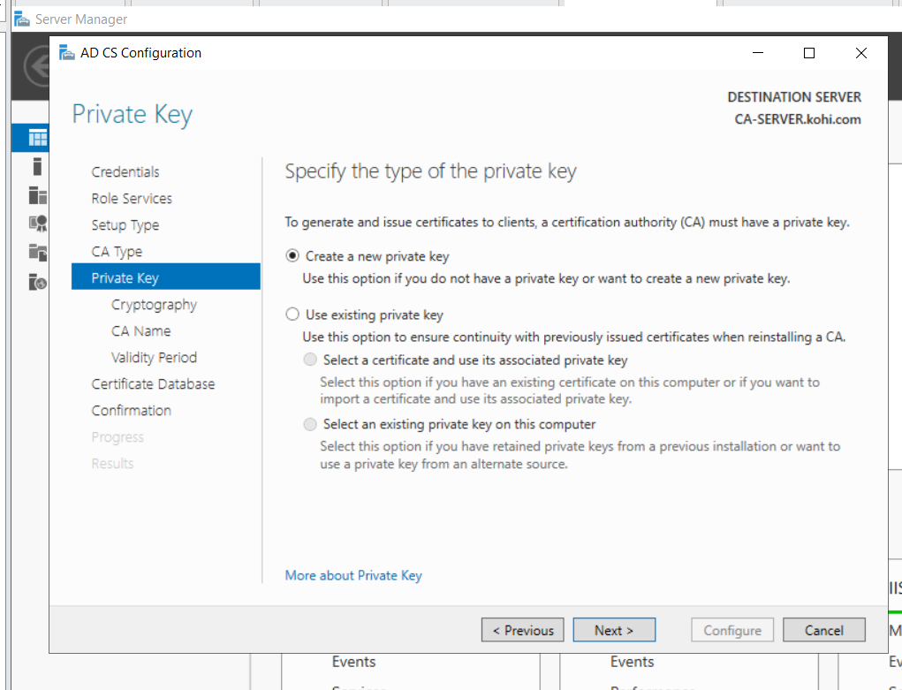

Click next

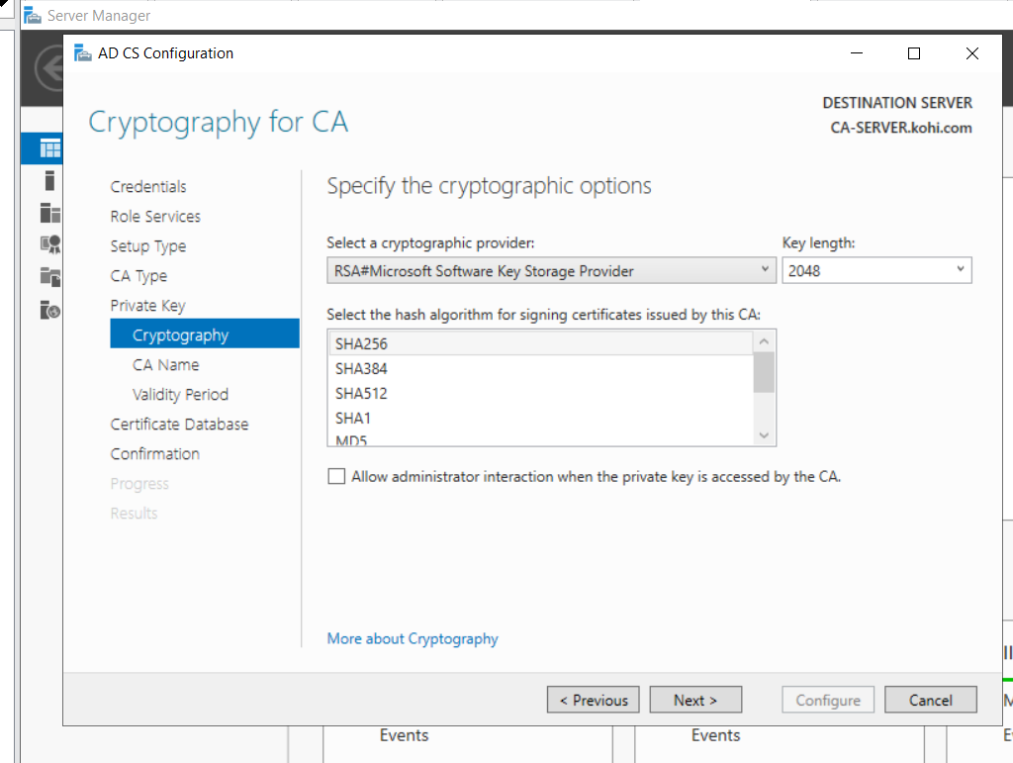

Click next

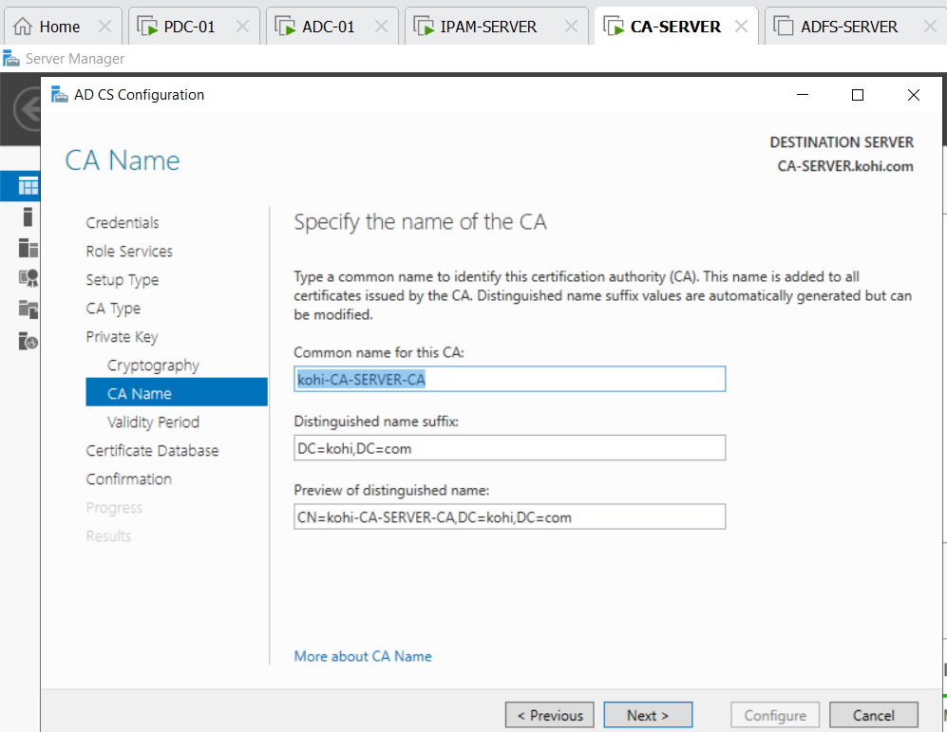

Click next

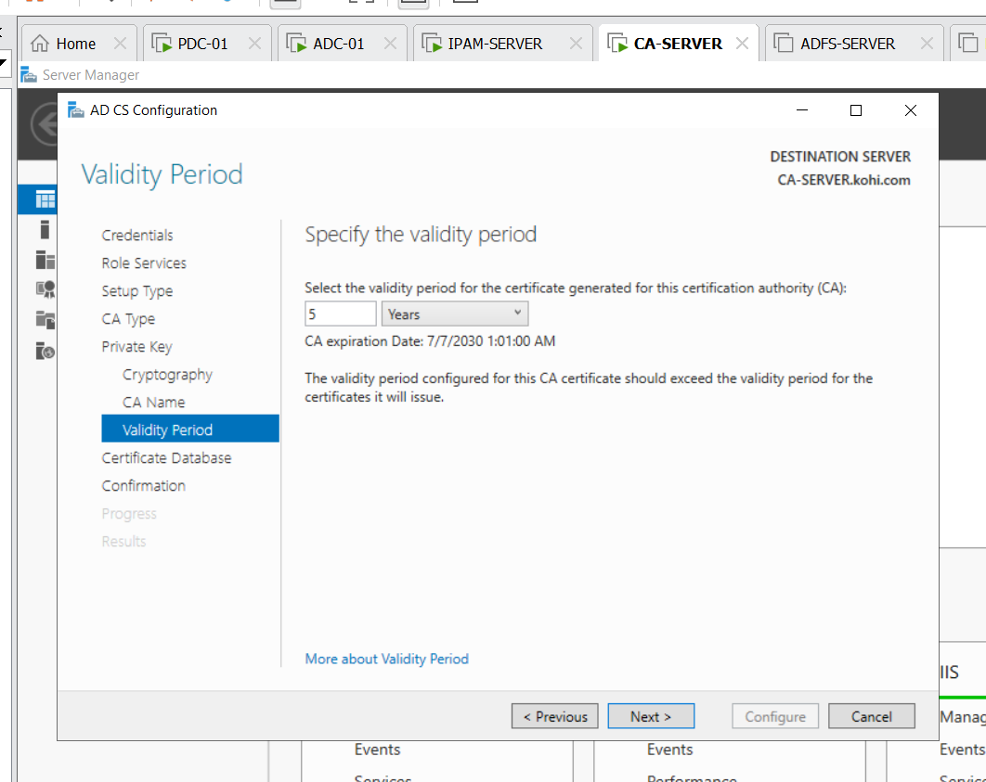

Click next

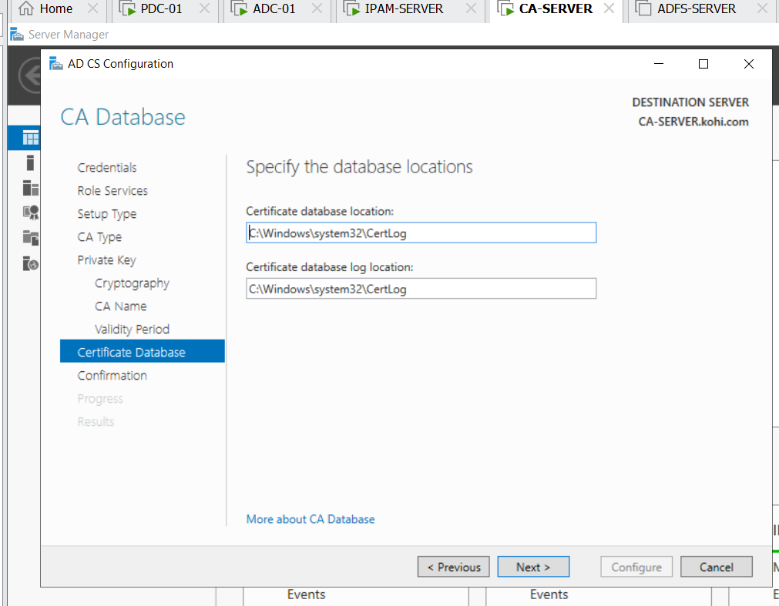click next

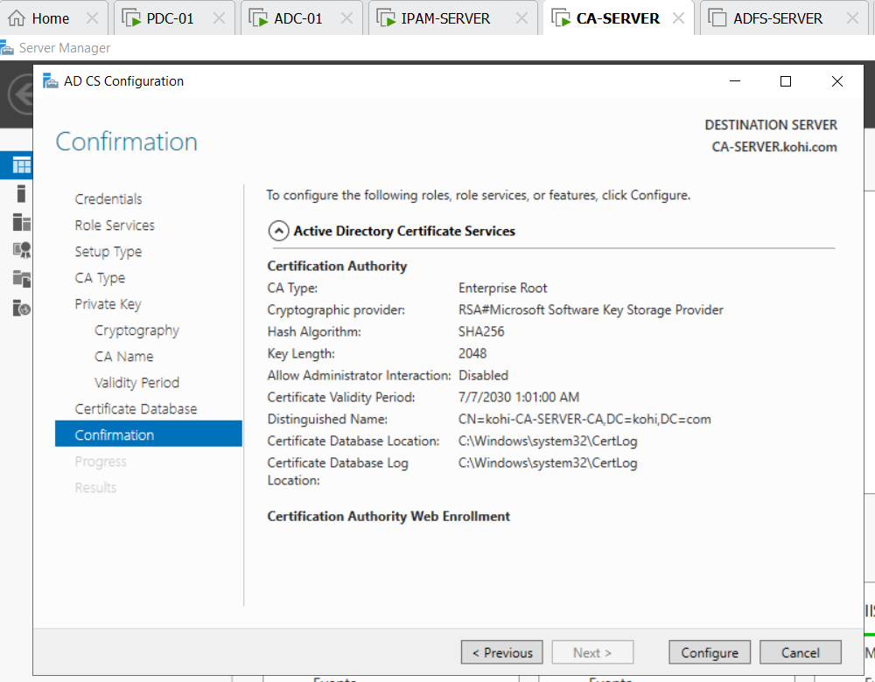click configure

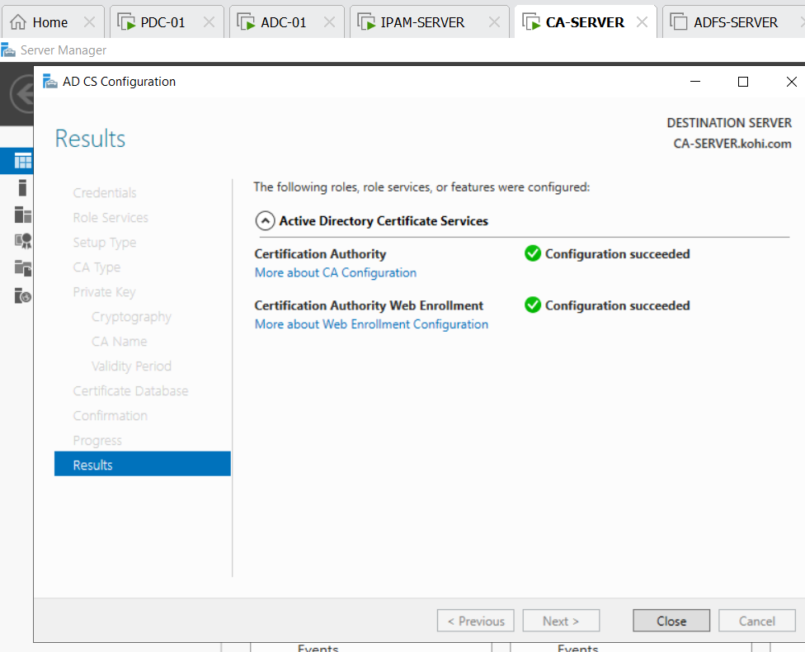click close

After installing we open mmc

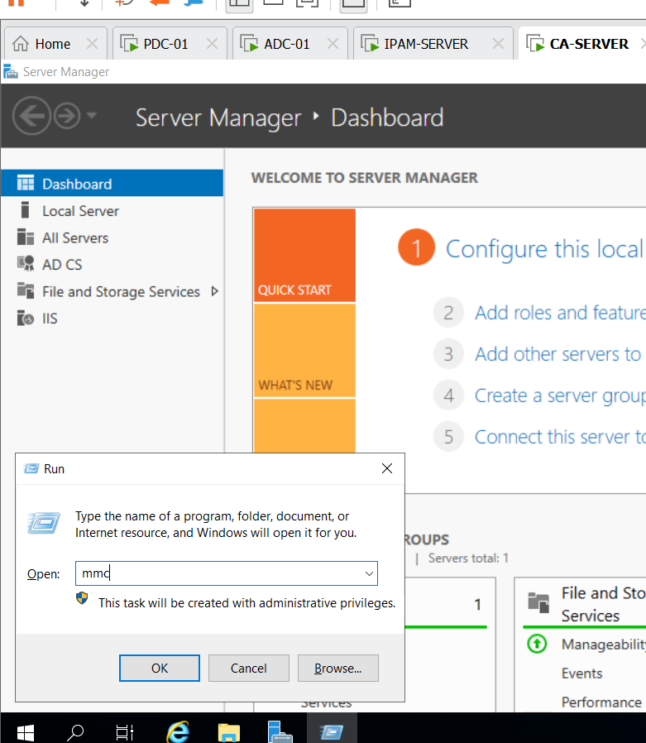

Click ok

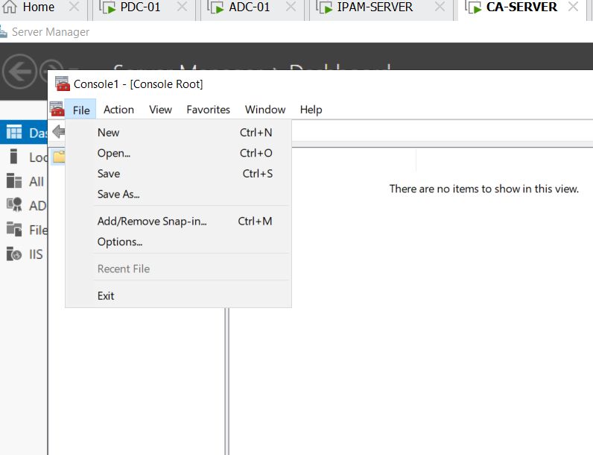

Click file add/remove snap-in

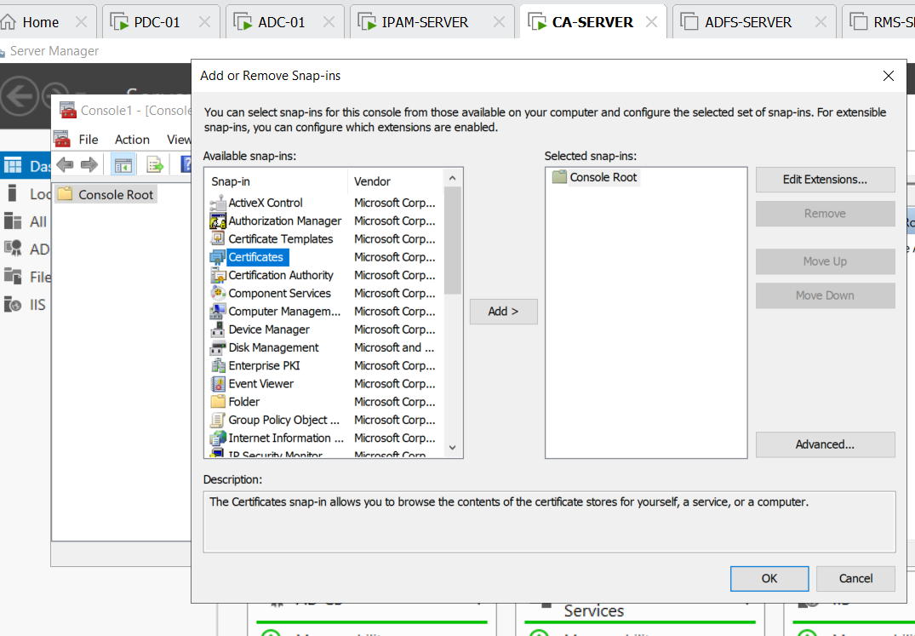

Click certificates and add

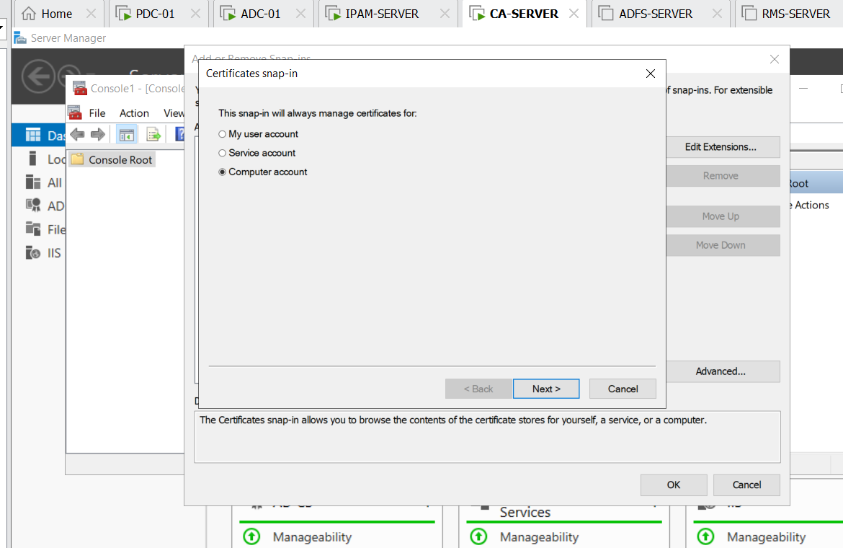

Click choose computer account

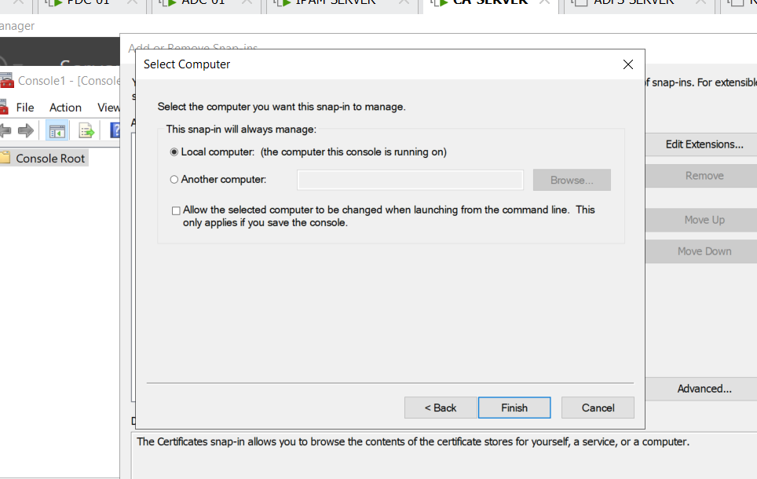

Click finish

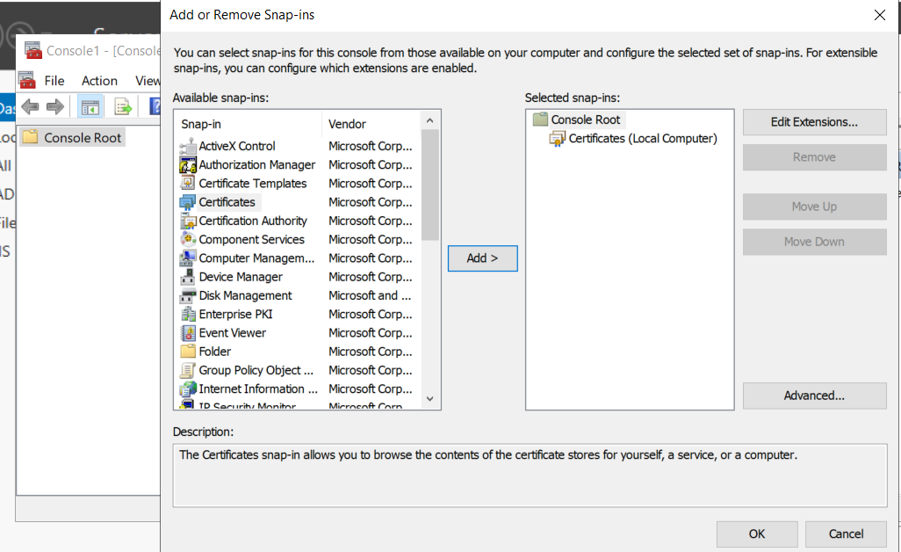

Click ok

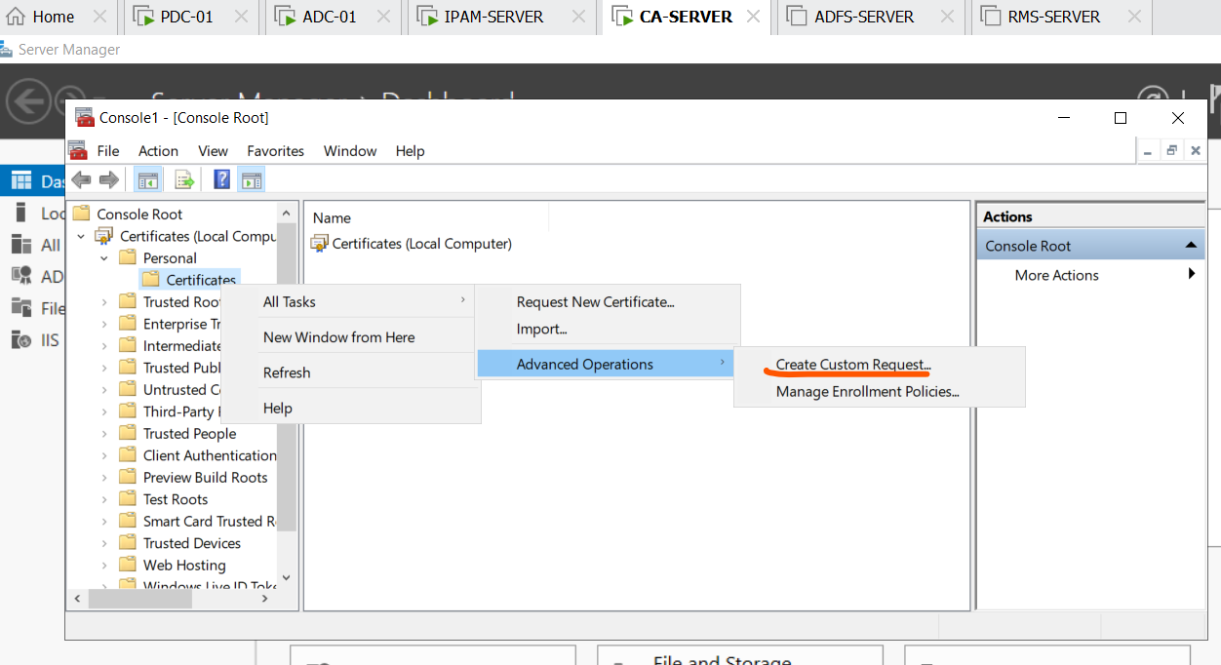

Right click choose all tasks -> advanced operations and >create custom request

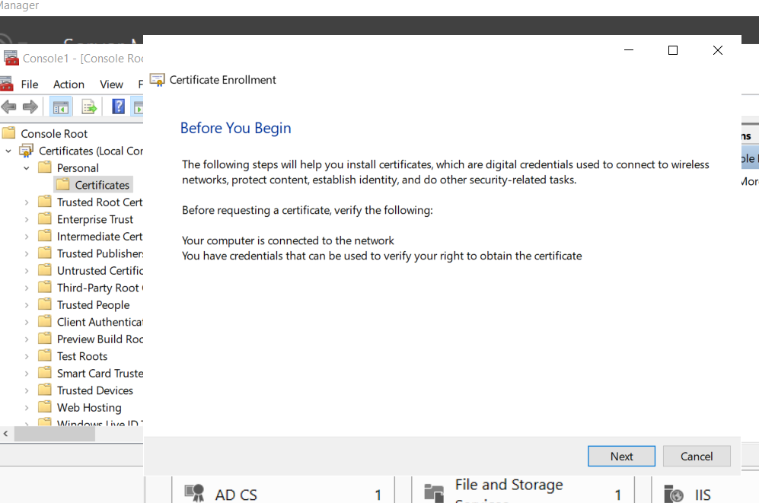

Next

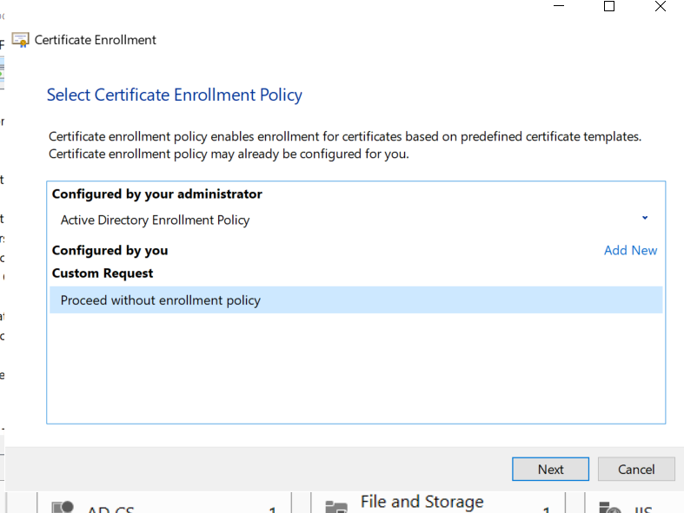

Click proceed without enrollment policy and next

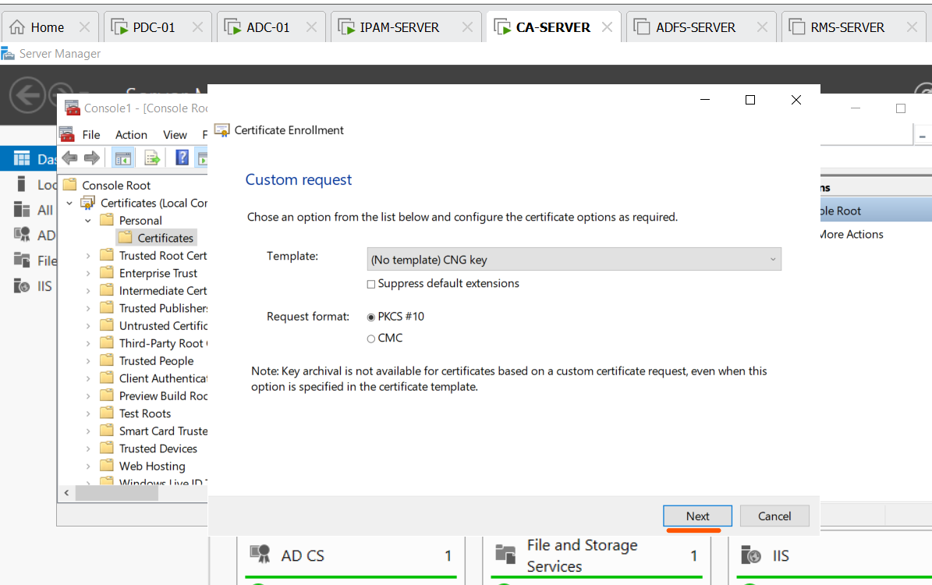

Click next

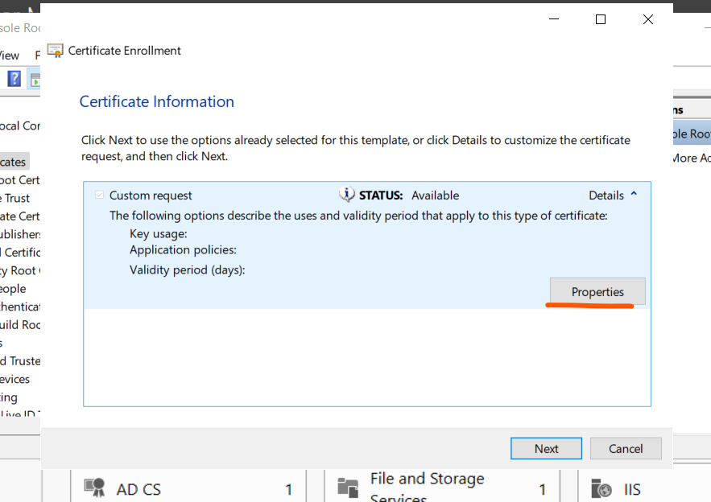

Click detail > click properties

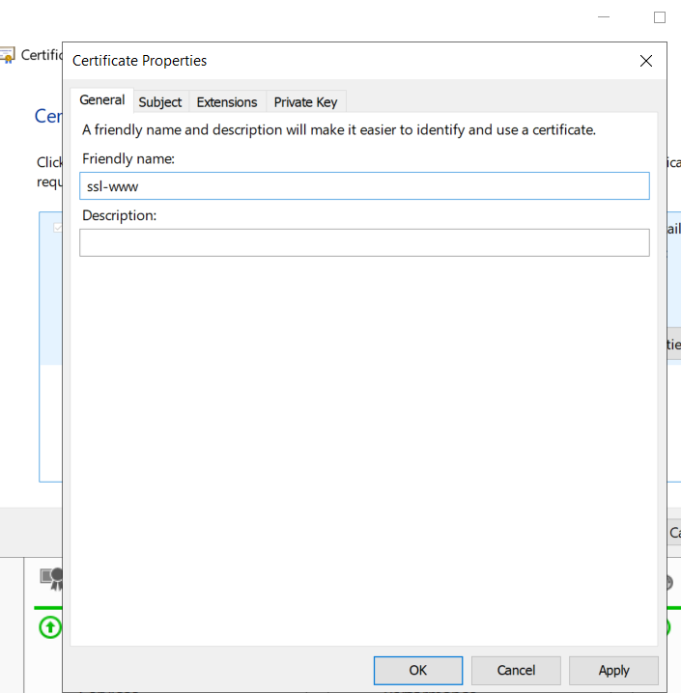

Friendly name-> we name it “ssl-www”

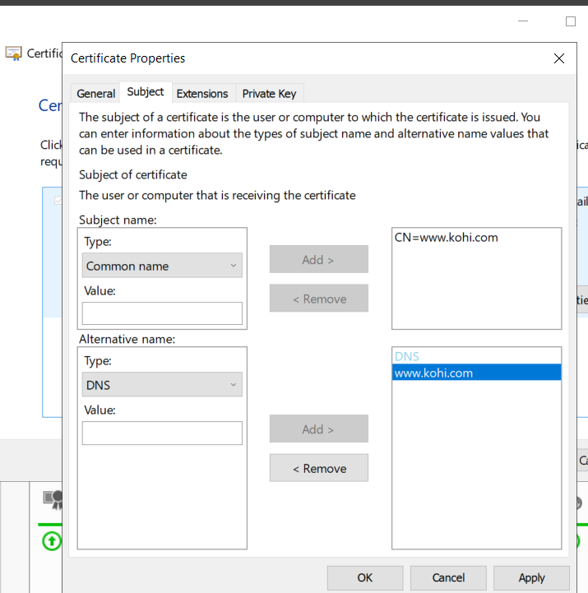

Common name => value: [www.kohi.com](http://www.kohi.com)

DNS 🡺 value: [www.kohi.com](http://www.kohi.com)

After that adding two both

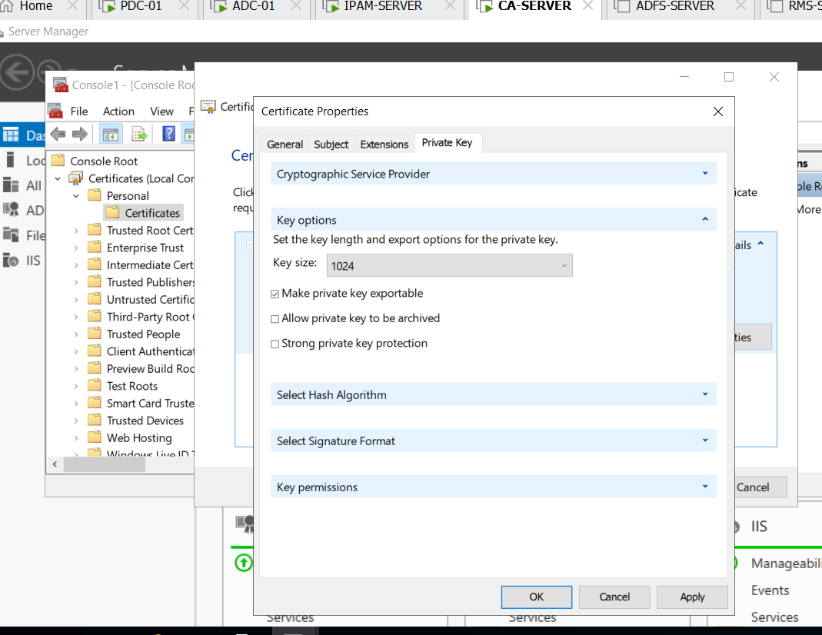

Private key => we click make private key exportable

Then apply and ok

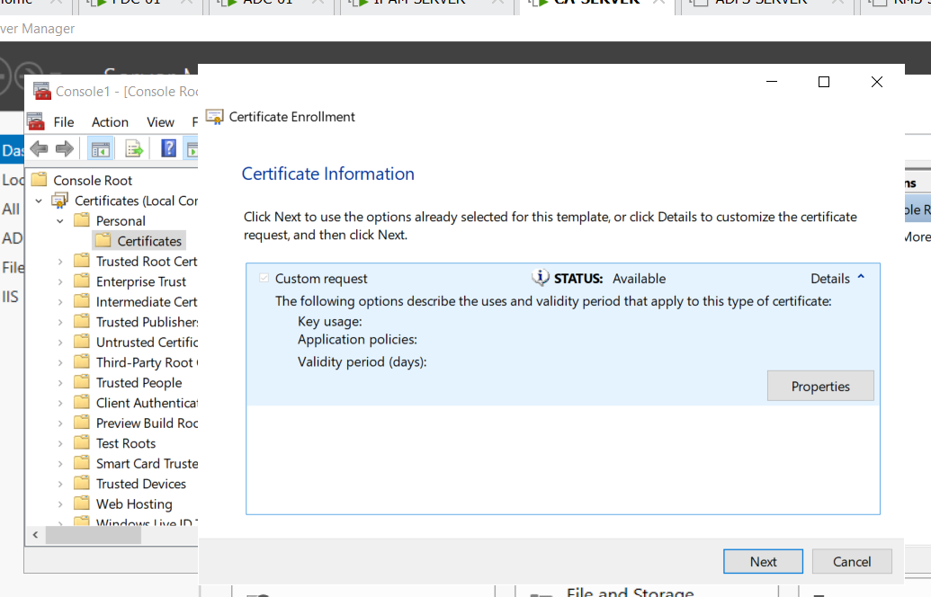

Click next

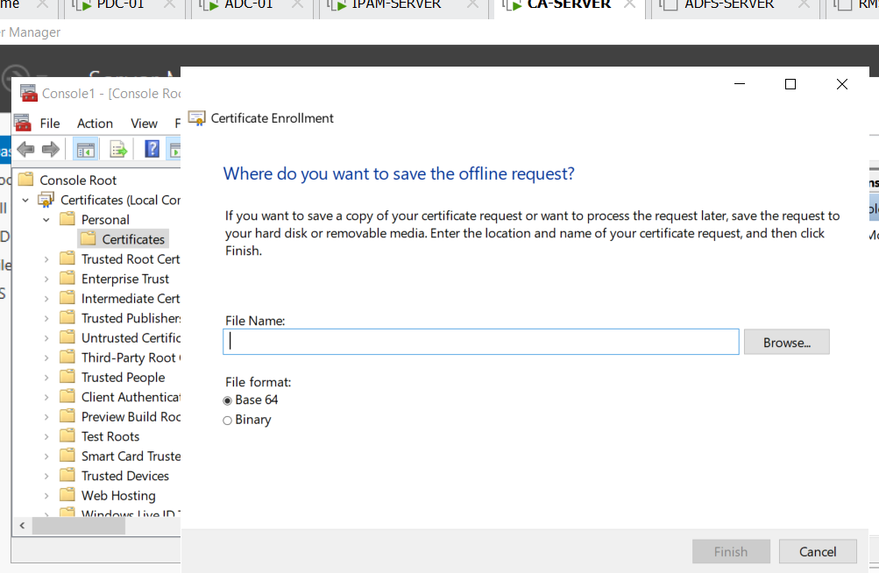

We click browse to save the file req

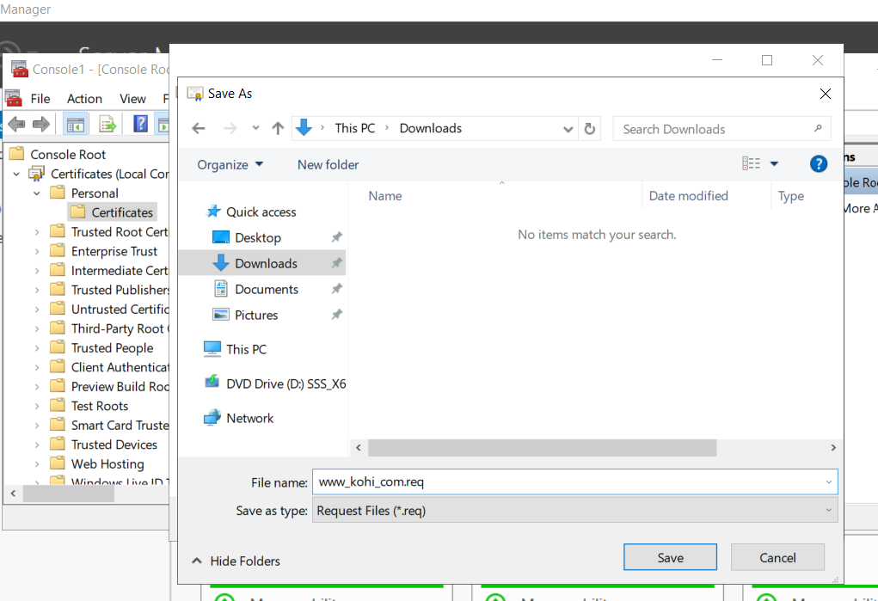

We set name like that and save

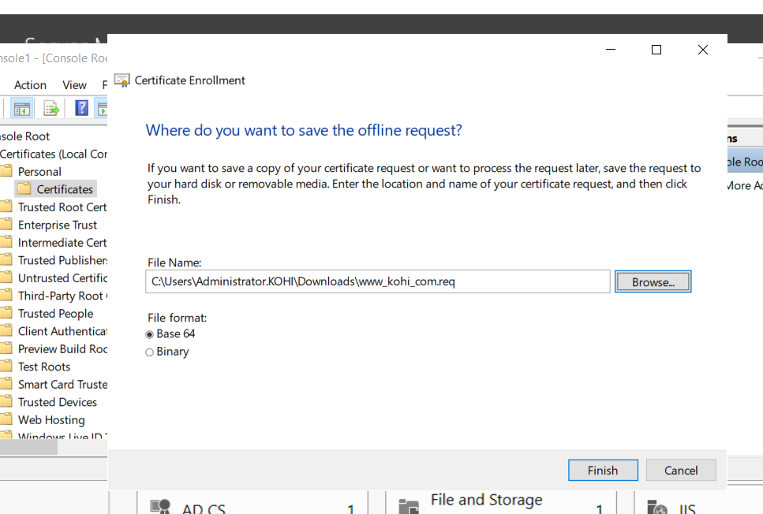

Click finish

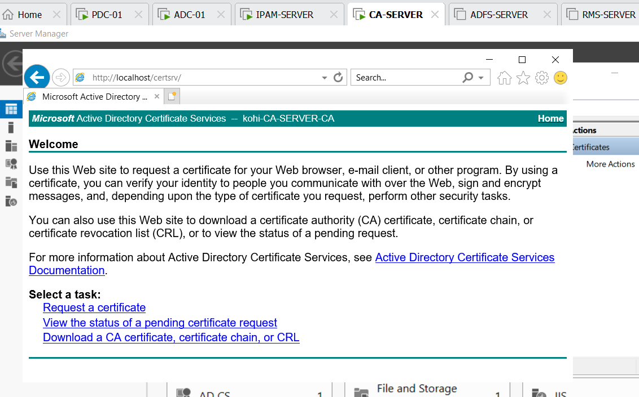

We open IE and enter <http://localhost/certsrv> and enter

after that we click request a certificate

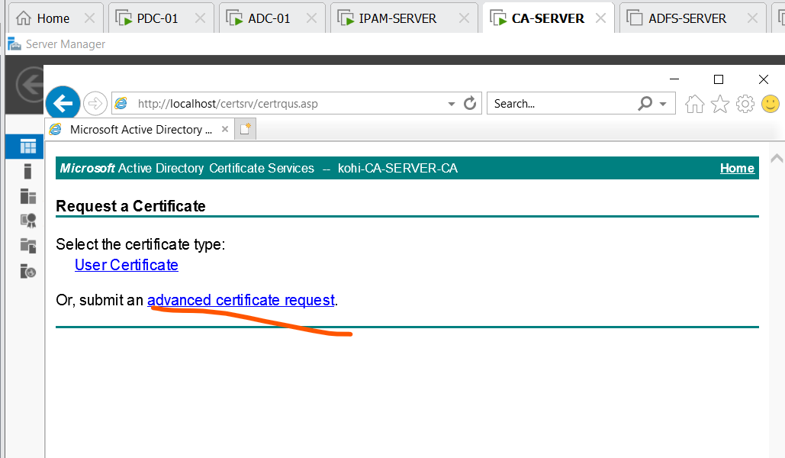

Choose advanced certificate request

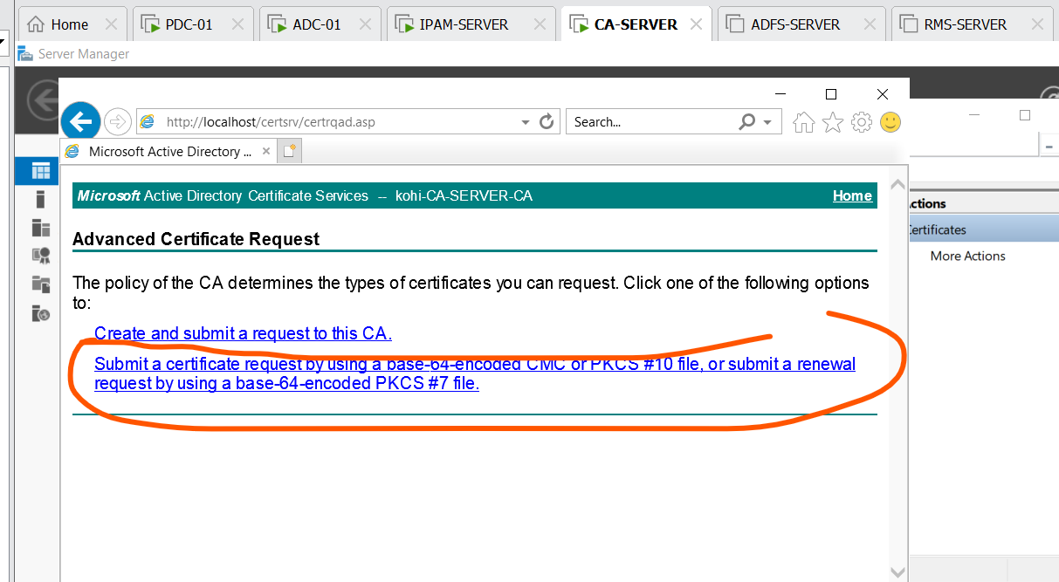

Choose this

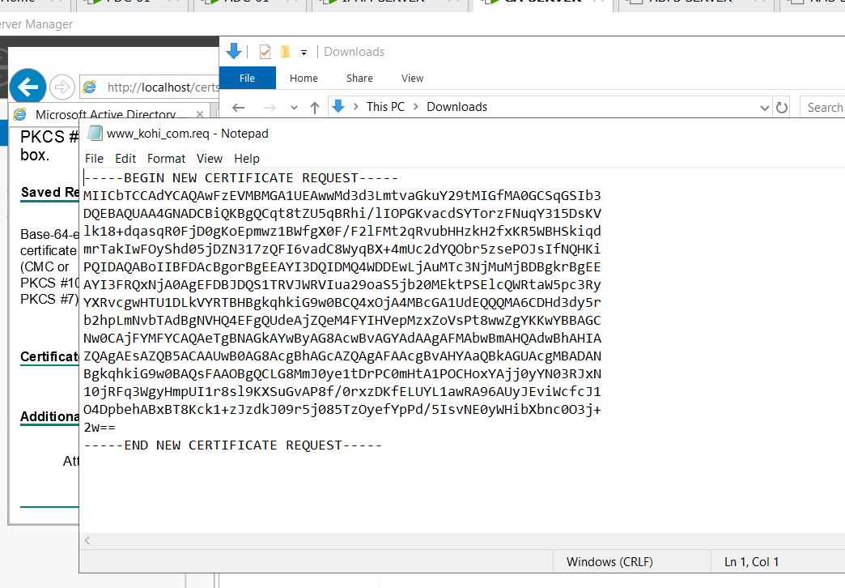

We open file www_kohi_com_req by notpad and copy it into the Saved request box

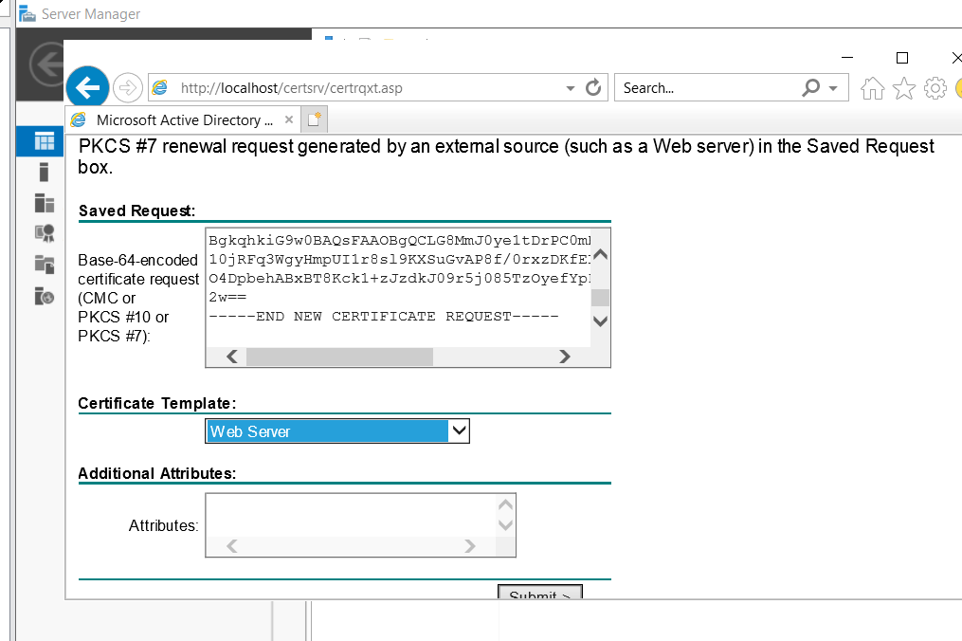

Certificate template => web server

And Submit

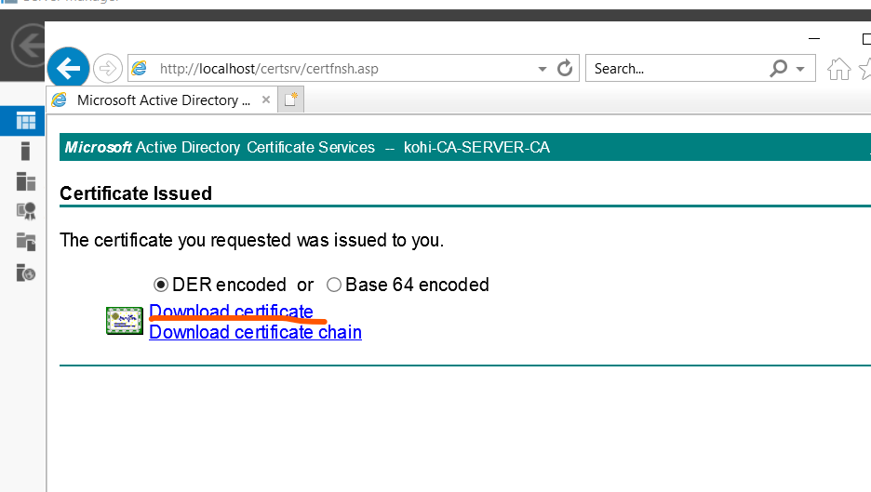

Choose download certificate

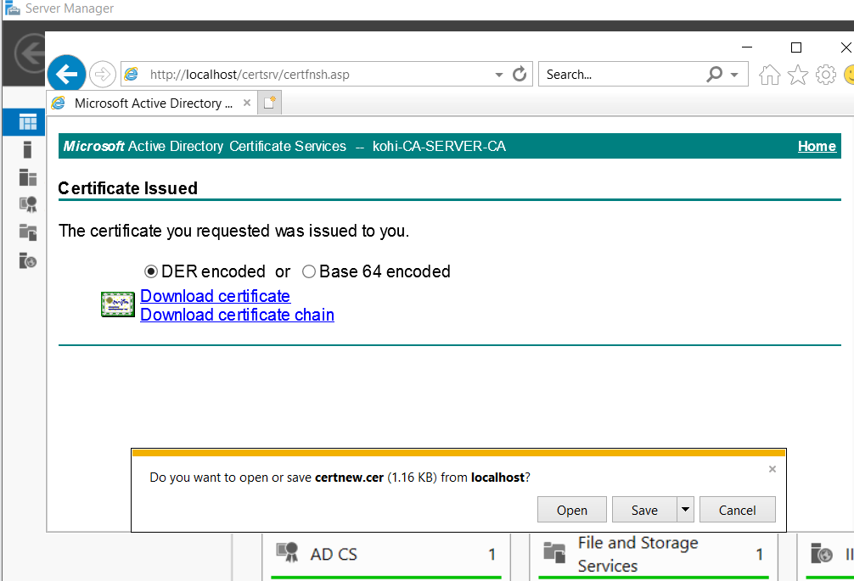

Click save

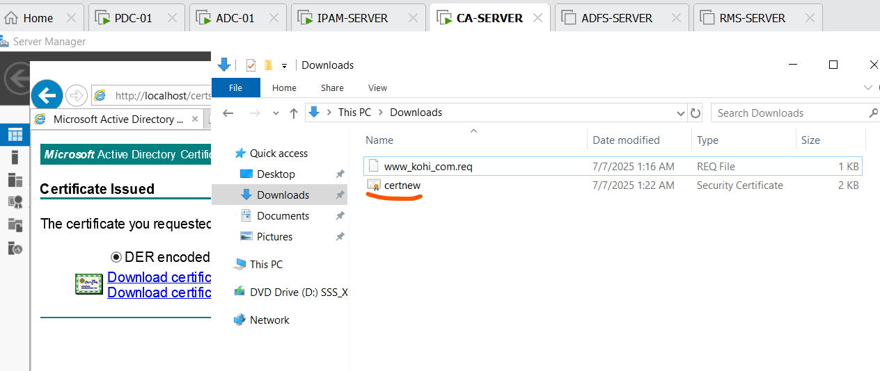

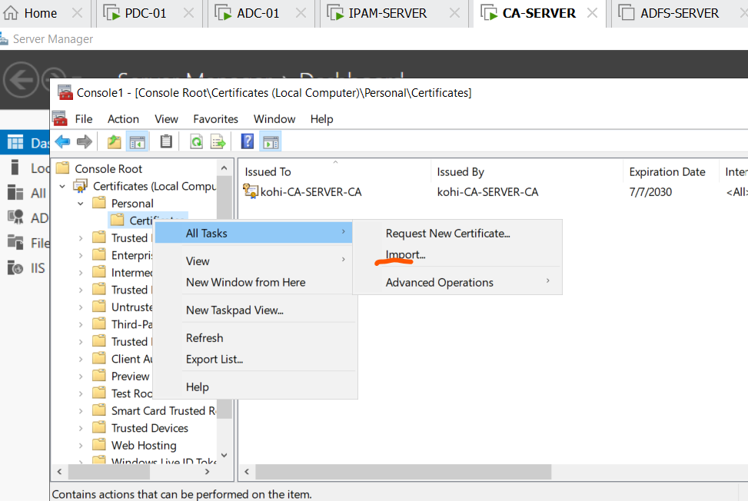

Returning the mmc we import that certificate just creating

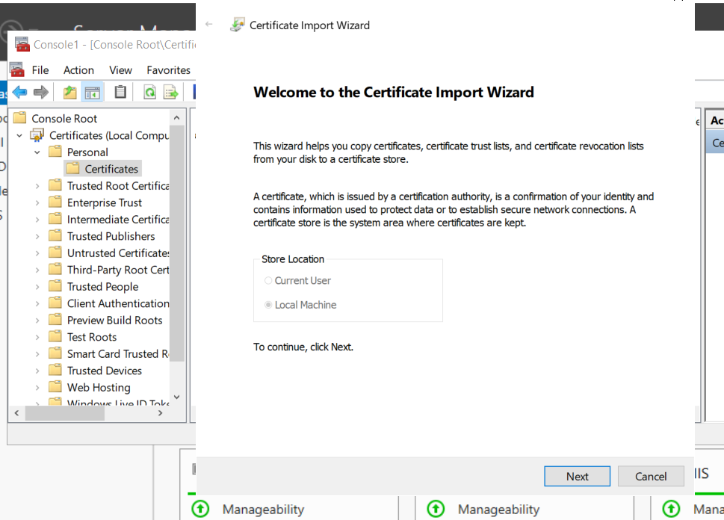

We click next

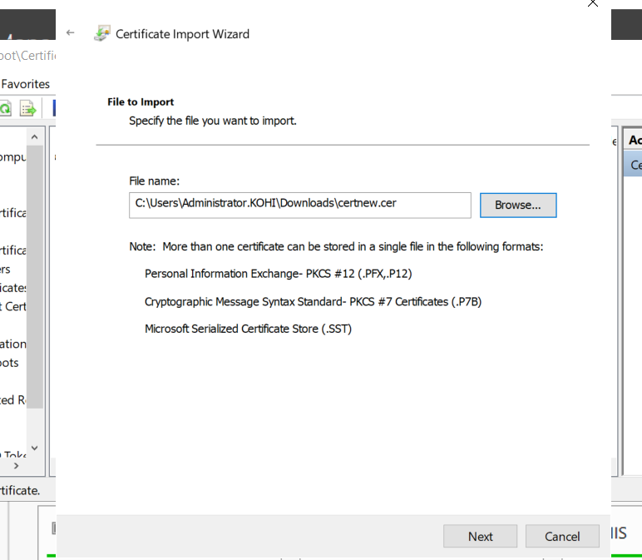

Browse the certificate and next

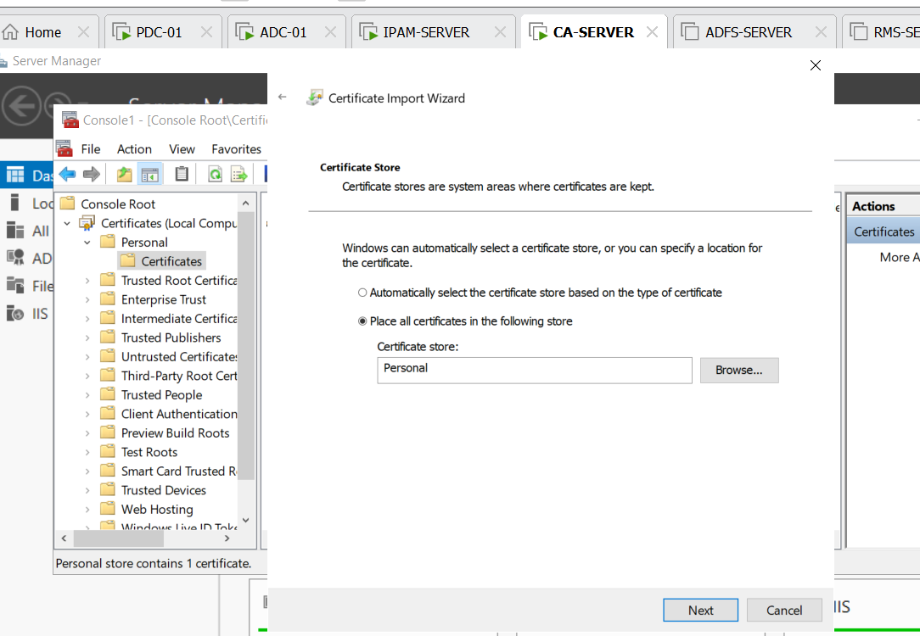

We click next

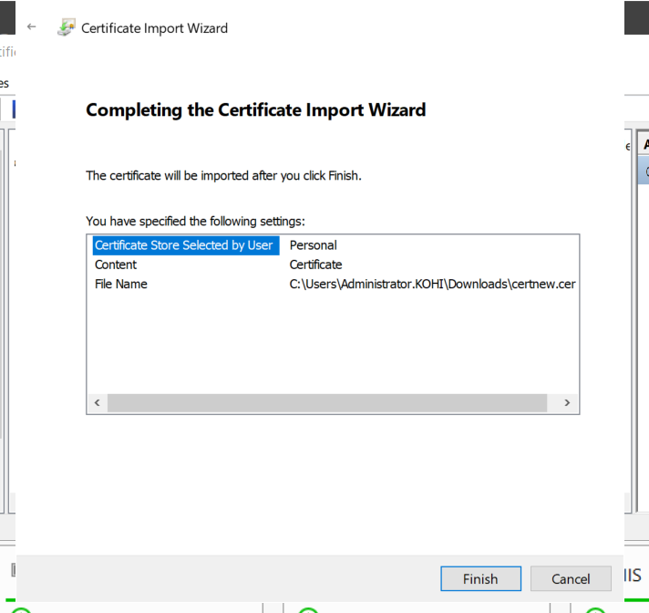

Click finish

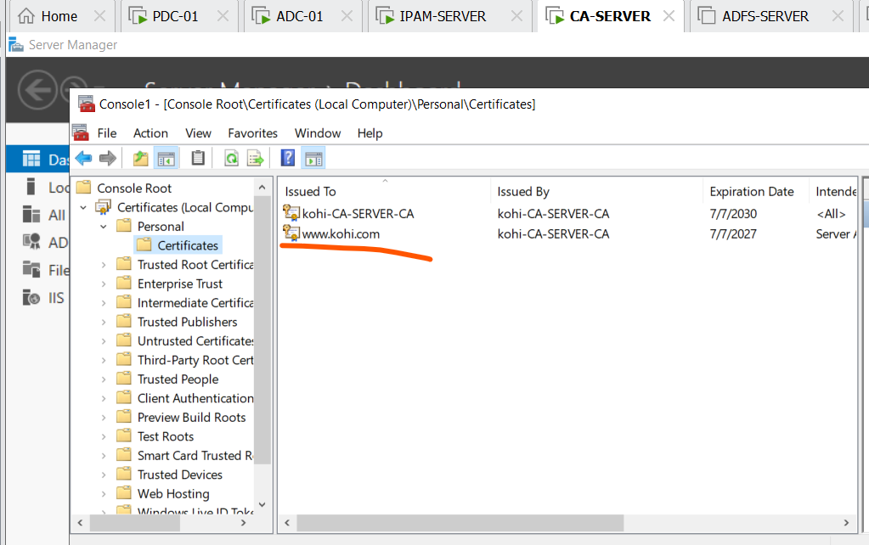

We can see [www.kohi.com](http://www.kohi.com) (certificate)

Then we start to configure [www.kohi.com](http://www.kohi.com) by https not http; in order to do that we click IIS

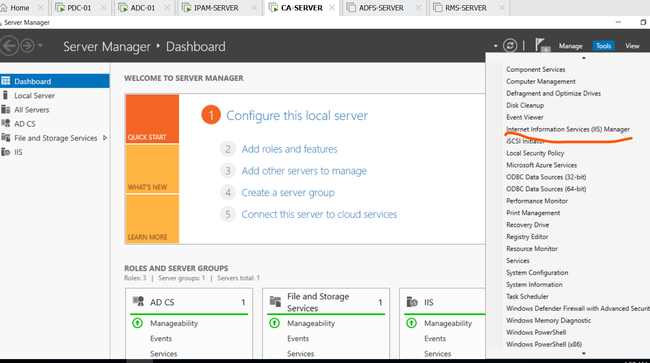

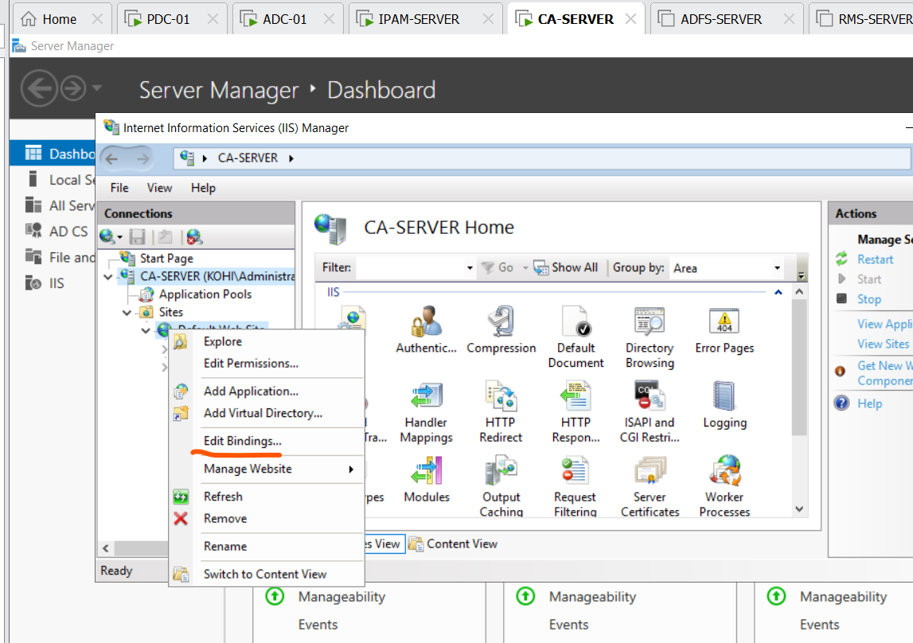

We click Edit bindings

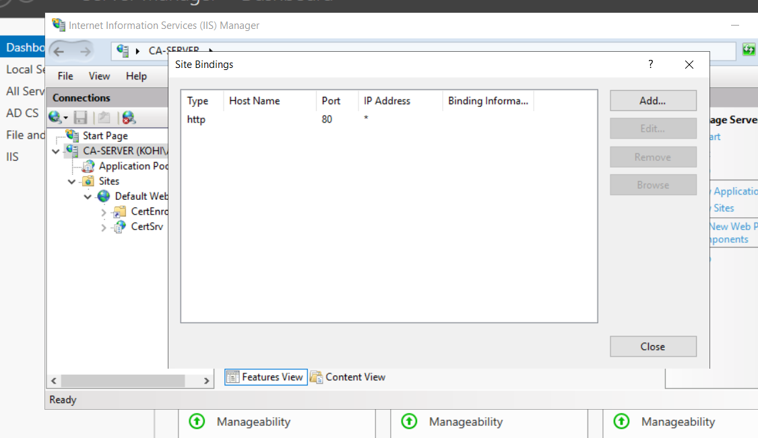

Click add

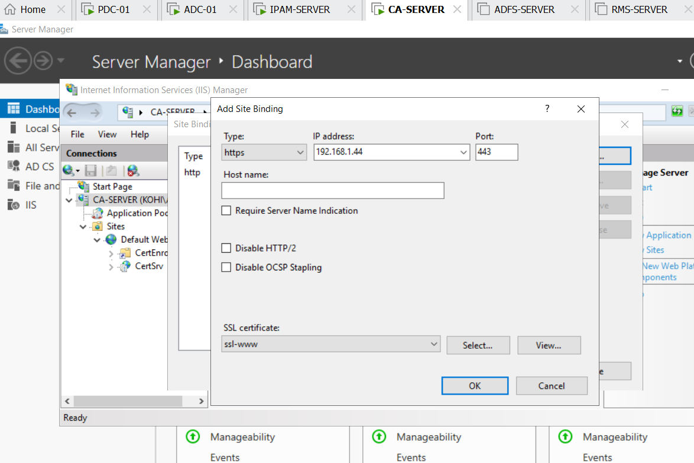

Adjusting the information in the box is like that and clicking OK

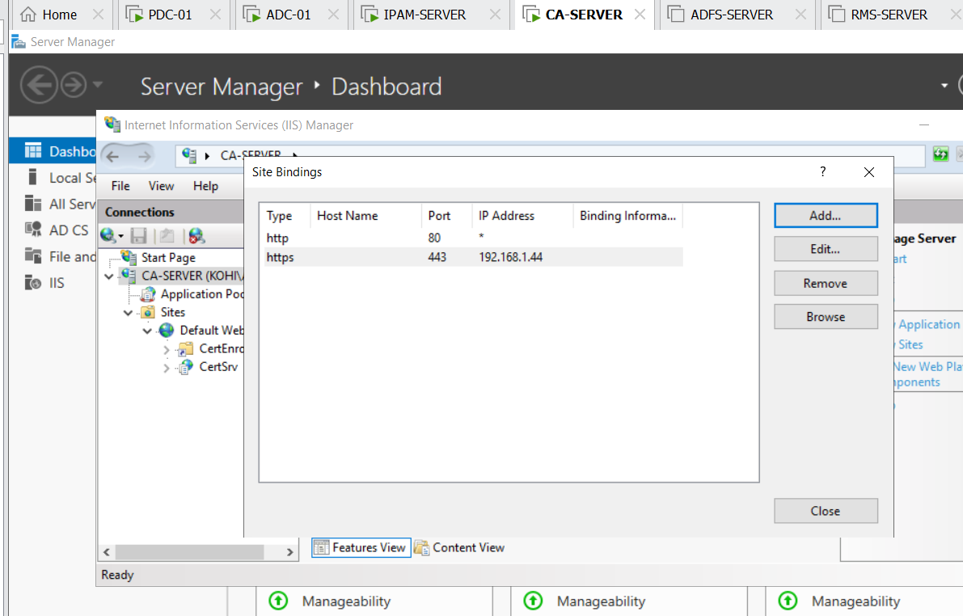

We click close

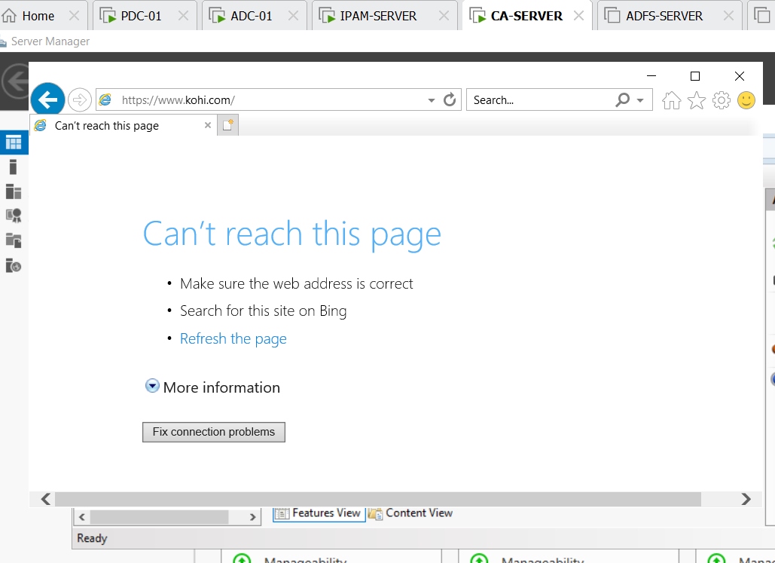

As you can see , I enter the link can’t reach, because we’ve not created the forward and reverse lookup for [www.kohi.com](http://www.kohi.com) on DNS, now we get back to DNS on PDC-01 OR ADC-01 and start to configure DNS

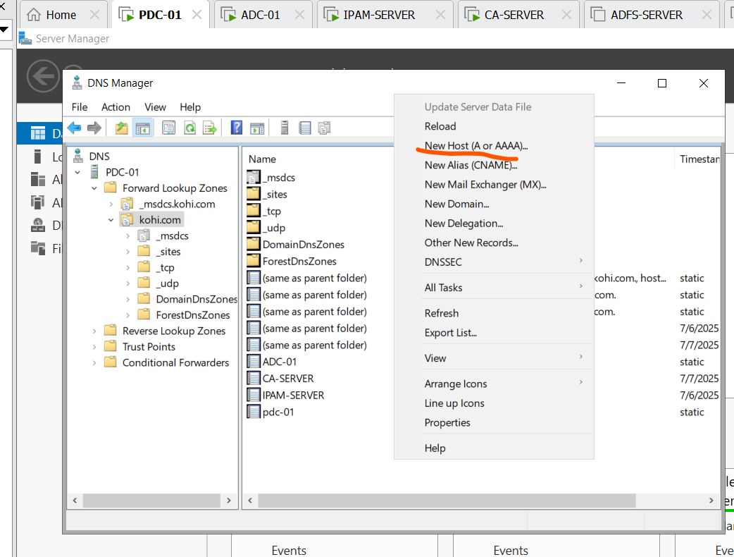

Create new host

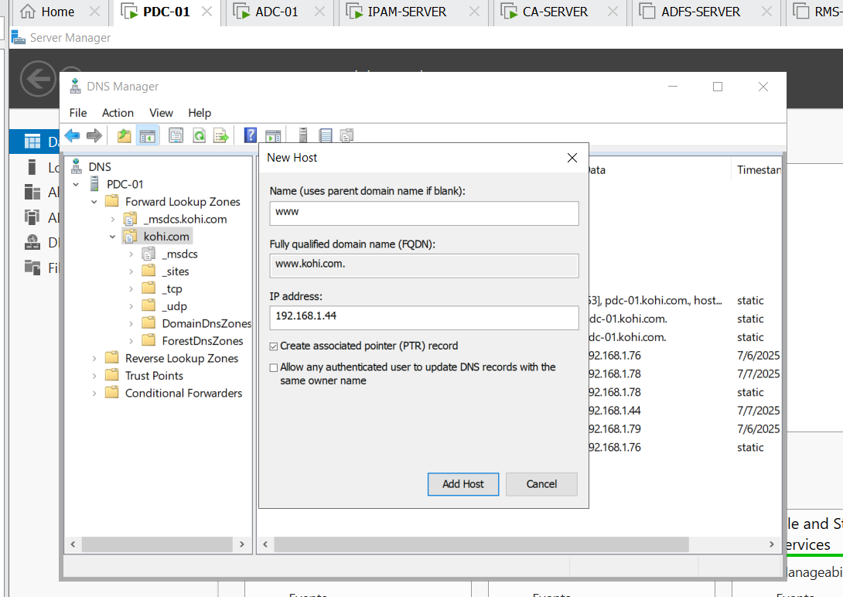

Name: www, and ip address which is belong to CA-SERVER

And don’t forget to check the created associated poiter(PRT) record, and click add host

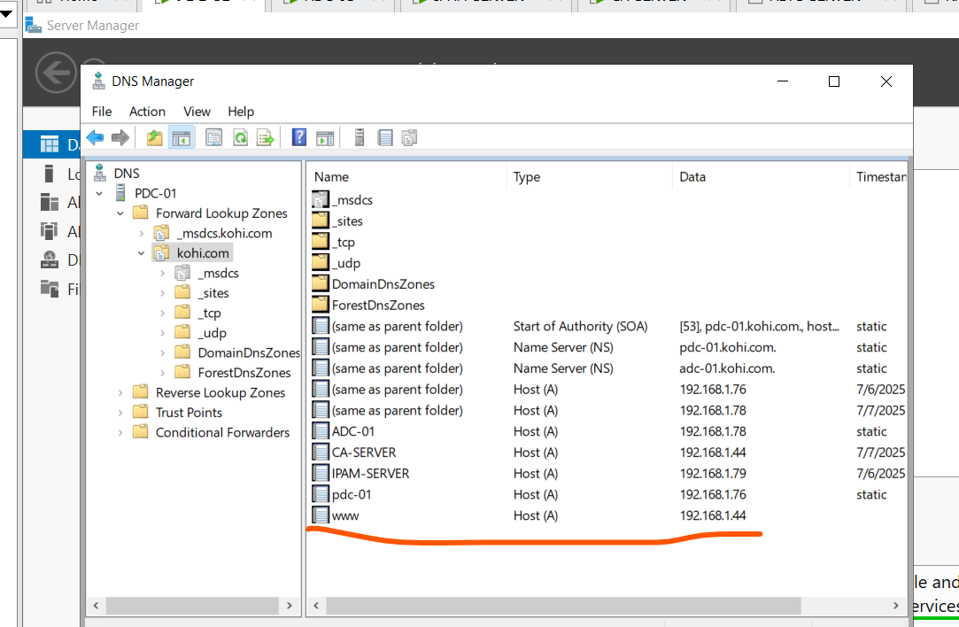

We have [www.kohi.com](http://www.kohi.com)

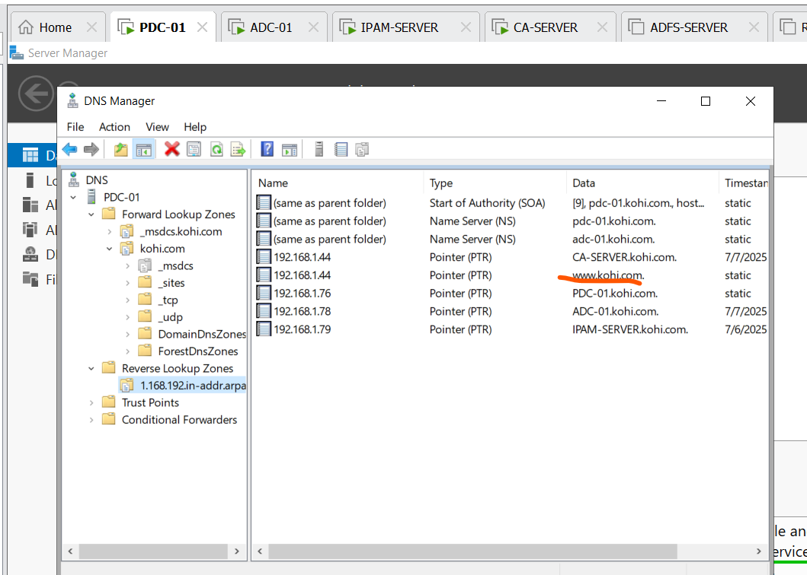

Check reverse , we also have [www.kohi.com](http://www.kohi.com)

Now we return to CA-SERVER and reload the link : <https://www.kohi.com> on IE

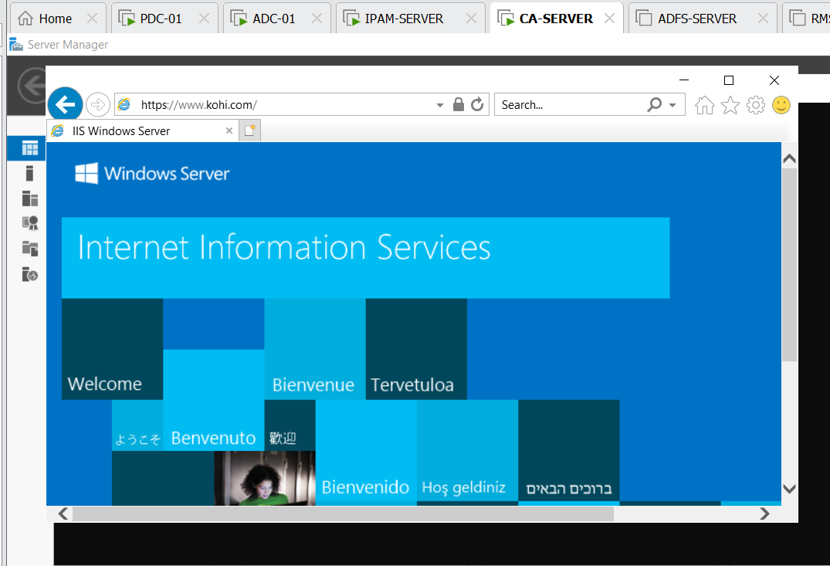

You can see ,it’s success

Now I would like all servers and clients when they enter this link on their IE it also appears the website like this

By doing that we click tools => certification authority

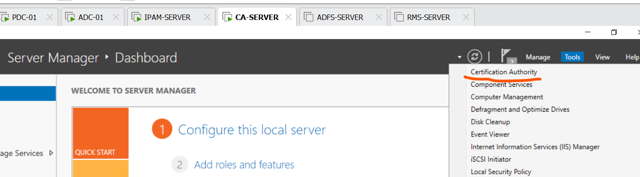

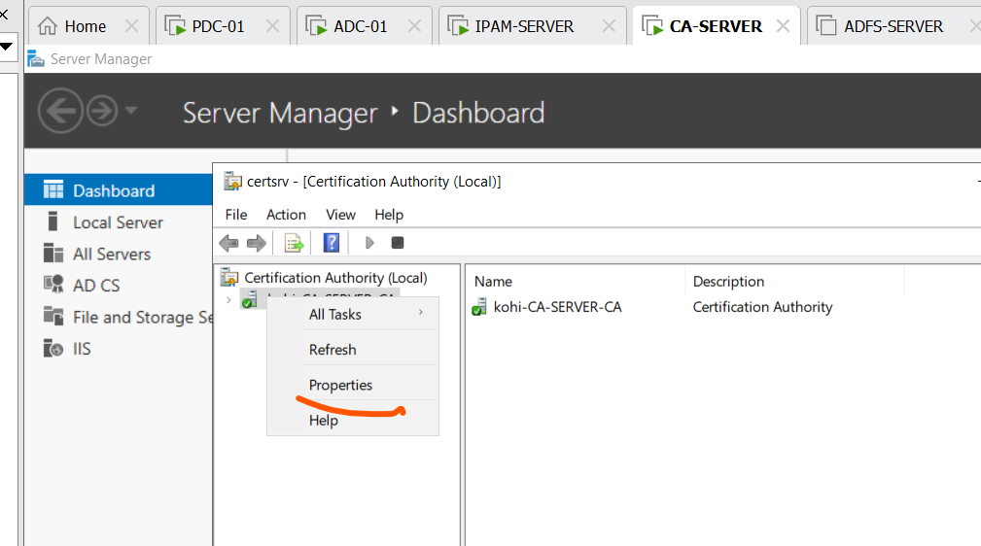

Right click and select properties

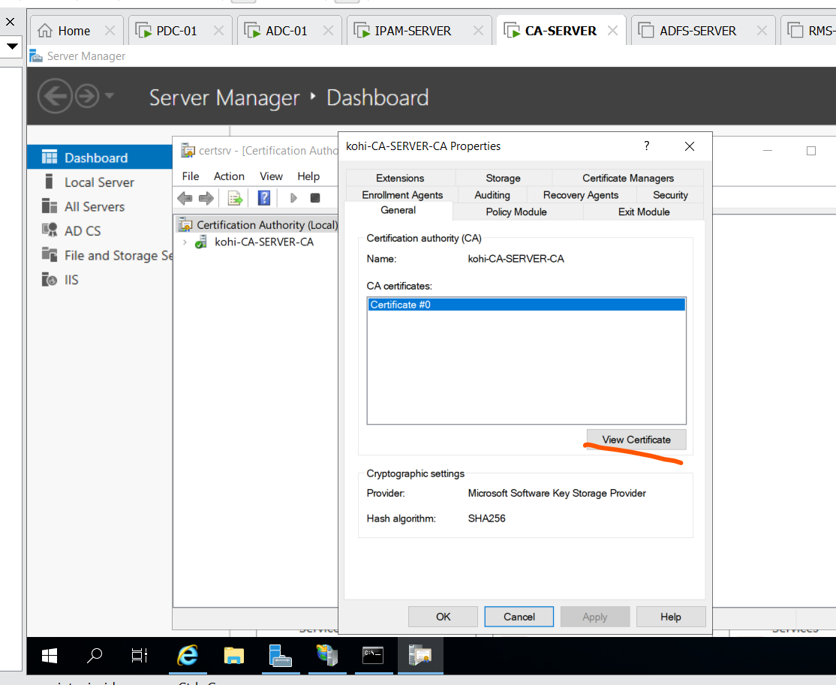

Choose view certificate

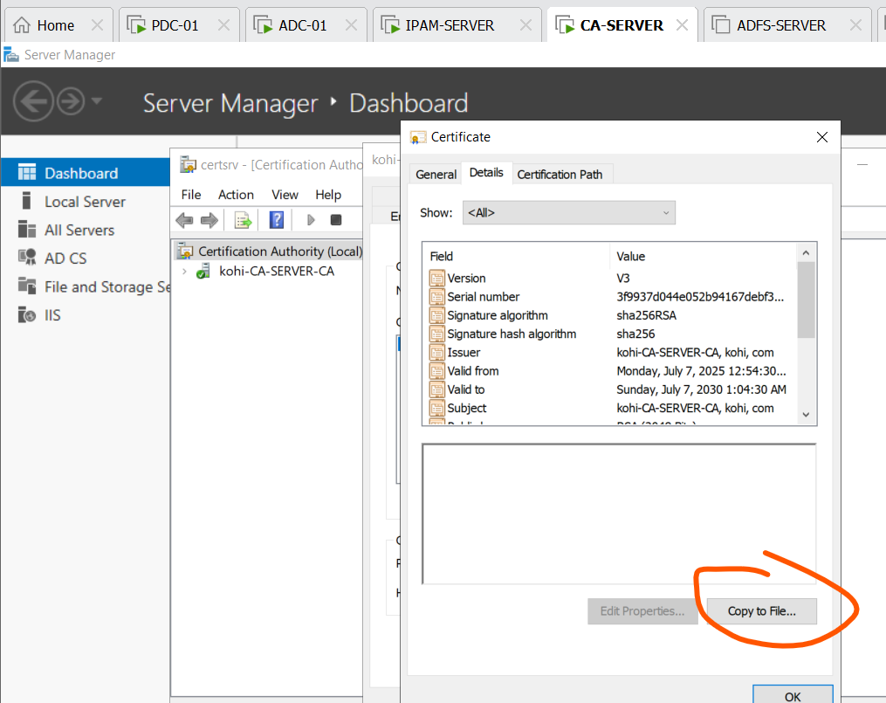

Staying tab Detail choose copy to file

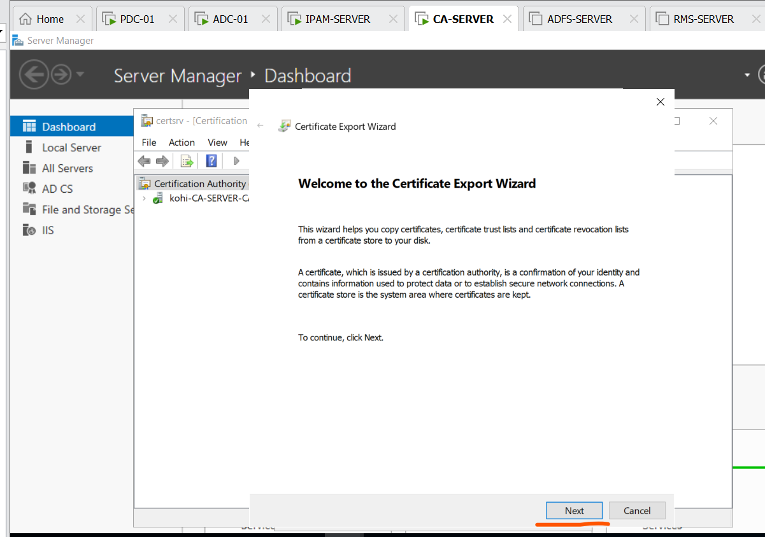

Click next

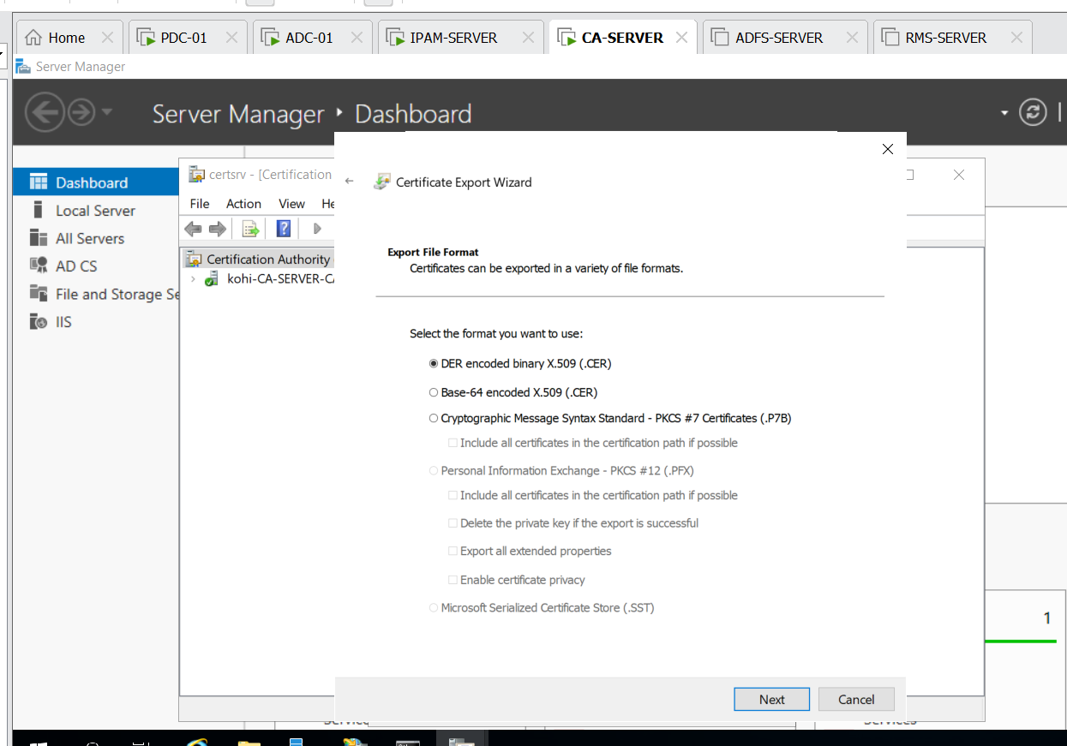

Click next

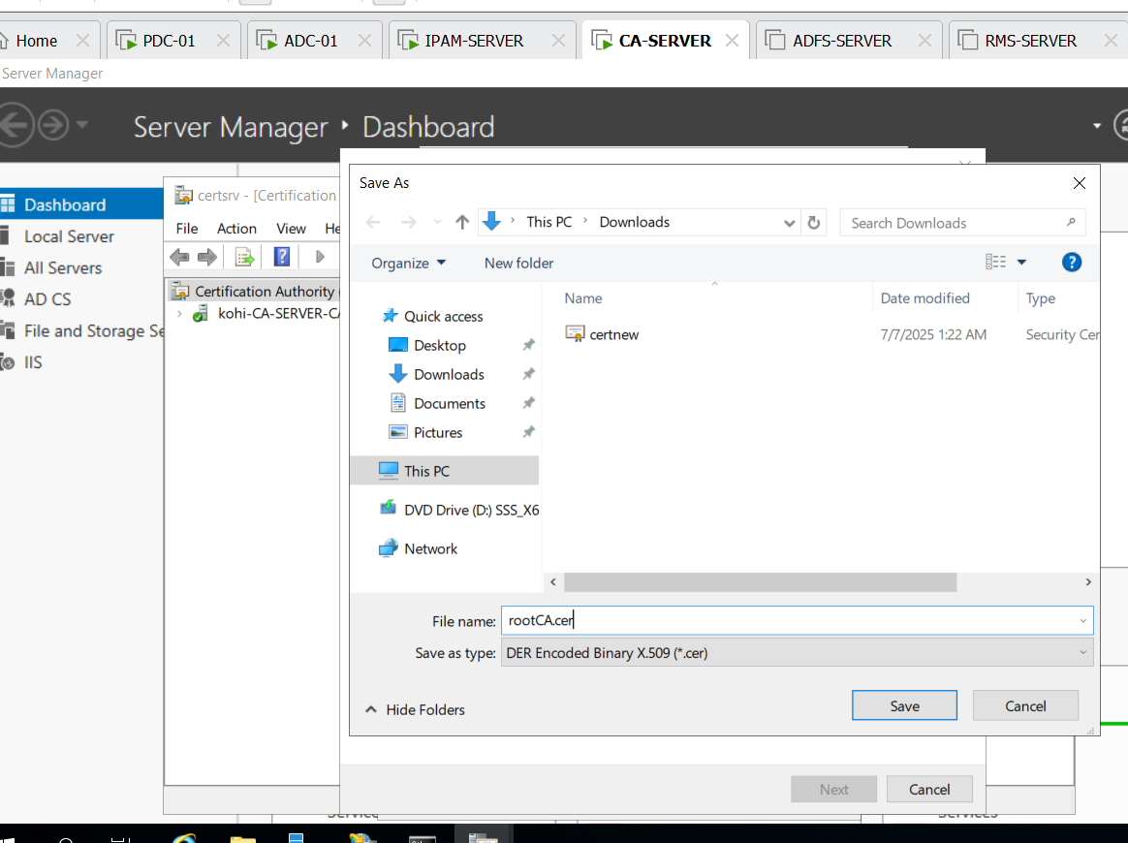

Setting name for this file and selecting save

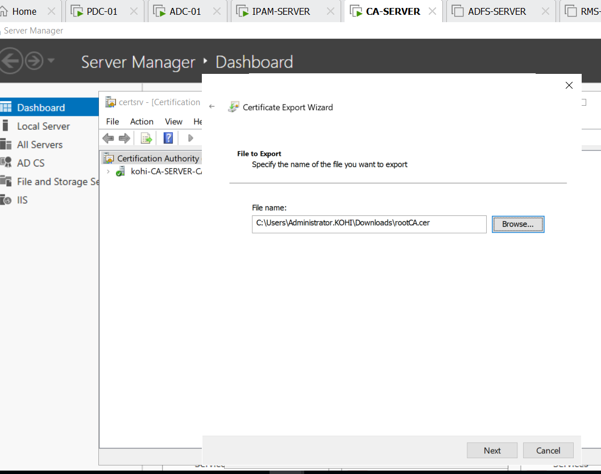

Click next

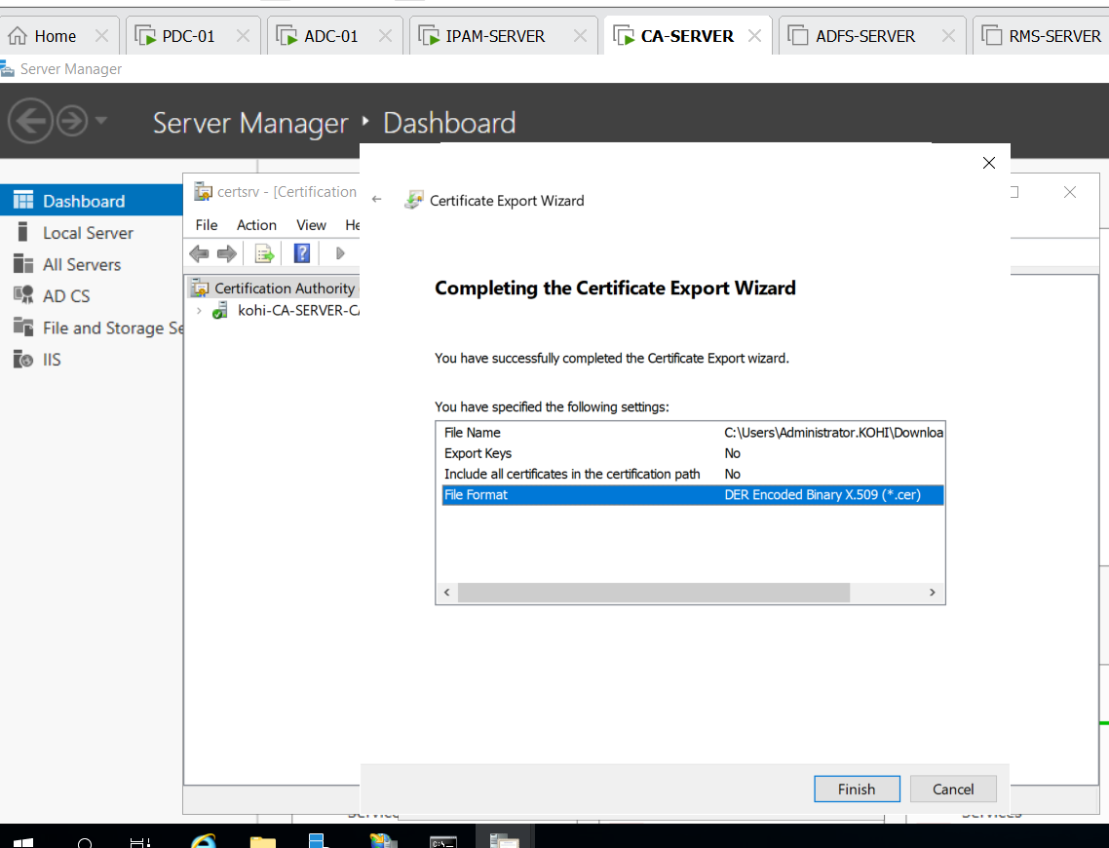

Choose file format and finish

Now I’m going to move this file naming rootCA.cer from CA-SERVER to PDC-01

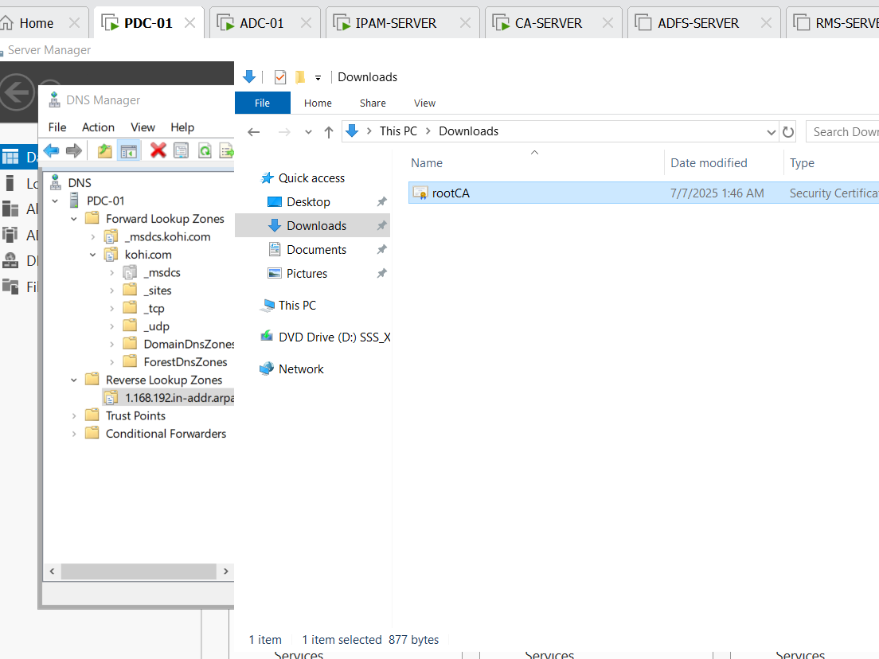

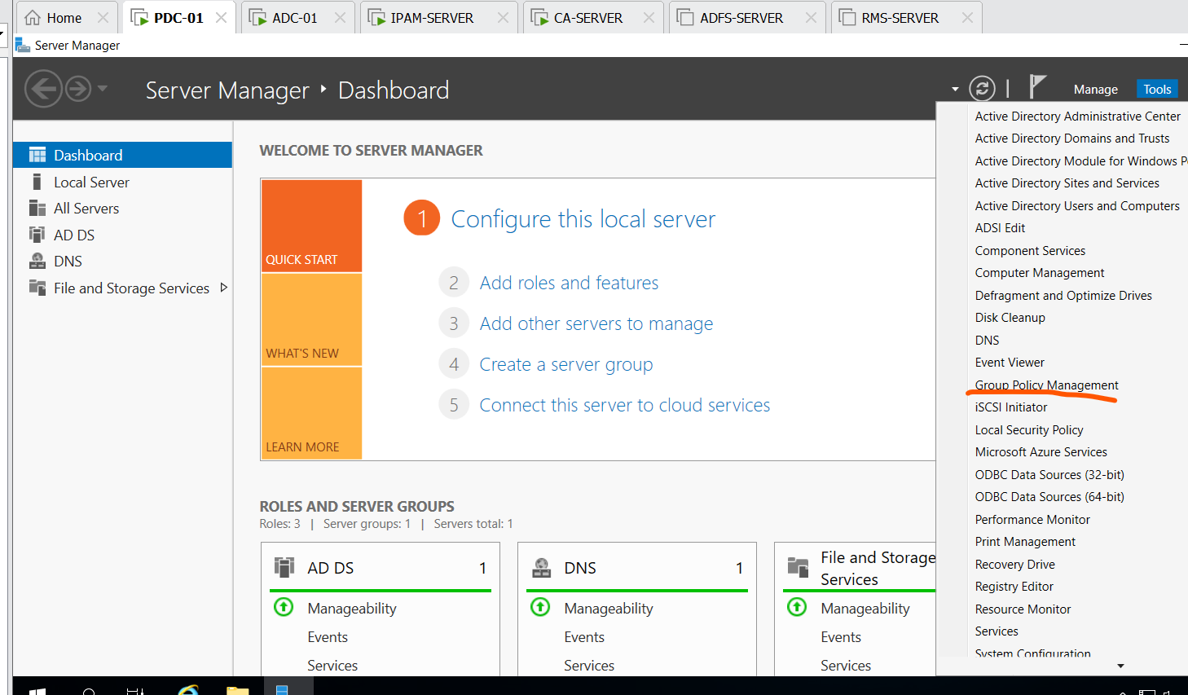

We click Group policy management

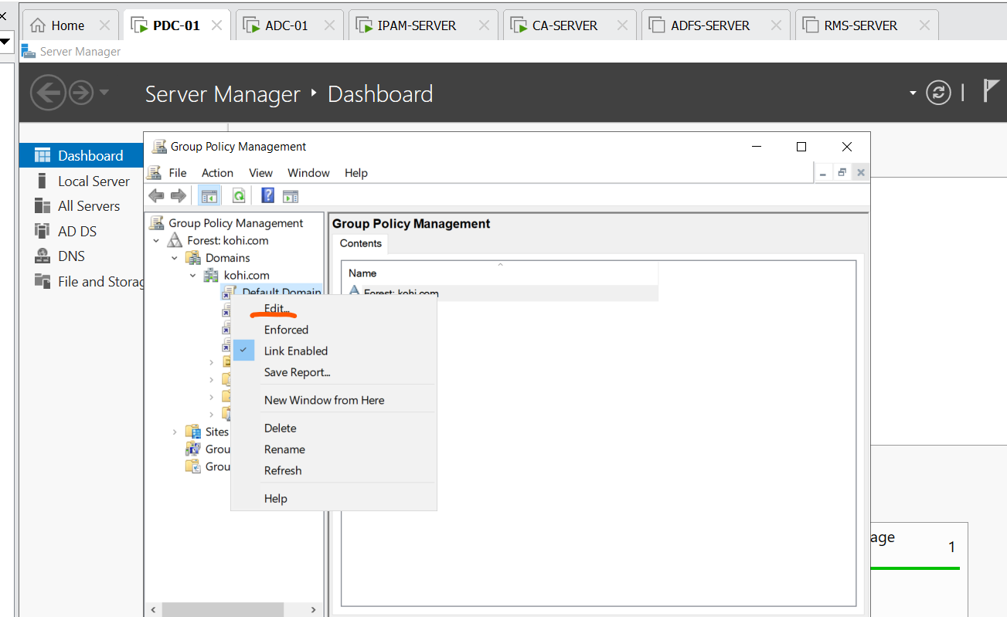

Click default domain policy and select edit

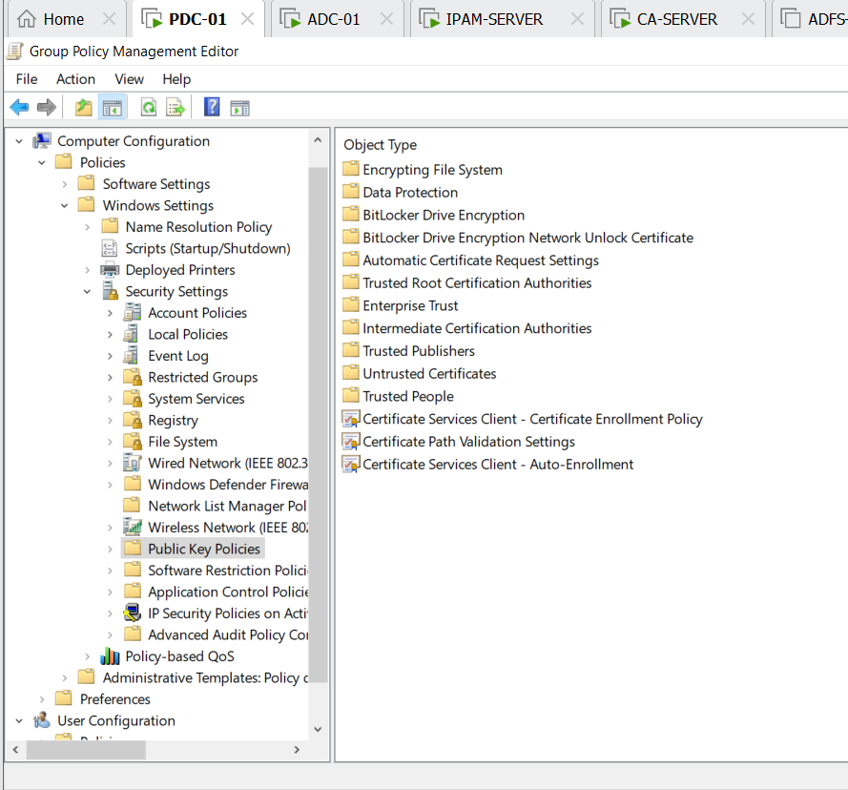

We click trusted root certification authorities

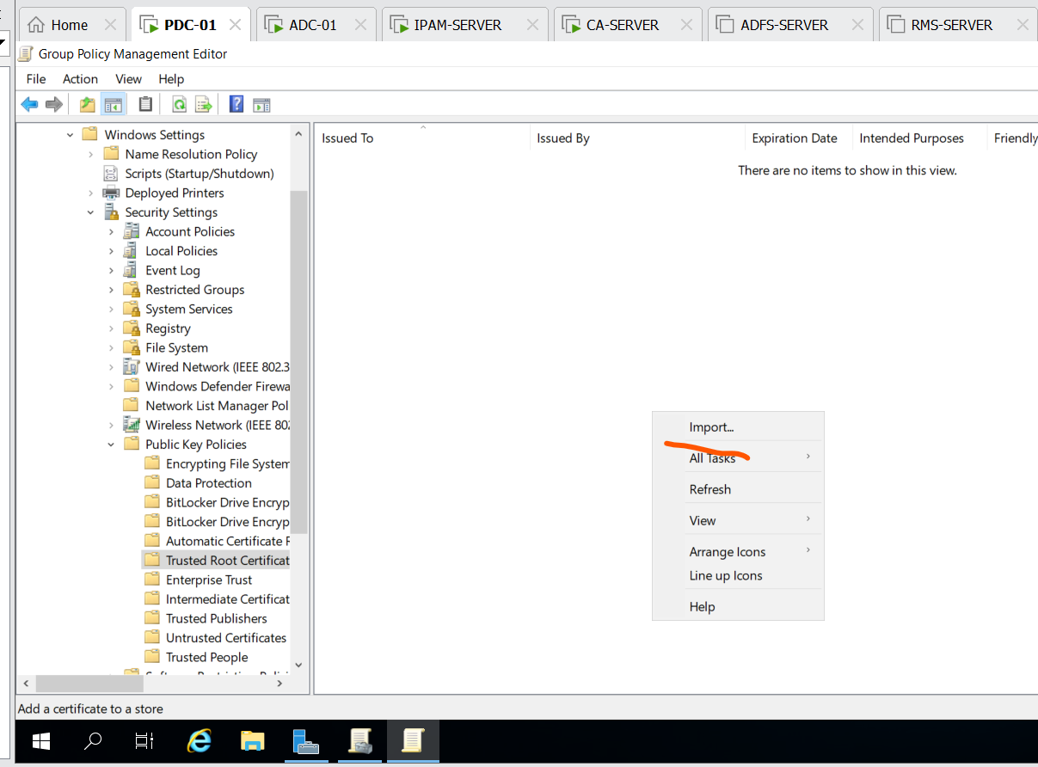

Right click , choose import

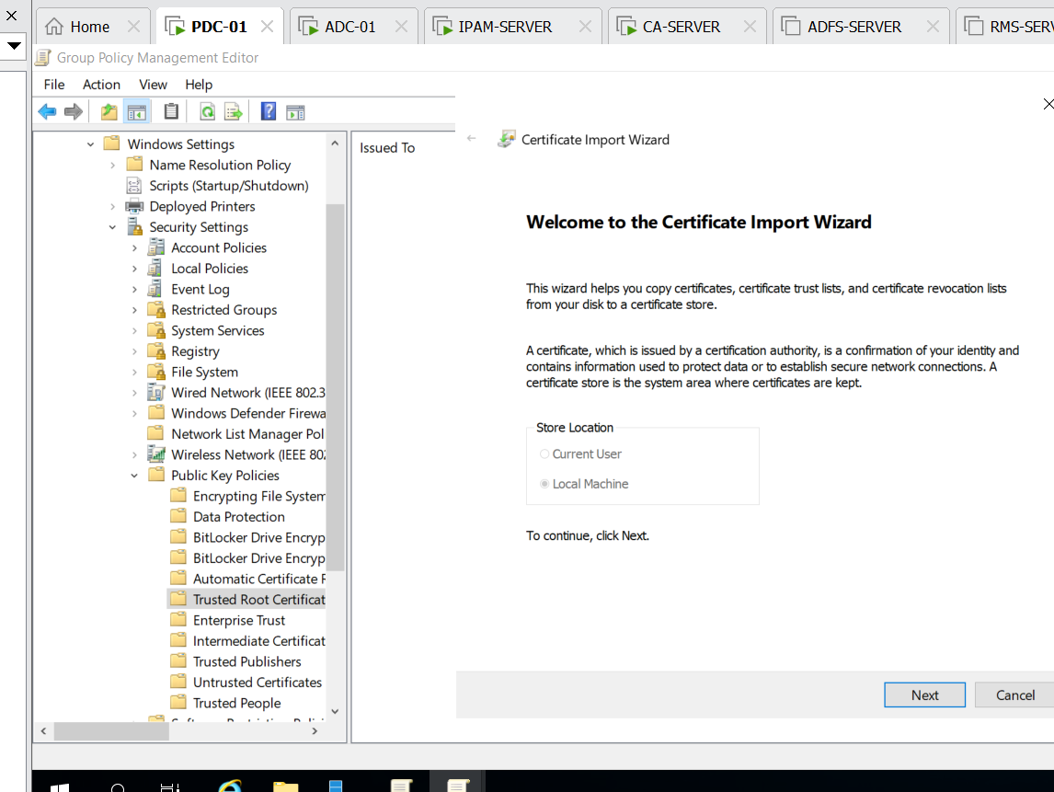

Click next

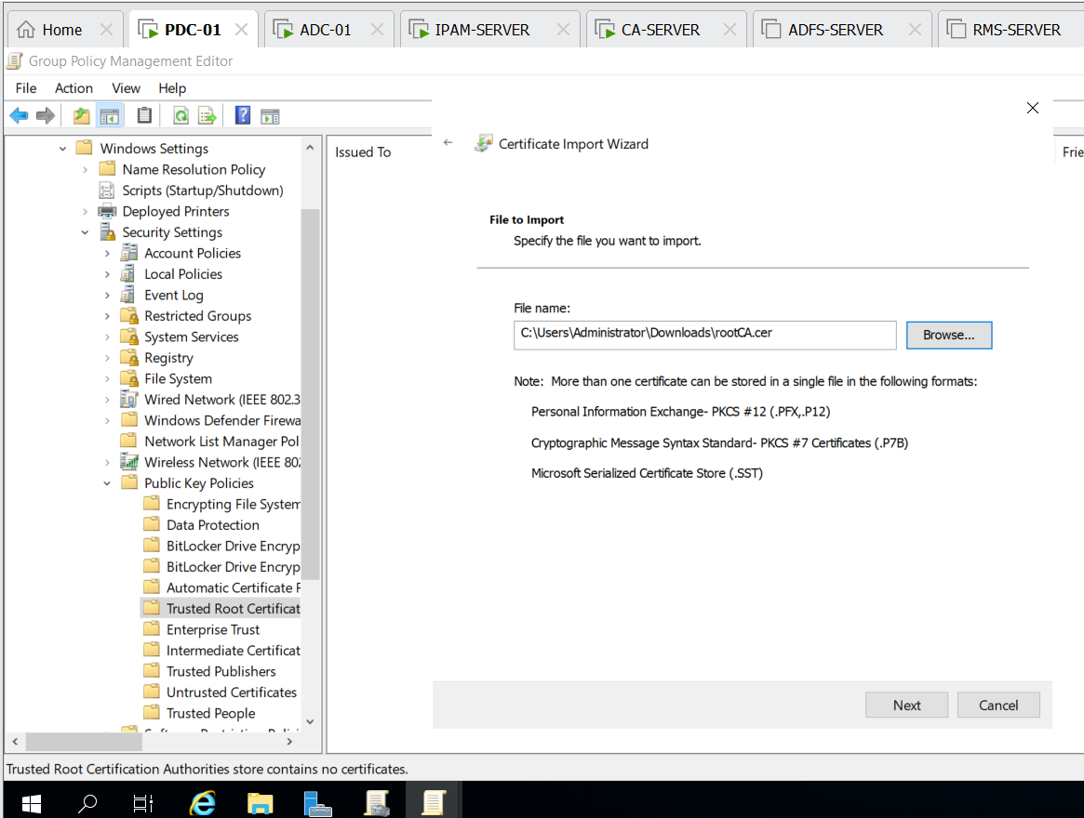

Browsing rootCA which is copied from CA-SERVER

And next

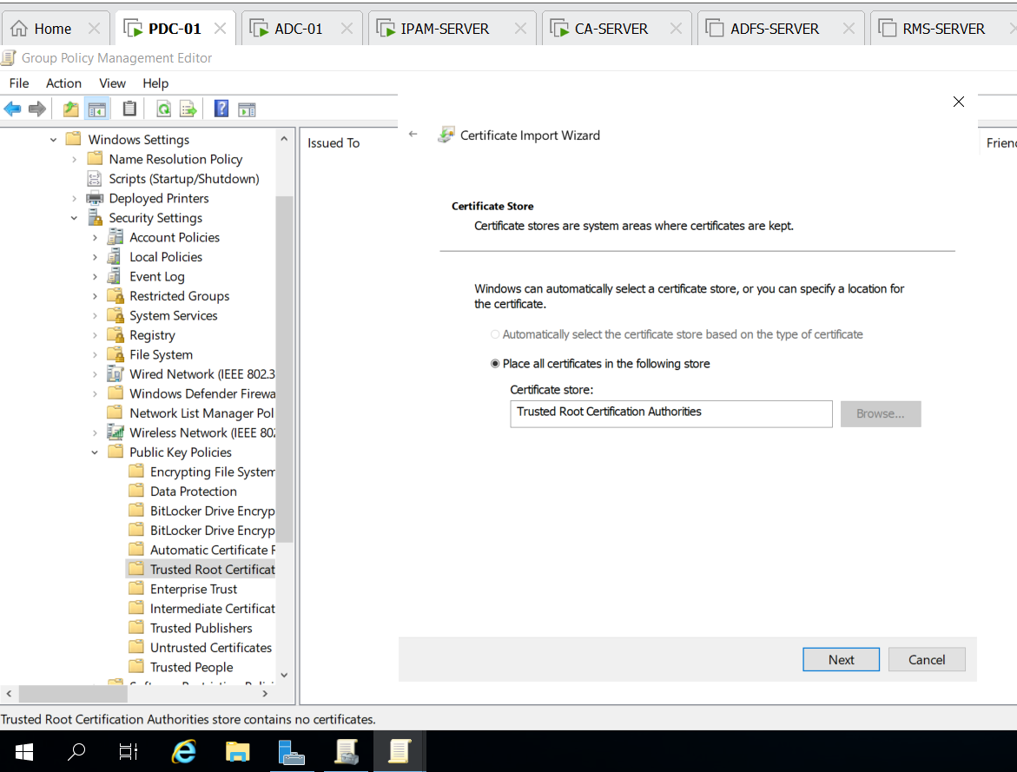

Click next

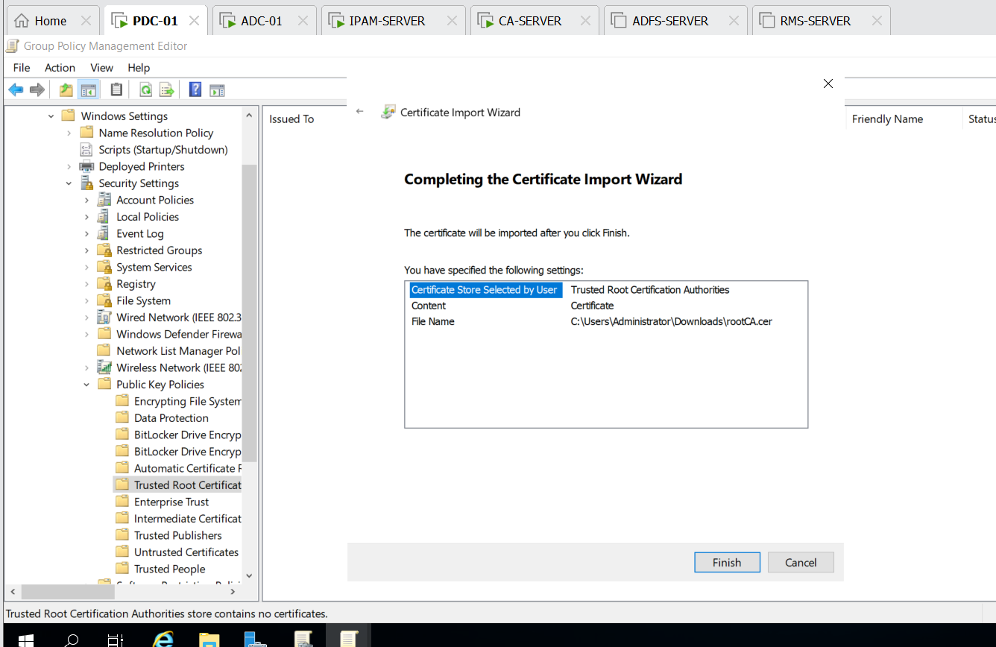

Click finish

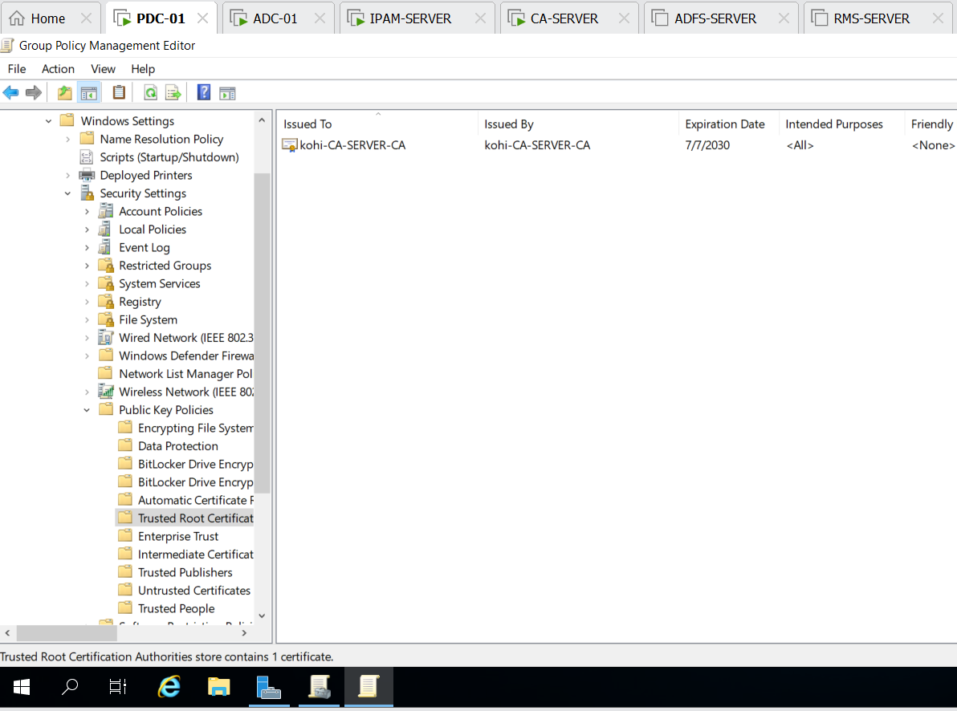

We import successfully

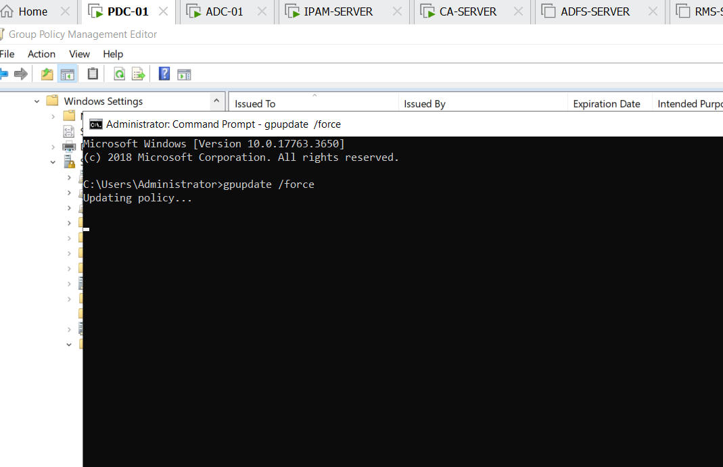

Don’t fortget to command gpupdate /force to update policies

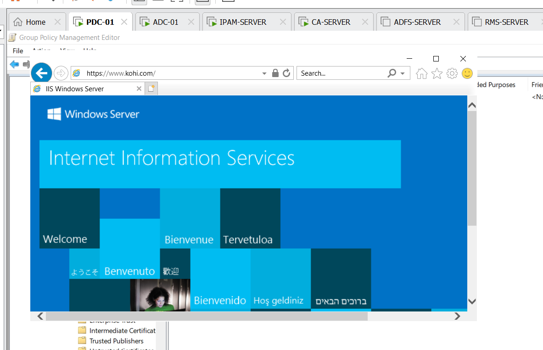

We did it successfully

On IPAM-SERVER

We do that similiarly

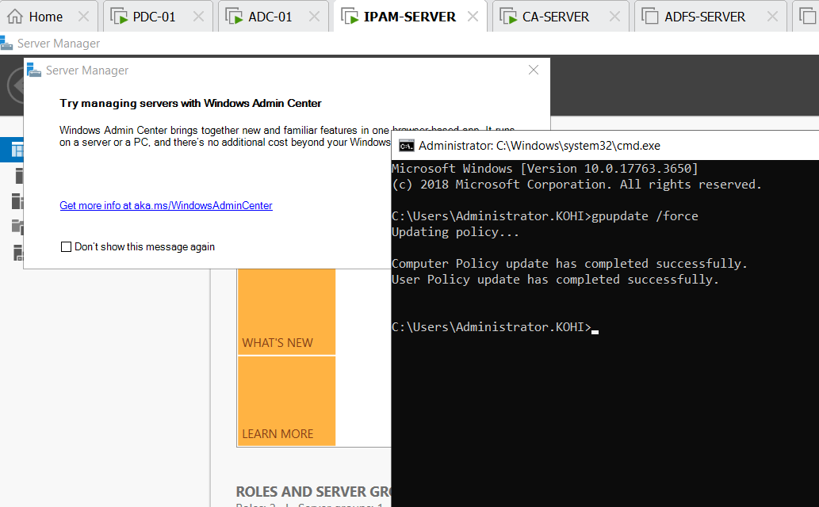

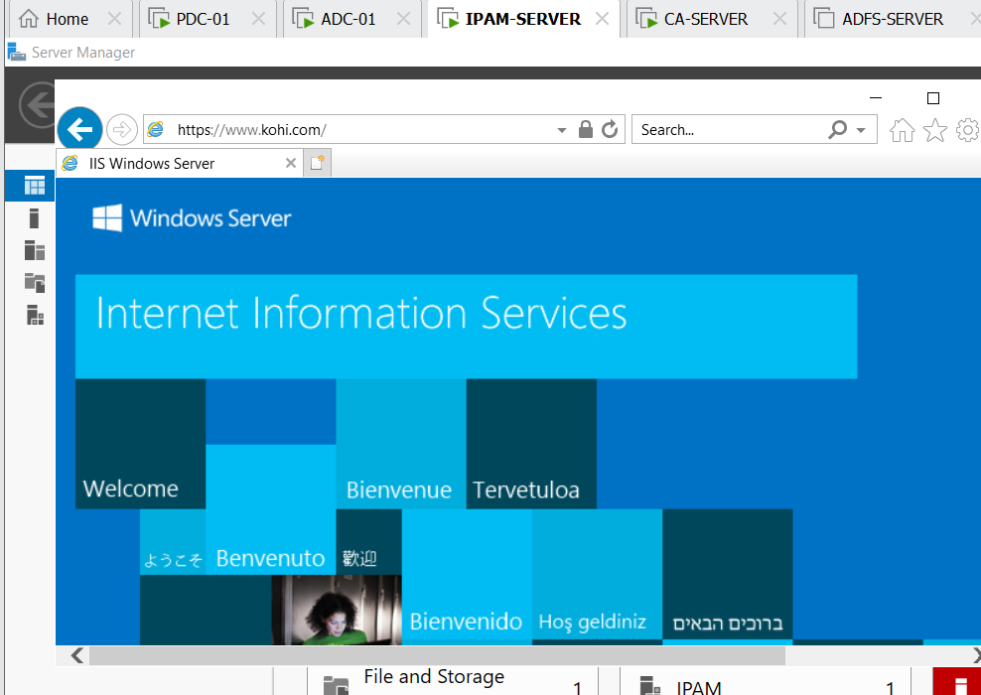

On ADC-01

